**The Bäckman’s ready for a new race weekend in WTCR**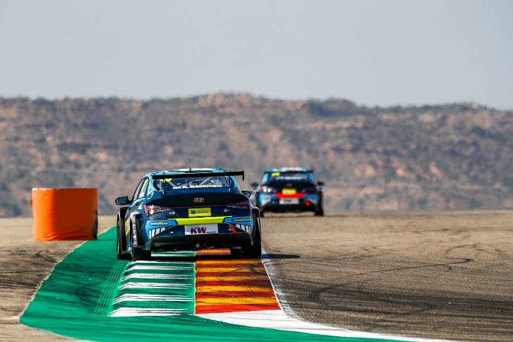Andreas and Jessica Bäckman competes this weekend in the fourth round of WTCR at the Hungaroring track in Hungary.  
Photo: FIA WTCR (Free rights to use the image)

**This weekend, August 21st-22nd, WTCR - FIA World Touring Car Cup and its 23 drivers heads to the Hungaroring track in Hungary. The racing siblings Andreas and Jessica Bäckman are looking forward to a new race weekend after a couple of weeks break and are comeback hungry!  
-  I have prepared by doing a lot of simulator and I’m very excited to be back racing again, Jessica Bäckman says.**

This weekend, August 21st-22nd, the fourth round of the FIA WTCR series will be held at the Hungaroring track in Hungary, near Budapest. The Hungaroring track is technically advanced. The Hungarian Grand Prix in Formula 1 takes place here, and has a maximum capacity of 70,000 in the audience. It will be the siblings Andreas and Jessica Bäckman's fourth race weekend in WTCR, and they will compete for the Italian team Target Competition in their Hyundai Elantra N TCR cars.

- It will be fun to race on a track that we’ve raced on before. It was the first race we did in TCR Europe in 2019 and I have some good memories. We have been struggling a lot to get the car to work the way we want. Hopefully this weekend we will achieve it and I will be happy if I could bring home a top 10 position. I have prepared by doing a lot of simulator and I’m very excited to be back racing again, **Jessica Bäckman** says.

- A quite technical track which has a good flow with sweeping corners. Last time I raced here I had quite good speed through the whole race weekend. Hopefully we will find some more speed this weekend so we can compete a bit higher up in the results list. Like the last race in Spain, it looks like it will be quite hot this weekend in Hungary as well, so it will be important to be well prepared for two hard races, **Andreas Bäckman** says.

**WTCR Race of Hungary - Hungaroring**Hungaroring, located less than 20 kilometers northeast of Budapest, is famous for hosting their first Formula 1 race in 1986 and has always been on the F1 calendar ever since. The track has a total of 14 corners with both fast and slow sections. Hungaroring´s close location to the Hungarian capital Budapest also gives the fans the opportunity to enjoy both racing and explore the capital's attractions.  
  
This weekend, 21-22 August, it's time for WTCR to run on the track in the WTCR  
Race of Hungary 2021 and which will be this year's fourth race in the WTCR.

- New race weekend, new opportunities. It will be fun to compete again, I feel prepared and ready. I really hope we can find some speed in the cars so we can race and fight higher up in the field, **Jessica Bäckman** says**.**

**WTCR is broadcasted LIVE on Eurosport**Throughout this season, all competitions will be broadcasted LIVE on both Eurosport on TV and can also be streamed via Eurosport Player. The two free practice sessions are also broadcasted LIVE on WTCR's [Facebook](https://www.facebook.com/WorldTouringCarCup)- and [YouTube](https://www.youtube.com/FIAWTCR) pages.

**Timetable for this weekend (WTCR Round 4):**(all times are in CEST/Swedish time)

**Saturday August 21st:**09:30 Free Practice 1 (Broadcasted LIVE on Eurosport Player & on FIA WTCR on [Facebook](https://www.facebook.com/WorldTouringCarCup) and [YouTube](https://www.youtube.com/FIAWTCR))  
12:30 Free Practice 2 (Broadcasted LIVE on Eurosport Player & on FIA WTCR on [Facebook](https://www.facebook.com/WorldTouringCarCup) and [YouTube](https://www.youtube.com/FIAWTCR))  
15:30 Qualifying (Broadcasted LIVE on Eurosport Player)  
18:45 Replay of the Qualifying (Broadcasted on Eurosport 2)

**Sunday August 22nd:**12:15 Race 1 (Broadcasted LIVE on Eurosport 2 & Eurosport Player)  
15:15 Race 2 (Broadcasted LIVE on Eurosport 2 & Eurosport Player)

**The FIA WTCR app**In the FIA WTCR app, you can follow the competitions with live timing, and there is also more information such as results and the championship standings. Here you will also find the latest news and photos. The FIA WTCR app is available on both [App Store](https://apps.apple.com/se/app/fia-wtcr/id358795125) and [Google Play](https://play.google.com/store/apps/details?id=com.eurosport.events.wtcc&hl=sv&gl=US).

**About the track (Hungaroring):**

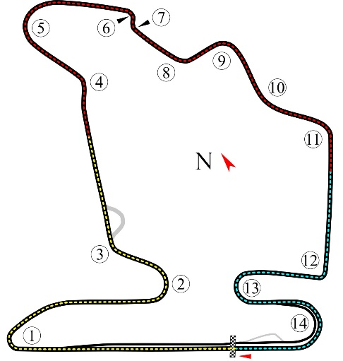

**Location:** Mogyoród, Ungern

**Length:** 4,381 km

**Corners:** 14

**Race length:** Race 1: 12 laps (52,532 km) and Race 2: 15 laps (65,675 km)

**Track record (TCR):** 1:52.365 / average speed 140.3 kph, Norbert Michelisz (Hyundai i30 N TCR) 2018

**WTCR Series Standings**

**FIA World Touring Car Cup for Drivers WTCR – Overall (Top 3)**FIA WTCR 2021 (After 3 of 8 race weekends)

1: Jean-Karl Vernay (FRA), 82 p.

2: Yann Ehrlacher (FRA), 74 p.

3: Yvan Muller (FRA), 67 p.

–

**21: Jessica Bäckman (SWE), 2 p.**

**22: Andreas Bäckman (SWE), 1 p.**

[See the full standings here](https://www.fiawtcr.com/standings/)

**WTCR Trophy – Overall (Top 3)**FIA WTCR 2021 (After 3 of 8 race weekends)

1: Gilles Magnus (BEL), 62 p.

2: Tom Coronel (NLD), 33 p.  
**3: Jessica Bäckman (SWE), 25 p.**-

**4: Andreas Bäckman (SWE), 22 p.**

[See the full standings here](https://www.fiawtcr.com/standings/)

**FIA World Touring Car Cup for Junior Drivers – Overall (Top 3)**FIA WTCR 2021 (After 3 of 8 race weekends)

1: Gilles Magnus (BEL), 166 p.

2: Luca Engstler (DEU), 125 p.

**3: Jessica Bäckman (SWE), 102 p.**

[See the full standings here](https://www.fiawtcr.com/standings/)

**WTCR – FIA World Touring Car Cup for Teams – Overall (Top 3)**FIA WTCR 2021 (After 3 of 8 race weekends)

1: Cyan Racing Lynk & Co, 141 p.

2: Engstler Hyundai N Liqui Moly Racing Team, 121 p.

3: Cyan Performance Lynk & Co, 112 p.

–

**11: Target Competition, 3 p.**

[See the full standings here](https://www.fiawtcr.com/standings/)

​ ***Free rights to use the images.***

***Download press-photos here:***[***http://bit.ly/jabaeckman-photos***](http://bit.ly/jabaeckman-photos)[***https://www.mynewsdesk.com/se/ja-backman/images***](https://www.mynewsdesk.com/se/ja-backman/images)

