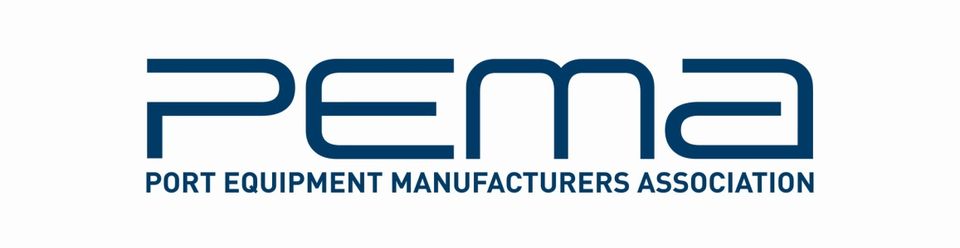

Media Release
Port Equipment Manufacturers Association returns to TOC Europe with expanded programme of educational events

Leading industry trade body stages 8th port equipment and technology live debate forum, new technical master classes and first ever Student Challenge at TOC Europe 2013

June 7, 2013 – The Port Equipment Manufacturers Association (PEMA) returns to the TOC Europe show in Rotterdam this 25-27 June with an expanded programme of educational events and activities, including its established industry debate forum, new in-depth master classes and the first ever PEMA Student Challenge, a collaboration with three leading technical universities.

The 8th PEMA State-of-the-Industry Port Equipment & Technology Discussion Forum takes place on the morning of 25 June. As in previous years, the Forum brings together key players from the world of port equipment and technology, plus members of the container terminal operator community, for lively, unscripted debate on current and future challenges. Under the theme “A Vision of the Future,” this year’s Forum will focus on two key areas of container terminal development - unmanned automated facilities and ‘traditional’ manned operations.

What could an automated container terminal look like in 10 years’ time and how do we get there from where we are today? What will the people working at future automated terminals do and what training will they need? How can the man-machine interface be managed for 100% safety? These are some of the key questions to be raised in the automated terminal debate. Talking points for the traditional manned terminals debate include: will diesel-electric equipment be phased out? Can process automation make a manned terminal run like an automated facility? And how can technology make crane drivers safer and more productive?

Companies taking part in the PEMA Forum this year include ABB, Brieda, Cavotec, IDENTEC, ICHCA, ISL, Jade, Kalmar, Konecranes, Moffatt & Nichol, Navis, OMG, Portunas, Siemens, SICK, smart-TECS, Symeo, TBA, TMEIC and TT Club. Guest panellists include Tom Ward, Chief Engineer at Ports America and Cosmin Carstea, Manager Systems Applications and Optimisation at DP World.

DP World’s Cosmin Carstea also joins Paul Avery, Associate Editor at World Cargo News and Emile Hoogsteden, VP Containers, Breakbulk & Logistics at the Port of Rotterdam, on the judging panel for the first PEMA Student Challenge. Developed in co-operation with Blekinge Institute of Technology, Delft University of Technology and the University of Hamburg, the Challenge pits student teams from the three universities against each other to deliver the best case study on the theme of “Inter Terminal Transport.” The three student teams will present their entries at TOC on the afternoon of 26 June, with the judges conferring and announcing the winner on the spot.

“Great technical education and research are critical for the future success of our industry and our goal at PEMA is to foster strong relations between the academic and business worlds so that both can thrive,” said John Lund of PEMA’s Special Events, Programmes & Education Committee. “We chose inter terminal transport for this first initiative to promote and showcase student talent because of its growing relevance to large European ports and one that is already being addressed by some of Europe’s premiere universities.”

PEMA will also stage two 90-minute master classes on the afternoon of 25 June, providing in-depth education on technology developments and implementation. The Process Automation Master class will walk attendees through the use of automated sensing, identification and locating technologies at the gate, yard and quay, while the Safety Master class will delve into machine-machine and man-machine safety, plus the use of safety analytics and tools.
Entry to the PEMA sessions is free of charge for visitors, exhibitors and delegates attending TOC Europe. For details of PEMA events at TOC Europe, visit: www.pema.org/pema-events. To register as a TOC attendee, visit www.tocevents-europe.com

About PEMA
Founded in 2004, PEMA provides a forum and public voice for the global port equipment and technology sectors. The Association has see strong growth in recent years, and now has nearly 70 member companies representing all facets of the industry, including crane, equipment and component manufacturers; automation, software and technology providers; consultants and other experts. www.pema.org

For more information on this media release, please contact Rachael White, PEMA Secretary General at: Tel +44 20 3327 0577 | rachael.white@pema.org

