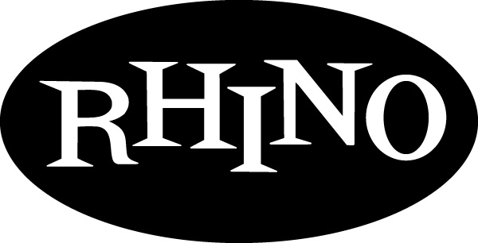
p r e s s r e l e a s e

INCOMING!!!

Queensrÿche PAY HOMAGE TO THEir IDOLS

with Take Cover

Adventurous 11-Song Collection of Covers Ranges From Black Sabbath

to Broadway, Including the Band’s Unique Take on Songs By U2,

Queen, Pink Floyd, Buffalo Springfield, Peter Gabriel,

The Police, The O’Jays, and More

Available From Rhino November 14

LOS ANGELES — Queensrÿche pay tribute to some of their favorite songs with an adventurous collection of covers that range from Black Sabbath and The O’Jays to Italian opera and Broadway musical. Singer and chief songwriter Geoff Tate, guitarists Michael Wilton and Mike Stone, bassist Eddie Jackson, and drummer Scott Rockenfield put their stamp on 11 classic tracks with TAKE COVER.

Not known for playing many covers live, Tate says the album gave the band a chance to relax and have some fun. “During sound checks, Stone and Michael like to play ‘name that riff,’ and sometimes the whole band joins in. That’s really the way this album came together too. We got together and started playing songs to each other, and then we picked our favorites.”

The eclectic list of songs reflects the members’ divergent tastes and includes a few surprising selections such as “Heaven On Their Minds” from the hit musical Jesus Christ Superstar, the O’Jays R&B classic “For Love Of Money” and an operatic epic originally performed by the Italian duo of Carlo Marrale and Cheope, “Odissea.” Recognized as an accomplished vocalist, Tate says he enjoyed the song’s demanding arrangement. “I really like this song because there is a lot for a singer to sink his teeth into, plus I got a chance to sing in Italian, which was interesting considering I don’t speak a word of it.”

The set covers a lot of ground both lyrically and musically, opening with “Innuendo,” Queen’s epic song about life and death; “Almost Cut My Hair,” Crosby, Stills, Nash & Young’s paean to freedom; and the medieval metal of Black Sabbath’s “Neon Knights.” Starting September 5, Queensrÿche and Black Sabbath with Ronnie James Dio (touring as Heaven And Hell), will play a month of North American concerts. Says Tate, “Ronnie took us out on our first European tour and he’s always been good to us. With the tour coming up, this seemed like a nice way to pay tribute to him. I hope he likes it, or I’m sure I’ll hear about it every night of the tour.”

TAKE COVER also features Queensrÿche’s distinctive arrangement of Pink Floyd’s “Welcome To The Machine,” an acoustic version of Buffalo Springfield’s “For What It’s Worth,” and a highly charged live version of U2’s “Bullet The Blue Sky.” “We’ll never top the originals; they’re classics for a reason,” Tate says. “We were more focused on finding different approaches that took the songs in unexpected directions.”

Singing Peter Gabriel’s “Red Rain” and the Police’s “Synchronicity II,” Tate says, were opportunities for him to explore music he’d previously overlooked. “I’d heard these songs on the radio before, but I didn’t really appreciate them before the guys suggested we record them. It was a rewarding experience doing this album because it gave us all a chance to pay tribute to some of the bands that have meant so much to us over the years, and we all discovered new songs to love.”

För mer information vänligen kontakta:
Jakob Ekendahl Warner Music Sweden
jakob.ekendahl@warnermusic.com
08-752 26 62

TAKE COVER
Track Listing
Original artist in parenthesis
- “Welcome To The Machine” (Pink Floyd)
- “Heaven On Their Minds” (Jesus Christ Superstar)
- “Almost Cut My Hair” (Crosby, Stills, Nash & Young)
- “For What It’s Worth” (Buffalo Springfield)
- “For The Love Of Money” (The O’Jays)
- “Innuendo” (Queen )
- “Neon Knights” (Black Sabbath)
- “Synchronicity II” (Police)
- “Red Rain” (Peter Gabriel)
- “Odissea” (Carlo Marrale & Cheope)
- “Bullet The Blue Sky” – Live (U2)

