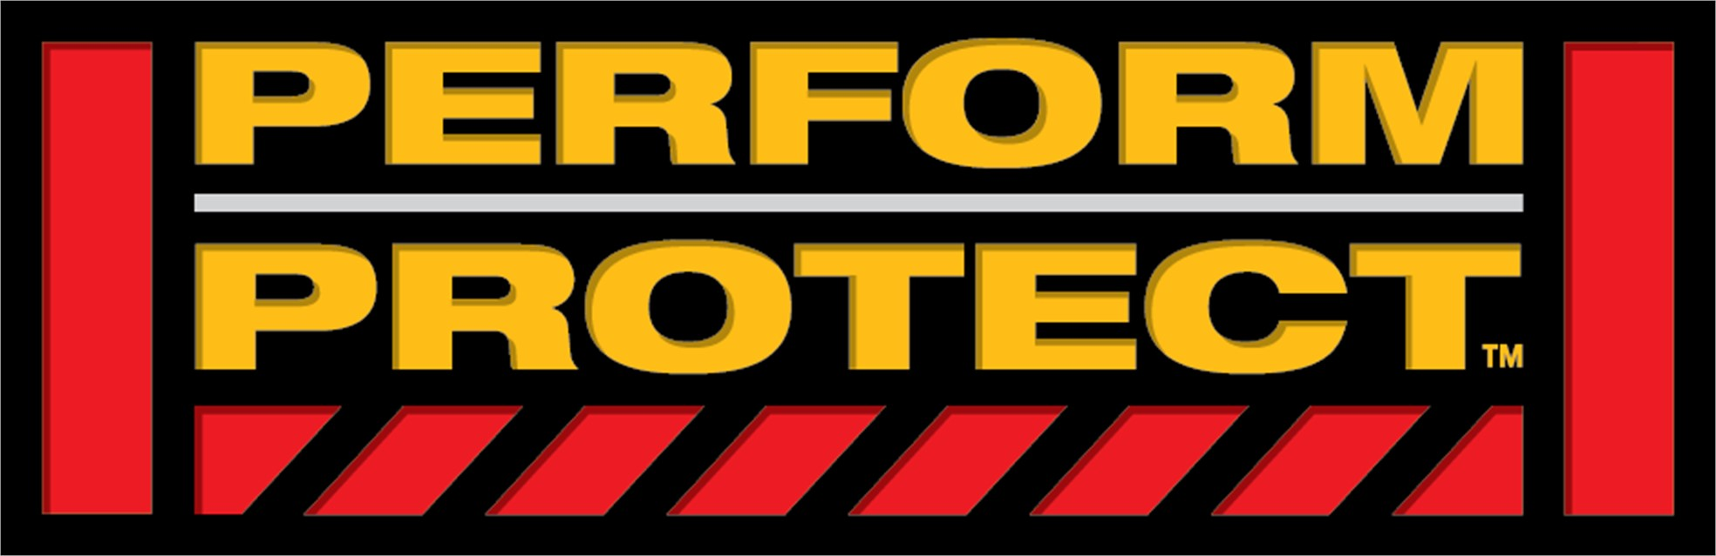

**FOR IMMEDIATE RELEASE**

Contact: Janette Baxter

Phone: (860) 406-9371

E-mail: janette.baxter@sbdinc.com

**Reduce Muscle Fatigue with DEWALT® Carbon Fiber Composite Hammer Tacker**

*25% less muscle exertion* and 45% less weight\**

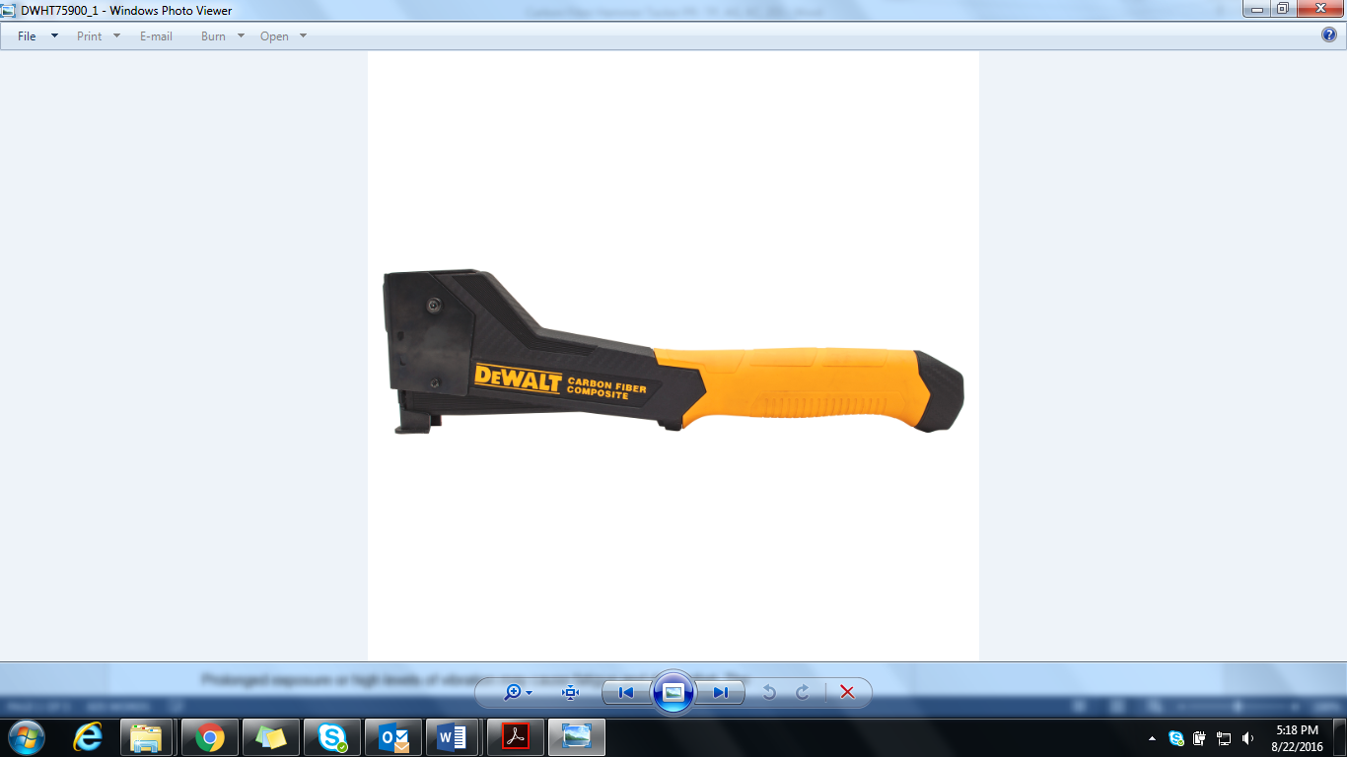

**New Britain, CT** — Experience the difference with DEWALT’s first Perform & Protect™ Hand Tool – the DEWALT® [Carbon Fiber Composite Hammer Tacker](http://www.dewalt.com/en-us/products/hand-tools/manual-fasteners/carbon-fiber-composite-hammer-tacker/dwht75900). DEWALT’s Perform & Protect™ tools are designed to provide a high level of one or more of the following: control, dust containment, or low vibration, without sacrificing performance. In this case, the DEWALT® Carbon Fiber Composite Hammer Tacker falls under the vibration pillar.

Prolonged exposure or high levels of vibration may cause fatigue and discomfort. The DEWALT® Carbon Fiber Composite Hammer Tacker — model [DWHT75900](http://www.dewalt.com/en-us/products/hand-tools/manual-fasteners/carbon-fiber-composite-hammer-tacker/dwht75900) —features a lightweight carbon fiber composite structure that weighs 45% less*, and reduces vibration levels by 45%* and muscle effort by 25%* allowing you to work longer with less fatigue.

Due to the internal complexity of traditional hammer tackers and bodies made of die-cast aluminum, they are not ergonomic in nature, but rather bulky and heavy to use, hold, and carry. This can lead to reduced jobsite productivity, especially for projects that require swinging overhead or multiple repetitions. Designed in conjunction with [United States Ergonomics](http://www.us-ergo.com/) standards, the DEWALT® Carbon Fiber Composite Hammer Tacker’s carbon fiber housing provides an ergonomic, slim, and comfortable handle that allows the user an enhanced feel.

“The lighter weight is expected to result in measureable ergonomic benefits to workers that carry the tools on their tool belts and/or use the tools for hours/day,” as stated by United States Ergonomics.

To meet United States Ergonomics testing standards, muscle activity levels of the hand and arm were recorded as carpentry and roofing professionals completed a series of common applications with the DEWALT® Carbon Fiber Composite Hammer Tacker. The muscle effort levels were analyzed to assess the effort for all major muscles involved in the tasks. Based on the positive testing performance of the DEWALT® Carbon Fiber Composite Hammer Tacker, it has been awarded the United States Ergonomics Ergonomic Product Certification.



Never sacrifice performance to get an easy swing—the DEWALT® Carbon Fiber Composite Hammer Tacker is tested up to 450,000 cycles**, ensuring product reliability and jobsite performance.

This product drives 5/16”, 3/8”, and 1/2” Heavy Duty Staples.

*\* Compared to Milwaukee® 48-22-1020. Milwaukee® is a registered trademark of Milwaukee Electric Tool Corp.*

*\*\* Compared to STANLEY® standard model, on average.*

*The yellow and mesh textured field combination is a trademark for DEWALT hand tools.*

**About DEWALT:**

[DEWALT](http://www.dewalt.com/en-us) is a leading manufacturer of industrial power tools, hand tools and accessories, including corded and cordless drills, saws, hammers, grinders, routers, planers, plate joiners, sanders, lasers, generators, compressors, nailers, saw blades, metal and masonry drill bits, abrasives, screw driving accessories and more, as well as hand tools and pneumatic tools. DEWALT® tools can be found nationally and internationally, wherever tools are sold. With more than 1,000 factory-owned and authorized locations, DEWALT has one of the most extensive service and repair networks in North America. For more information, visit [www.dewalt.com](http://www.dewalt.com) or follow DEWALT on [Facebook](https://www.facebook.com/dewalt), [Instagram](https://www.instagram.com/dewalttough/) and [Twitter](https://twitter.com/DEWALTtough).

**About United States Ergonomics:**

United States Ergonomics is comprised of Certified Professional Ergonomists and experienced professionals who have been applying the best practices in ergonomics, health & safety for decades. Our goal is to improve human efficiency, comfort and the quality of life by enhancing the design of products and the workplace. US Ergonomics is the only company in the United States providing ergonomics product certification. For more information, visit <http://www.us-ergo.com>.

###