Exodus-logo--web-cmyk

**Exodus Launches Family Kilimanjaro Climb**

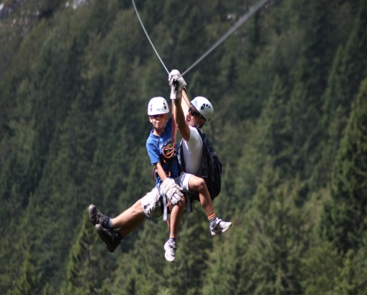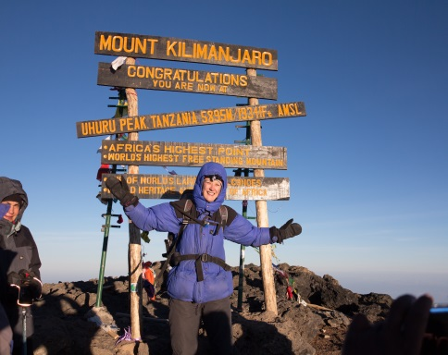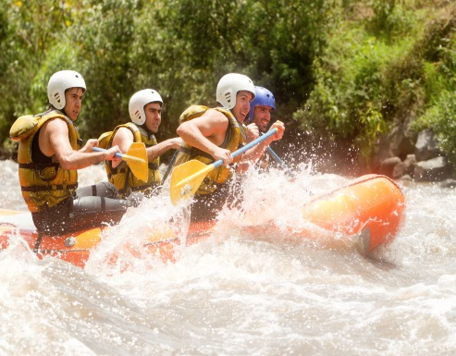

**Exodus launch new products as families ask for more adventurous holidays**

**London, XX February 2015**: Exodus, the UK’s leading adventure tour operator, has announced a swathe of new family trips for 2015, including incredible Mount Kilimanjaro family departures.

Exodus has introduced six brand new dedicated family holidays as well as 11 new family departures on trips that were previously only offered to groups of adults, one of which is the Lemosho route Mount Kilimanjaro climb. These exciting developments are in response to bookings that show a growing trend in families seeking more adventurous holidays, especially those travelling with older children and teenagers. New for 2015, child prices are valid for travellers aged 14 and under, making these adventures more accessible than ever. Families will definitely not be short on adventure for 2015, as these new trips offer a huge range of possibilities - not only is there the opportunity to tackle Mount Kilimanjaro, Africa’s highest mountain, other new trips include a Sri Lankan biking adventure and journeying through South East Asia.

Throughout 2014, Africa, Asia, Jordan and Cuba were very popular with families, whilst high activity level trips were particularly favoured in Europe. The new family-only departures to the summit of Mount Kilimanjaro reflect the trend towards more adventurous family holidays and is definitely the most challenging of the choices for families.

The new specialised family trip to South East Asia will give children and adults alike incredible cultural experiences as this tour visits three countries (Vietnam, Cambodia and Thailand) and takes in a spectacular array of sights and sounds, including exploring the magical waterways of the Mekong Delta.

In Europe, families can now also enjoy two new multi-activity weeks, one for the summer and one for the winter. Guests can head to Slovenia and the beautiful Soca Valley for summer adventures or the incredible Tatra Mountains in Slovakia for a whole host of fantastic winter activities.

**New family trips and departures for 2015 include:**

[**Kilimanjaro Climb/Lemosho Route –Tackle Africa’s highest mountain with the family**](http://www.exodus.co.uk/tanzania-holidays/walking-trekking/kilimanjaro-climb-lemosho-route/tyr-1#gallery) **– New Family Departure**

The most challenging of the new departures, families with children aged 13 years and over can now climb the Lemosho route of Mount Kilimanjaro. The route takes a western approach as guests cross the caldera of the Shira Volcano and traverse beneath the southern icefields of Kibo. The group spends eight days on Africa’s highest mountain, leaving plenty of time for acclimatisation and a chance to soak up the ever changing scenery. **This is a 12 day, group trip (min. age 13 years). Priced from £2,799 per adult and £2,519 per child - includes flights, most meals, all accommodation, tour leader throughout, Kilimanjaro park fee and all transport and listed activities. First departure is 03 August 2015.**

**[Puglia Family Adventure – Discover the heart of the Mediterranean](http://www.exodus.co.uk/italy-holidays/puglia-family-adventure/fvp?flights=1) – New for 2015**

Puglia, in the heart of the Mediterranean, is still a relatively undiscovered region of Italy. This trip boasts a complete set of activities that all the family can get involved with. Days of cultural exploration are alternated with more active adventures, from traditional pasta making one day to exploring the famous Castellana Caves the next. **This is an eight day, group trip (min. age 8 years). Priced from £1,199 per adult and £1,079 per child - includes flights, most meals, all accommodation, tour leader throughout and all transport and listed activities. First departure is 23 May 2015.**

[**Portugal Family Adventure – Adventure galore in Portugal’s largest protect area**](http://www.exodus.co.uk/portugal-holidays/family/portugal-family-adventure/fer) **– New for 2015**

This new active family trip is based around the charming town of Vila Nova de Milfontes in the heart of Vicentine Coast National Park, the largest protected area in Portugal. Incredible surroundings provide the backdrop to a multitude of activities including a jeep tour, orienteering by kayak, cycling, abseiling and of course the region’s best-loved sport, surfing! **This is an eight day, group trip (min. age 8 years). Priced from £1,079 per adult and £972 per child - includes flights, all breakfasts, all accommodation, tour leader throughout and all transport and listed activities. First departure is 23 May 2015.**

[**Costa Rica Mixed Activity – Take the family to Manuel Antonio National Park, home to 6% of the world’s plants and animals**](http://www.exodus.co.uk/costa-rica-holidays/discover/costa-rica-mixed-activity/auf?flights=1) **– New Family Departure**

Costa Rica has everything from rumbling volcanoes to sweeping, sandy beaches and misty forests. This mixed activity trip to Costa Rica sees guests try grade III white-water rafting, cycle around the beautiful Lake Arenal and zip-line through the misty cloud forest of Monteverde. If that’s not enough there is plenty of extraordinary wildlife to see in the Manuel Antonio National Park with 6% of the world’s plant and animal species to be found, many of them endemic. **This is a ten day, group trip (min. age 12 years). Priced from £1,999 per adult and £1799 per child - includes flights, all breakfasts, all accommodation, tour leader throughout and all transport and listed activities. First departure is 04 April 2015.**

[**Slovenia Multi Activity - A week of thrills for the family in an undiscovered destination**](http://www.exodus.co.uk/slovenia-holidays/discover/slovenia-multi-activity/avq?flights=1) **– New Family Departure**

This active week in Slovenia is perfect for those looking for an adventure with the family but don’t want to travel too far. On the banks of the Soca River, the ideal conditions combine for a variety of adventurous activities including white-water rafting, canyoning and kayaking. Exploits on dry land comprise mountain biking as well as a thrilling ride on one of Europe’s longest zip lines. **This is an eight day, group trip (min. age 12 years). Priced from £1059 per adult and £953 per child - includes flights, all breakfasts, six dinners and all accommodation. First departure is 25 July 2015.**

[**Sri Lanka Biking Adventure – Experience this beautiful country on Exodus’ first 2 week family cycling holiday**](http://www.exodus.co.uk/sri-lanka-holidays/family/sri-lanka-biking-adventure/fiw) **– New for 2015**

The first dedicated 2 week family cycling holiday from Exodus see’s families’ ride through incredible landscapes while picking up a healthy dose of culture. This 16 day trip involves 8 days of cycling at 20km on average a day through tranquil Sri Lankan countryside as well as the chance to cycle through archaic ruins and climb the fortress at Sigiriya. There is also the opportunity for some wildlife spotting with a game drive in search of elephants through the Minneriya National Park before ending the cycling adventure on the beautiful beaches of the south west coast, a peaceful finale to an action packed trip. **This is a 16 day, group trip (min. age is 12 years). Priced from £2,249 per adult and £2,024 per child - includes flights, all accommodation, all breakfasts, tour leader throughout and all transport and listed activities. First departure is 25 July 2015.**

[**South East Asia Adventure – Journey through three strikingly different countries**](http://www.exodus.co.uk/vietnam-holidays/family/south-east-asia-adventure/fij) **– New for 2015**

This trip is on the more leisurely side but still packs a punch and has a huge fun factor as the itinerary, specialised for families, takes in Vietnam, Cambodia and Thailand. Guests can sample delicious cuisine and master chopstick skills, explore the magical waterways of the Mekong Delta as well as crawl through the Cu Chi war tunnels that the Vietcong used to fight in. Visitors also get the chance to relax on pristine beaches in and around visits to vibrant metropolises including Bangkok. **This is a 15 day, group trip (min. age 8 years). Priced from £1,849 per adult and £1,664 per child - includes flights, 13 breakfasts, all accommodation, tour leader throughout, arrival and departure transfer and all transport and listed activities. First departure is 25 July 2015.**

**-ENDS-**

**For more information or to book please visit** [**www.exodus.co.uk**](http://www.exodus.co.uk) **or call 0845 863 9601.**

**Press Information**

For more information or to discuss a trip, please contact Arthur Duncan, Carolyn van Vliet, Sara Whines or Natalie Amos at Four bgb on 0203 697 4200. Email: [exodus@fourcommunications.com](mailto:exodus@fourcommunications.com)

**About Exodus**

Celebrating its 40th year, leading adventure tour operator Exodus has a vast range of adventure and activity holidays across seven continents, offering places as diverse and as exhilarating as Kilimanjaro, Machu Picchu, the Ice Hotel and Antarctica.

Whether it is solo travellers, couples, groups or families, Exodus offers an incredible choice of different trips for all ages.

Operating in 90 countries with over 450 tours, Exodus insists on low impact tourism and increasingly looks to bring benefit to local communities.

Activities on offer include walking, trekking, cycling, mountain biking, rafting, kayaking, caving, cross-country skiing, snowshoeing and dogsledding as well as many many more…