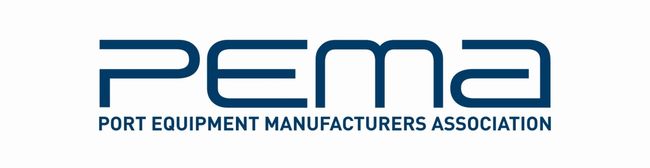

**Media Release**

**Port Equipment Manufacturers Association concludes its largest AGM to date**

**February 24, 2015 – The Port Equipment Manufacturers Association (PEMA) held its largest ever Annual General Meeting (AGM) in Amsterdam earlier this month, with more than 100 industry executives holding discussions on key developments in the sector, and keynote speeches on trends and challenges in port and terminal operations.**

“This was PEMA’s best attended and most successful AGM to date. We would like to thank all delegates, and extend a special thank you to our panel of guest speakers,” says PEMA President, Ottonel Popesco.

The Association’s membership, and the scope of its activities, grew in 2014, a year in which PEMA marked its 10th anniversary. During the year, PEMA published its seventh survey on mobile port handling equipment, its third ship-to-shore container crane survey, as well as its third survey on yard container cranes.

PEMA also continued to reinforce its work on safety, the environment and technological developments through a growing range of activities such as information papers, recommendations on standards and best practice, live educational work and networking events.

“With our growing membership, and diverse range of activities, PEMA is well positioned to ensure that the port equipment and technology sectors have a clear, unified voice in the industry,” says Popesco.

Key decisions and announcements made during the AGM include the confirmation of the PEMA Autumn Members Meeting date and location – October 27 to 29 in Shanghai –further details of which will be released in due course; Michael Dempsey, WAM Technologies, was re-elected to the PEMA Board, and Maurizio Bragagni, Tratos, was elected to the PEMA Board for a three-year term.

The formation of a fourth PEMA committee, to focus on equipment, design and infrastructure issues, was also proposed. Existing PEMA committees regularly publish findings and recommendations on safety, technology and the environment.

The full PEMA Board for 2015 is: Ottonel Popesco, Cavotec, PEMA President; Mika Mahlberg, Konecranes, PEMA Vice President; Per-Anders Holmstrom, Bromma, PEMA Vice President; Jens Koerting, Hyster/NACCO, Treasurer; Maurizio Bragagni, Tratos Cavi, Board member; Michael Dempsey, WAM Technologies, Board member; and Stephan Stiehler, SICK, Board member.

The PEMA Board would like to express its gratitude to Michael Eckle, Conductix- Wampfler, for his contribution as Board Member over the past three years.

**About PEMA**

Founded in 2004, PEMA provides a forum and public voice for the global port equipment and technology sectors. The Association has seen strong growth in recent years, and now has nearly 80 member companies representing all facets of the industry, including crane, equipment and component manufacturers; automation, software and technology providers; consultants and other experts. You can learn more about PEMA at our website: [pema.org](http://www.pema.org/)

For more information on this media release, please contact Rachael White, PEMA Secretary General at: Tel +44 20 8279 9403 | [rachael.white@pema.org](mailto:rachael.white@pema.org)