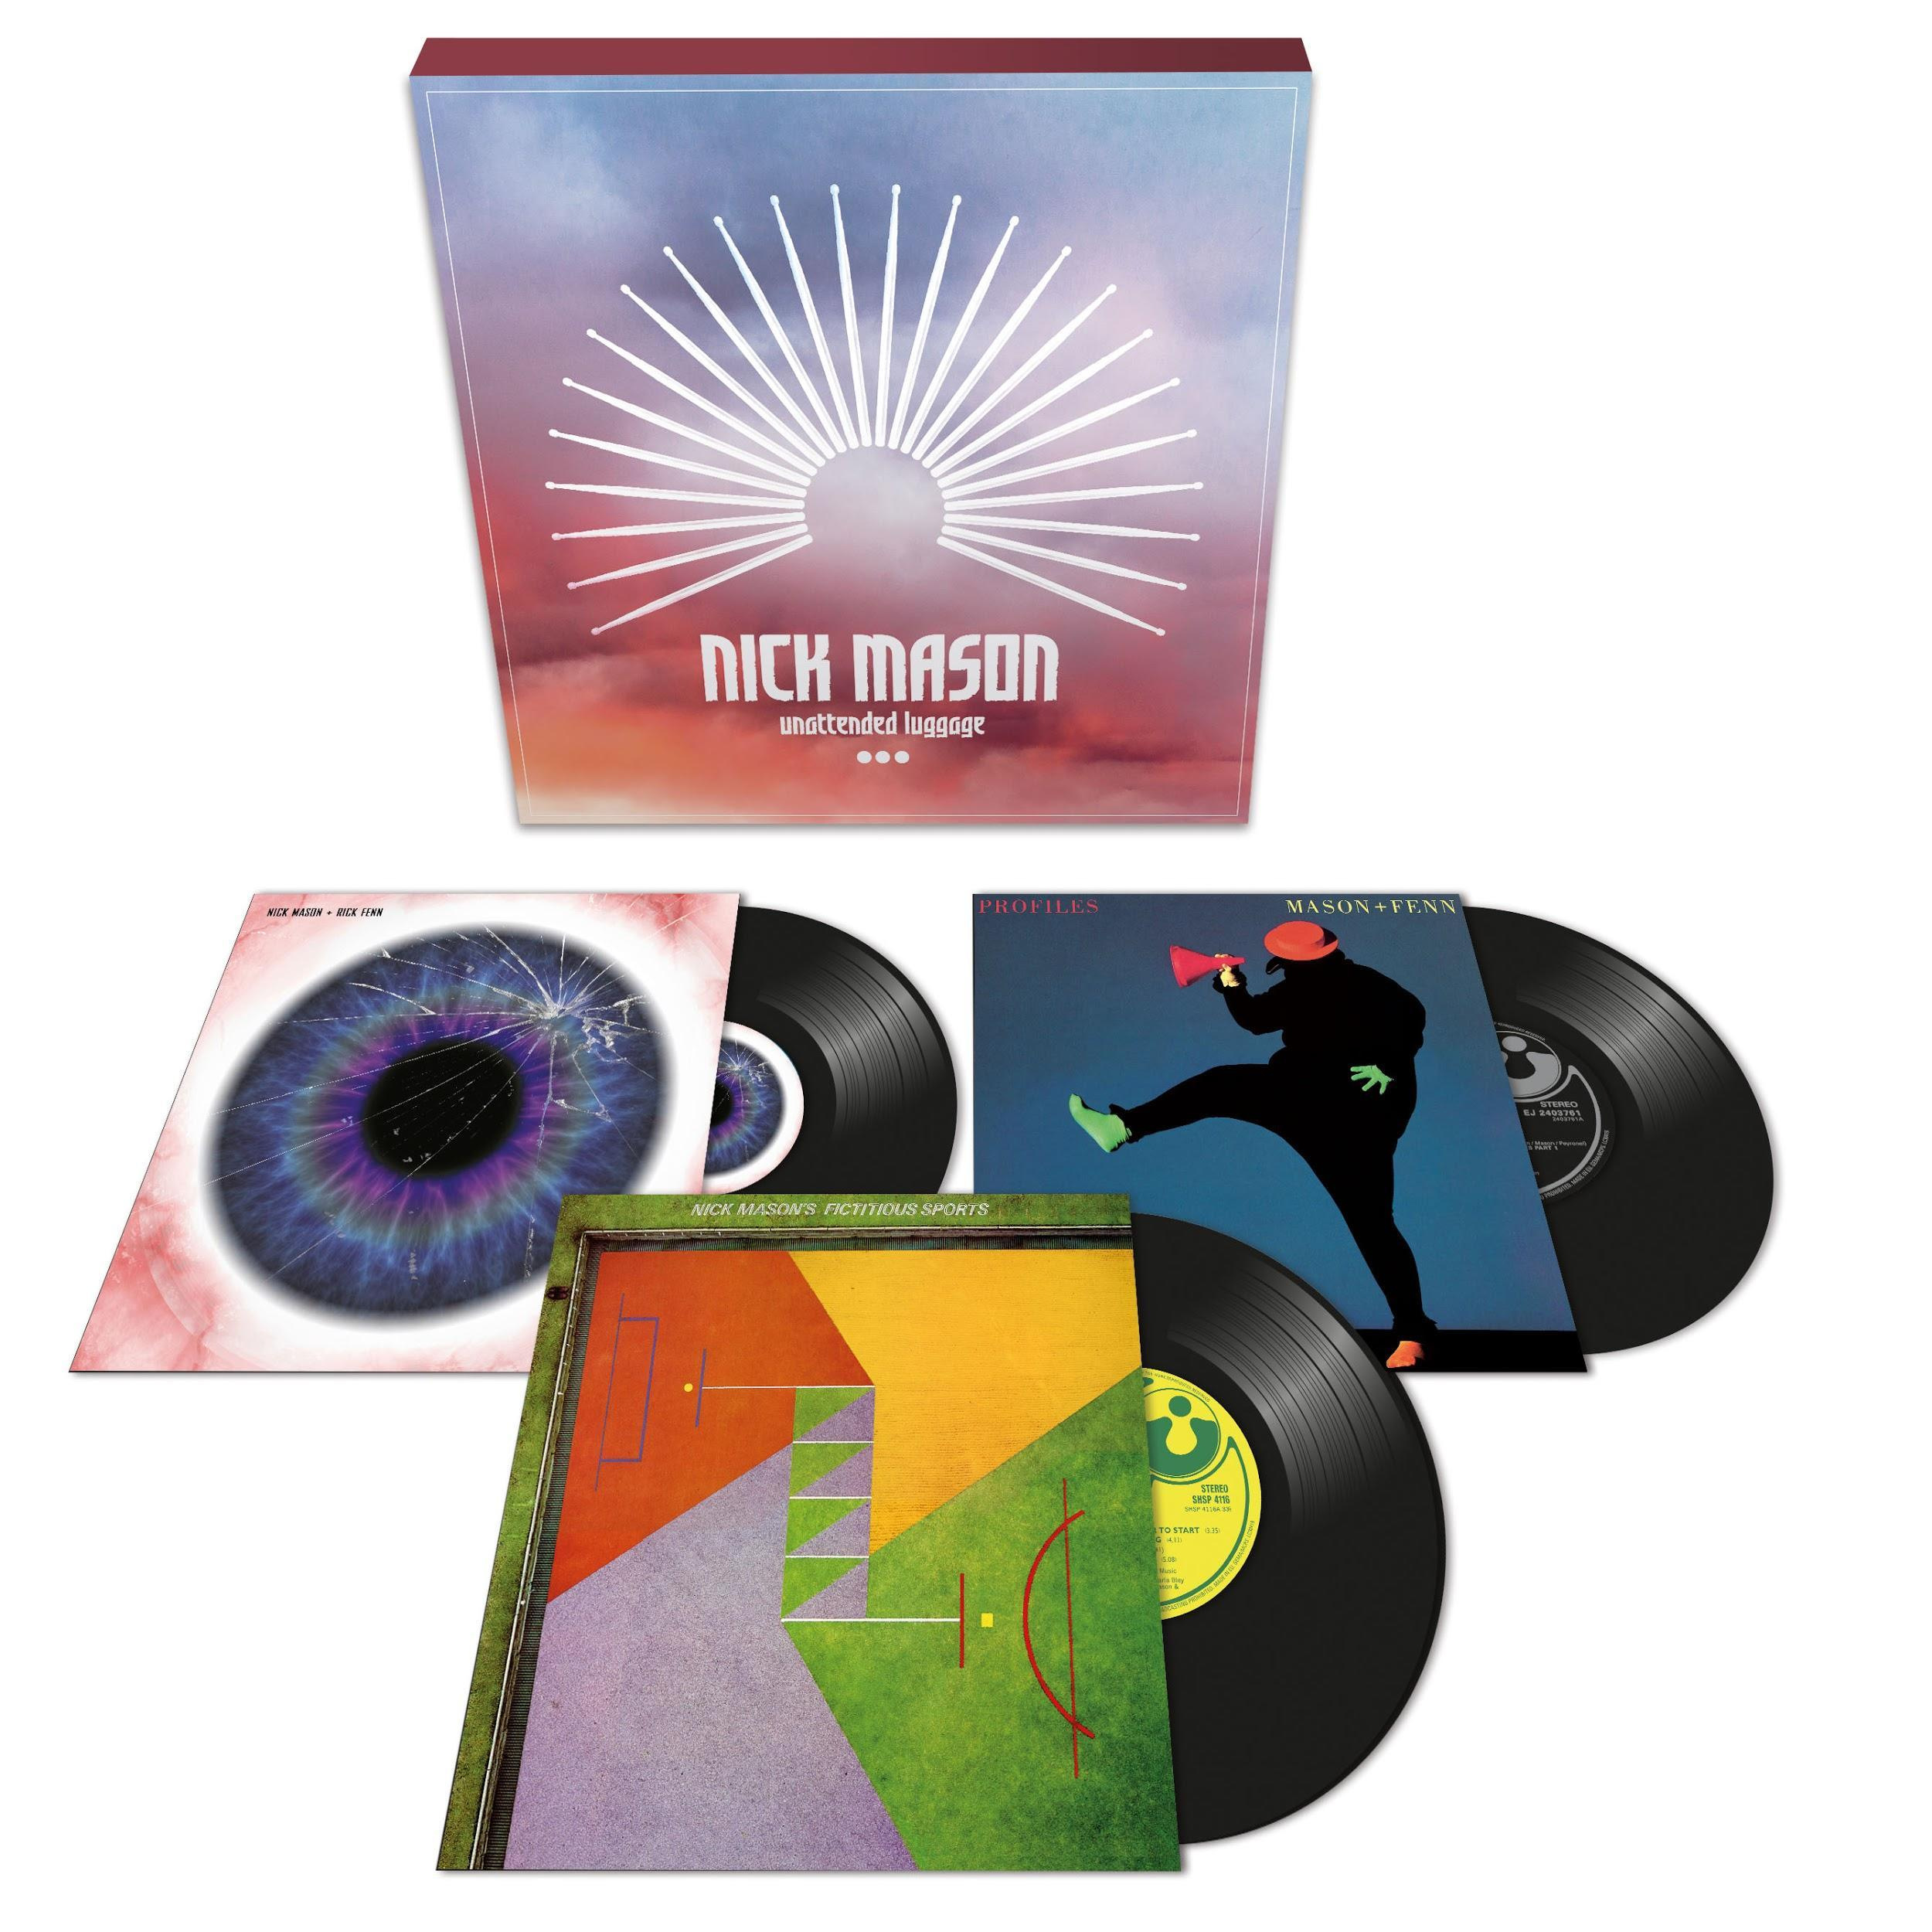
‘Unattended Luggage’
Nick Mason to release vinyl and cd box sets of his three solo albums
Including...
‘Fictitious Sports’
‘Profiles’
‘White of the Eye’

Released August 31, 2018

For images of the product and Nick Mason - http://bit.ly/2JdRRHQ

For the first time in over 20 years, Nick Mason’s, solo albums, ‘Nick Mason’s Fictitious Sports’, ‘Profiles’ and ‘White of the Eye’ will be available in both CD and vinyl three-disc boxsets. Released on 31 August through Warner Music, these limited edition box sets will be available shortly before Nick tours Europe with his acclaimed new band Nick Mason’s Saucerful Of Secrets.

Nick Mason is one of the biggest selling artists of all time. A co-founding member of Pink Floyd, he is the only constant member of the group, performing on all of their albums as well as all of their live shows. In May of this year, Nick debuted his new band Nick Mason’s Saucerful Of Secrets with four intimate shows in London (Camden Dingwalls 20 May and The Half Moon in Putney 21, 23 and 24 May) to an incredible reception.

Unattended Luggage is a further celebration of Nick Mason and his undeniably significant contribution to music. The set contains;

‘Nick Mason’s Fictitious Sports’ - Nick’s debut solo album which was originally released in 1981 and saw him collaborate with a variety of different musicians including Robert Wyatt and Carla Bley.

‘Profiles’ - A collaboration with 10cc guitarist Rick Fenn, it was Nick’s second album outside of Pink Floyd and was released in 1985 as ‘Mason + Fenn’. This is a mainly instrumental album except for tracks ‘Lie for a Lie’, which features vocals from Maggie Reilly and former bandmate David Gilmour and ‘Israel’, sung by UFO keyboardist Danny Peyronel.

‘White of the Eye’ - A soundtrack for a British thriller movie of the same name, Nick once again collaborated with Rick Fenn. Originally released in 1987, in conjunction with the film's release, this is the first time the record has been made available for over 20 years, and the first time it will appear on CD.

Nick Mason says, "These recordings hold a very special place for me in my musical life. 'Fictitious Sports' developed initially from working with Mike Mantler, Carla Bley and Robert Wyatt on a couple of their projects, and benefited enormously from a whole crew of great musicians that I was introduced to by them at Grog Kill Studios in Woodstock.

“'Profiles' and 'White of the Eye' were an extension of working with Rick Fenn on some advertising and short documentary film soundtracks, which then developed into something more.

“Listening back after 30 odd years, I'm delighted they are getting the reissue treatment. I’m rather hoping that sales will be sufficient to damage the market in the original rare vinyl versions!”

The individual albums ‘Nick Mason’s Fictitious Sports’, ‘Profiles’ and ‘White of the Eye’ will all be available as a download and through streaming platforms.

Nick Mason’s Saucerful Of Secrets will be touring through Europe in September. Tickets are on sale now from www.thesaucerfulofsecrets.com. The UK shows are;

Sunday 23rd September - Portsmouth, Guildhall
Monday 24th September - London, Roundhouse
Tuesday 25th September - Birmingham, Symphony Hall
Thursday 27th September - Manchester, O2 Apollo
Friday 28th September - Glasgow, SEC Armadillo
Saturday 29th September - Nottingham, Royal Concert Hall

Nick Mason’s Saucerful Of Secrets reviews from 20 May 2018…

“...this was the most extraordinary and joyous show, a reminder of what a peculiar and brilliant band Pink Floyd were... If you have the slightest interest in Pink Floyd, do not miss this group when they return to larger venues later this year. You won’t even need acid to blow your mind.”
✭✮✮✮✮ Michael Hann, Financial Times

“The sound was immense, electrifying, galvanising, mesmerising and still deeply strange, bending the formats of primal rock into all kind of weird and wonderful shapes. From the warped garage rock opening of Interstellar Overdrive, Astronomy Dominie and Lucifer Sam to the closing proto-shoegaze blitz of One of These Days and bent musical hall wackiness of Point Me at the Sky, it was a set of such startling intensity it seemed to mock the very notion of nostalgia. It was enough to make you wonder whether rock has progressed very far at all since the Sixties.
✭✮✮✮ Neil McCormick, The Daily Telegraph

T: @nickmasondrums / FB:www.facebook.com/NickMasonDrums
T: @pinkfloyd / FB:www.facebook.com/pinkfloyd www.pinkfloyd.com

Full European Tour Dates;
Sunday 2nd September - Stockholm, Sweden, Circus
Monday 3rd September - Copenhagen, Denmark, Forum Black Box
Tuesday 4th September - Rostock, Germany, Moya
Thursday 6th September - Amsterdam, Holland, Carre
Saturday 8th September - Antwerp, Belgium ,Stadsschouwburg
Sunday 9th September - Luxembourg, Den Atelier
Monday 10th September - Paris, France, Olympia (On sale at a later date)
Tuesday 11th September - Dusseldorf, Germany, Mitsubishi Elektrikhalle
Thursday 13th September - Hamburg, Germany, Laeiszhalle
Saturday 15th September - Stuttgart, Germany, Beethovensaal
Sunday 16th September - Berlin, Germany, Tempodrom
Monday 17th September - Lepzeig, Germany, Haus Auensee
Wednesday 19th September - Vienna, Austria, Stadhalle F
Thursday 20th September - Milan, Italy, Tetro Arcimboldi
Friday 21st September - Zurich, Switzerland, Samsung Hall
Sunday 23rd September - Portsmouth, UK, Guildhall
Monday 24th September - London, UK, Roundhouse
Tuesday 25th September - Birmingham, UK, Symphony Hall
Thursday 27th September - Manchester, UK, O2 Apollo
Friday 28th September - Glasgow, UK, SEC Armadillo
Saturday 29th September - Nottingham, UK, Royal Concert Hall

