Kongsberg Maritime introduces Health Management: holistic equipment monitoring for ships
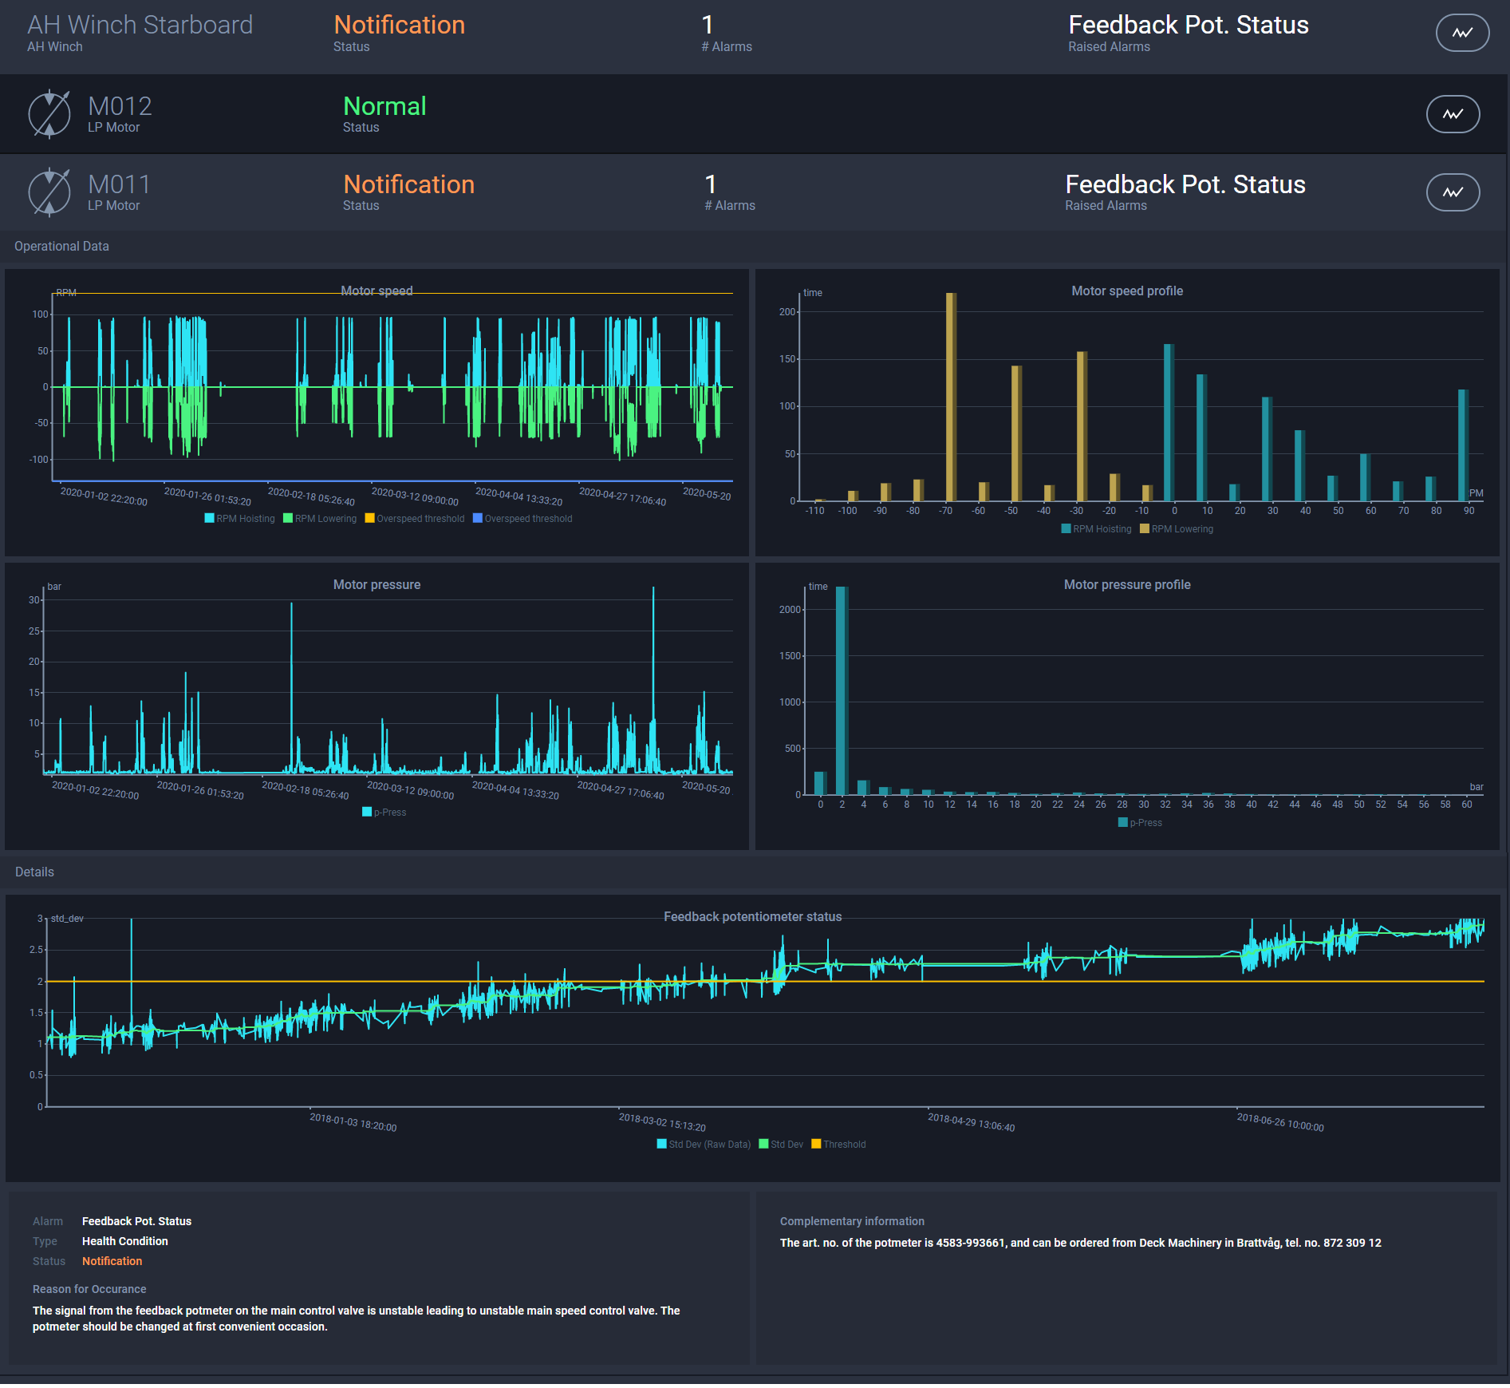
An example of the data available from the Health Management dashboard
Kongsberg, Norway, 2nd July 2020 – Kongsberg Maritime is proud to introduce Health Management to the Vessel Insight portfolio of applications. With Health Management, ship owners can monitor onboard equipment via one unified interface and predict failures through early detection of abnormal behaviour. This holistic facility, whilst often cited as a key functionality for smart ships, has not been readily available to date, making this launch a milestone in the development of smart technologies for the maritime sector.
Due for launch in August, the new Health Management application will initially support Bergen engines, Kongsberg Maritime’s low-pressure hydraulic winches, and rotating machinery such as KONGSBERG and third-party thrusters, pods, shaftline and auxiliaries. Additional equipment will be added to the system in a planned roll-out over the following months, making Health Management applicable to vessels across the maritime industry.
Health Management helps customers to mitigate the capital and operational risks associated with the failure or unplanned maintenance of critical machinery. By continuously reporting equipment condition, Health Management facilitates intelligent maintenance planning, increasing reliability and reducing operational expenditure by limiting vessel and equipment downtime. This keeps vessels working and extends equipment lifetime through early identification of abnormal wear or suboptimal operation; in some cases, this may allow servicing to be performed only when needed.
Jan Chirkowski, VP Analytics & Fleet Operations at Kongsberg Maritime, explains: “By continually appraising machinery condition, Health Management allows customers to spot the early onset of a failure and continue operation with the affected equipment under observation. Maintenance needs can be planned in advance when most convenient for the customer, spare parts ordered, and vessel downtime scheduled as necessary. Any downtime is minimised, and the vessel is returned to operation as swiftly as possible. The net result is to maximise profitability.”
Kongsberg Maritime is uniquely placed to lead the market in this area, drawing on exclusive knowledge of its own vast portfolio of equipment – combined with certified monitoring of KONGSBERG and third-party machinery – to provide holistic condition monitoring solutions for all equipment critical to a customer’s operations and deliver it on one unified platform.
Ends
For further information, please contact:
Gunvor Hatling Midtbø, VP Communication
Kongsberg Maritime
Tel: +47 9921 4209
gunvor.hatling.midtbo@km.kongsberg.com
David Pugh
Saltwater Stone
Tel: +44 (0)1202 669244
d.pugh@saltwater-stone.com

About Kongsberg Maritime
Kongsberg Maritime is a global marine technology company providing innovative and reliable ‘Full Picture’ technology solutions for all marine industry sectors including merchant, offshore, cruise, subsea and naval. Headquartered in Kongsberg, Norway, Kongsberg Maritime has manufacturing, sales and service facilities in 34 countries.
Kongsberg Maritime solutions cover all aspects of marine automation, safety, manoeuvring, navigation, and dynamic positioning as well as energy management, deck handling and propulsion systems, and ship design services. Subsea solutions include single and multibeam echo sounders, sonars, AUV and USV, underwater navigation and communication systems.
Training courses at locations globally, LNG solutions, information management, position reference systems and technology for seismic and drilling operations are also part of the company’s diverse technology portfolio. Additionally, Kongsberg Maritime provides services within EIT (Electro, Instrument & Telecom) engineering and system integration, on an EPC (Engineering, Procurement & Construction) basis.
Kongsberg Maritime is part of Kongsberg Gruppen (KONGSBERG), an international, knowledge-based group that celebrated 200 years in business during 2014. KONGSBERG supplies high-technology systems and solutions to customers in the oil and gas industry, the merchant marine, and the defence and aerospace industries.
Web: Kongsberg Gruppen | Kongsberg Maritime
Social media: LinkedIn | Twitter | Facebook

