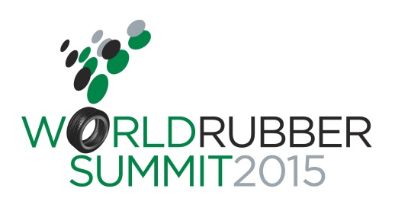
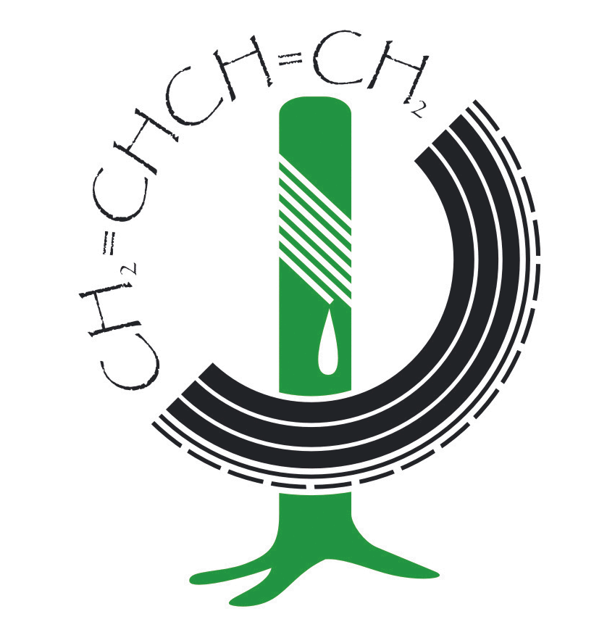
International Rubber Study Group

PRESS RELEASE

Michelin’s Luc Minguet to Speak at World Rubber Summit 2015
Singapore, 5 December 2014 – The International Rubber Study Group, in partnership with SingEx Exhibitions, announced today that Michelin’s Senior Vice President and Chief Procurement Officer, Mr Luc Minguet will deliver one of the keynote speeches at the World Rubber Summit 2015. The summit will be held in Singapore, 24-25 March 2015 at MAX Atria at the Singapore EXPO Exhibition and Convention Centre. The theme for the Summit is “Productivity & Sustainability for Tomorrow’s Market – What drives it?”
The Michelin Group is a leader in innovation for sustainable mobility. Michelin defines sustainable mobility as making mobility clean, safe and connected, to make travel more accessible and affordable. To achieve this, Michelin relies on the innovations developed by its Research & Development teams on 3 continents, its partnership with original equipment manufacturers, as well as listening to end users.
At the World Rubber Summit, Luc Minguet will provide key insights on how Michelin is putting its beliefs into action. He will share practical examples of programmes and initiatives which Michelin are developing in their procurement chain that contribute towards attaining the company’s vision of sustainable mobility.
Held under the umbrella of World Rubber Week, the World Rubber Summit 2015 will take place alongside Tyrexpo Asia, the Rubber Exchange Forum and other related industry seminars and networking receptions. Aside from the keynote speeches, the Summit will also feature thought-provoking interactive panel discussions and for the first time, topical in-depth breakout sessions presented by industry leaders and subject matter experts.
Panel sessions will address these topics:
- The Road Ahead for the Tyre Industry
This panel will feature a discussion on the future of the tyre industry. The session will address the impact of growth in emerging markets over the next decade and how that will impact dramatic increases in vehicle ownership, countered by the focus of developed markets on environmental impact with reduced fuel consumption and CO2 emissions.
- The Future of Natural Rubber in a Bouncing World
During this panel, discussion will focus on the methods used to increase productivity of the natural rubber producing sector, rewarding smallholders and meeting Corporate Social Responsibility/Sustainability expectations throughout the value chain.

- Supply Chain Optimisation from Tree to Tyre
This discussion will centre on the importance of logistics as well as vital issues confronting the global rubber industry, such as competition with other commodities, the impact of the relatively low value of rubber as a cargo and how to link the supply to the demand that is often oceans apart.
Confirmed speakers for the panel sessions presently include Rajiv Budhraja, the Secretary General for the Automotive Tyre Manufacturers’ Association (ATMA); Fazilet Cinaralp, the Secretary General for the European Tyre and Rubber Manufacturers Association (ETRMA); and Sheela Thomas, the Secretary General for the Association of Natural Rubber Producing Countries (ANRPC) among others.
The breakout sessions will spotlight the viewpoint of emerging markets as to the future as well as discuss the industry’s approach to sustainable development. The sessions will also address questions such as, “What are the future directions for the rubber industry?” and “How can traders’ best add value to support the industry?”
Registration to the Summit opens on 10 December 2014.
- ENDS -

About IRSG

IRSG is a unique organisation within the rubber industry creating a platform for the producers and consumers from all sectors of the rubber industry, natural rubber (NR), synthetic rubber (SR), tyre sector, rubber processors, traders, financial sector, consultants etc., to discuss all issues of relevance to the integrated global rubber value chain.

About SingEx Exhibitions

SingEx Exhibitions is a subsidiary of SingEx Holdings, and is wholly owned by Singapore’s investment company, Temasek Holdings. SingEx Exhibitions owns, develops and manages a series of trade exhibitions and conferences in various industries including urban solutions, logistics, information technology, healthcare and commodities. The company collaborates with both local and international partners to create new market platforms via trade events in key industries with high growth potential. SingEx Exhibitions has an extensive network of relationships with regional governmental agencies, international trade associations, and leading businesses in key sectors which enables it to form joint ventures, acquire, market and scale events around the world. For more information, visit www.singex.com.

Media Contacts:

Rohaila Eas
SingEx Exhibitions Pte Ltd
T: +65 6403 2227
E: rohaila.eas@singex.com

Christina Ho
IRSG
T: +65 65880463
E: christina@rubberstudy.com

