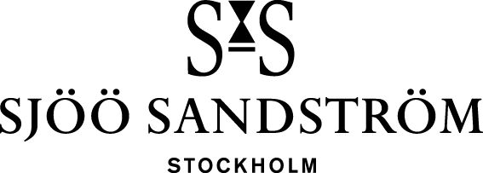

Press release, Stockholm, 2023

Annual Edition 2023

**Swedish watch manufacturer Sjöö Sandström was established in 1986 and is the only Swedish watch brand in the luxury segment. Each year the company launches a unique and limited edition of the iconic model Royal Steel. This exclusive edition, available only in 86 pieces, celebrates Sjöö Sandström’s legacy as well as the irresistible passage of time.**

Equally to he number of available pieces stems from the company’s founding year, so does the design of the Annual Edition – spiked with a contemporary touch.

We are delighted to share the exciting news about the release of our highly anticipated 2023 Annual Edition. This edition builds upon the esteemed Royal Steel Worldtimer yet introduces a completely reimagined design. Drawing inspiration from the groundbreaking work of Carl Wilhelm Scheele, the 2023 Annual Edition of the Royal Steel Worldtimer proudly incorporates tungsten into its design. Scheele, a pioneering Swedish chemist of the 18th century, is credited with the discovery of tungsten oxide. In homage to his contributions, our timepiece features a tungsten bezel, symbolizing durability and resilience. Tungsten remains an integral part of our history that can be found in many of our previous models.

With a sleek design and a captivating color scheme, this model represents a contemporary take on sophistication. As we move forward, the legacy of orange continues to inspire and remind us of its powerful impact and the early years of our journey. Formulärets överkantThe inclusion of Arabic numerals on the dial not only enhances its aesthetic appeal but also ensures practicality. Additionally, the GMT function seamlessly tracks two time zones, making it the perfect watch for travelers and explorers while journeying across the world.

* *We’re happy to offer yet another timepiece which celebrates our Swedish heritage. We expect it to sell out as quickly as previous, temporary collections. Due to the massive interest in our Annual Editions, we invite our customers to already sign up for 2024’s edition by sending an email to* [*sjoosandstrom@sjoosandstrom.se*](mailto:sjoosandstrom@sjoosandstrom.se)*, says Kristofer Johansson, partner at Sjöö Sandström.*

**Specifications**

**CASE:** Ø41 mm Stainless steel.   
**CASE-BACK:** Unique “annual 2023” case-back.  
**GLASS:** Scratch resistant sapphire crystal with anti-reflective coating.   
**DIAL:** Grey   
**BEZEL:**  Tungsten  
**BRACELET:** Orange and an extra black rubber with folding buckle.   
**WATER RESISTANCE:** 10ATM (100 meters)   
**MOVEMENT:** SS G16 Automatic movement (Swiss Made) **RRP:** 29.800 SEK

[www.sjoosandstrom.com](https://www.sjoosandstrom.com/collection/annual-edition-2023/021286)

**For more information, please contact:**   
Kristofer Johansson

Press contact, Sjöö Sandström Sweden AB

[kristofer.johansson@sjoosandstrom.se](mailto:kristofer.johansson@sjoosandstrom.se)

Telephone: +46 760 06 82 90