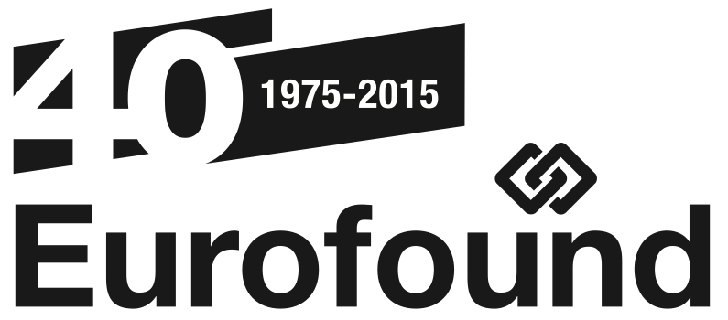
Press Release

29 January 2015
---------------------------------------

www.eurofound.europa.eu @eurofound

Eurofound launches the fieldwork for the 6th European Working Conditions Survey:
Eurofound launches the sixth edition of its survey assessing working conditions across Europe
(Dublin, Ireland): On Monday 2 February 2015 Eurofound will launch the fieldwork for the 6th European Working Conditions Survey (6th EWCS). Based on interviews with over 43,000 workers, this critical and timely research tracks the current state of working conditions in Europe, highlights the quality of work and employment, and monitors changing trends. The first findings of the 6th EWCS will be presented at the end of 2015.
The European Working Conditions Surveys (EWCS) provide valuable and unique comparative information about working conditions, including issues such as working time, health and safety at work, work organisation, work-life balance, training, and overall satisfaction with working conditions. The underlying aim is to help policymakers improve overall living and working conditions.
To date, Eurofound has carried out five European Working Conditions Surveys (1991, 1995, 2000, 2005, and 2010). This sixth wave of the survey will build on the lessons learned from the previous five surveys and will provide a rich portrait of workplace trends in Europe over the last 25 years.
The survey offers an opportunity for workers to make their voices heard about the state of their working conditions and about how working conditions and quality of work affect their lives.
In cooperation with Ipsos, Eurofound will interview around 43,000 workers in 35 European countries during the period February to June 2015. Interviews will be carried out face-to-face in the person's home. The collected information will be treated in the strictest confidentiality, guaranteeing the anonymity of interviewees. The survey targets a random sample of working people 1,000 to 3,300 people per country.
Further information:
- www.eurofound.europa.eu/surveys/ewcs
- www.eurofound.europa.eu/surveys/2015/sixth-european-working-conditions-survey-2015
- www.ipsos.com

Contact:
- Ms Sophia MacGoris, Surveys Assistant, Eurofound, on email: smg@eurofound.europa.eu or telephone: +353-1-204 3130.
- Mr Andrew Johnson, Director of International Research, Ipsos on email: andrew.johnson@ipsos.com, telephone: +32 2 642 49 16 and mobile: +44-7760-293 421.
- Mr Måns Mårtensson, Media Manager, Eurofound, on email: mma@eurofound.europa.eu, telephone: +353-1-204 3124, or mobile: +353-876-593 507.

ABOUT EUROFOUND AND PARTNERS
The European Foundation for the Improvement of Living and Working conditions (Eurofound) is a tripartite European Union Agency, whose role is to provide knowledge in the area of social and work-related policies. Eurofound was established in 1975 by Council Regulation (EEC) No. 1365/75.
Ipsos is a leading survey research organisation, employing 16,000 staff across 87 countries, with global operational capabilities. Established in 1975, it conducts qualitative and quantitative research across a broad range of sectors on behalf of clients including the European Union institutions, international financial institutions, the UN and its agencies, NGOs, national governments and a wide range of private sector organisations.
Update your contact details and subscription preferences with Eurofound here.
For more information about Eurofound and its work, and free access to all our data and findings, visit our website and follow us on these social media channels: Twitter, LinkedIn, Facebook, Google+, YouTube, or Flickr.

