Kongsberg Maritime to launch next-generation
HUGIN Endurance AUV
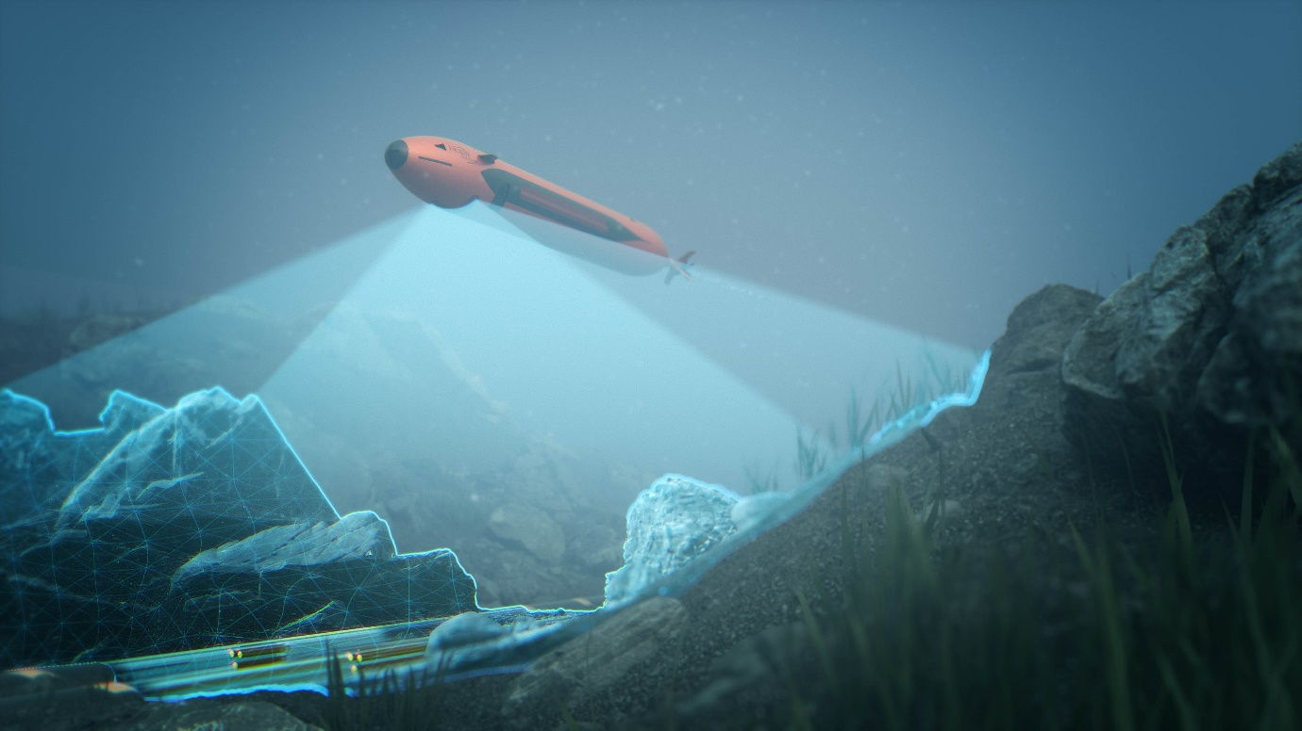Kongsberg Maritime’s new HUGIN Endurance AUV can map up to 1,100 km² on a single mission
Kongsberg, Norway, 4th February 2021 – Kongsberg Maritime is proud to announce the next generation of its advanced HUGIN Autonomous Underwater Vehicle (AUV). Named HUGIN Endurance, the new AUV boosts operational duration to approximately 15 days, enabling extended survey and inspection missions far from shore.
This longevity allows HUGIN Endurance to undertake extensive missions without the support of a mothership. Shore-to-Shore operations offer the opportunity to reduce carbon footprint for commercial activities and yet retain unrivalled data resolution and accuracy. With this in mind, KONGSBERG has added its Maritime Broadband Radio (MBR) communications system to HUGIN Endurance’s payload, allowing it to surface and share large quantities of data swiftly with any suitably equipped installation, such as another vessel, shore station or a wind turbine fitted with an MBR antenna.
For defence applications, HUGIN Endurance makes persistence a reality. Whether it is long range military survey; wide area mine detection, classification and identification; or even patrolling a choke point listening for submarines, this new extended range capability offers new solutions to existing and future challenges.
HUGIN AUVs already set the standard for autonomous underwater operations thanks to their rugged reliability and accurate, cutting-edge sensor payloads. The HUGIN Endurance is no exception; it can be equipped with a wide array of sensors including the high-resolution KONGSBERG HiSAS synthetic aperture sonar, a wide swath multibeam echo sounder, sub-bottom profiler and magnetometer, together with other sensors to detect parameters such as methane, current and turbidity.
This proven portfolio of hydroacoustic sensors, communications and other technologies – teamed with unparalleled operational range – ensures that HUGIN Endurance is well equipped for advanced situational awareness scanning, and mapping/inspection activities for far-field applications such as offshore wind farms. It also delivers significant sustainability benefits, not only when contrasted with conducting operations from surface vessels but also compared with other AUV operations, as the reduction in the need for surface support further diminishes the environmental footprint.
“We are proud to launch HUGIN Endurance, which represents a step change in AUV operations,” says Richard Mills, Vice President of Marine Robotics Sales, Kongsberg Maritime. “Teaming long endurance with large area coverage capabilities allows a single AUV to map areas up to 1,100 square kilometres in a single mission – a target impossible until now. With its unprecedented long-range capability and advanced communications, HUGIN Endurance sets a new standard for autonomous subsea mapping and inspection, yielding unmatched operational flexibility, efficiency and sustainability.”
Ends

For further information, please contact:
Gunvor Hatling Midtbø, VP Communication
Kongsberg Maritime
Tel: +47 9921 4209
gunvor.hatling.midtbo@km.kongsberg.com
David Pugh
Saltwater Stone
Tel: +44 (0)1202 669244
d.pugh@saltwater-stone.com

About Kongsberg Maritime
Kongsberg Maritime is a global marine technology company providing innovative and reliable ‘Full Picture’ technology solutions for all marine industry sectors including merchant, offshore, cruise, subsea and naval. Headquartered in Kongsberg, Norway, Kongsberg Maritime has manufacturing, sales and service facilities in 34 countries.
Kongsberg Maritime solutions cover all aspects of marine automation, safety, manoeuvring, navigation, and dynamic positioning as well as energy management, deck handling and propulsion systems, and ship design services. Subsea solutions include single and multibeam echo sounders, sonars, AUV and USV, underwater navigation and communication systems.
Training courses at locations globally, LNG solutions, information management, position reference systems and technology for seismic and drilling operations are also part of the company’s diverse technology portfolio. Additionally, Kongsberg Maritime provides services within EIT (Electro, Instrument & Telecom) engineering and system integration, on an EPC (Engineering, Procurement & Construction) basis.
Kongsberg Maritime is part of Kongsberg Gruppen (KONGSBERG), an international, knowledge-based group that celebrated 200 years in business during 2014. KONGSBERG supplies high-technology systems and solutions to customers in the oil and gas industry, the merchant marine, and the defence and aerospace industries.
Web: Kongsberg Gruppen | Kongsberg Maritime
Social media: LinkedIn | Twitter | Facebook

