Haglöfs SS19
Stockholm, January 2019
grym evo jacket | Tough, technical and sustainable
The Grym Evo Jacket is one of the key pieces from Haglöfs’ forthcoming SS19 season. It’s a tough and technical 3-layer shell jacket, built with sustainability in mind. It's perfect for trekking activities and features everything you'll need for a trip deep into the wilderness.
The Grym Evo Jacket is a hard-wearing and highly protective 3-layer shell jacket, built from carefully selected sustainable materials. It's made with Haglöfs’ own PROOF™ ECO technology – where recycled materials have been used to create a material that offers an outstanding level of weatherproofing. The jacket has been constructed with ultrasonically welded seams for a combination of optimal protection and high levels of comfort while trekking.
Robert Olsson, Senior Clothing Designer at Haglöfs, explains:
“Based on a stripped-back and toned-down design, the Grym Evo Jacket is ageless, truly versatile and long-lasting. The jacket features everything you'll need when you’re trekking deep in the wildest bits of wilderness you can find, including a trackable RECCO® reflector. It'll be a trusty companion on any adventure.”
The Grym Evo Jacket comes in dune, true black and desert yellow for men (XS-XXL), and dune and true black for women (XS-XXL). It will be launched in March 2019. Estimated retail price: 350€.

For more information, please contact:
Erica Wigge
Global Publishing Manager
+ 46 8 584 906 59
erica.wigge@haglofs.se

GRYM EVO JACKET – FACT SHEET
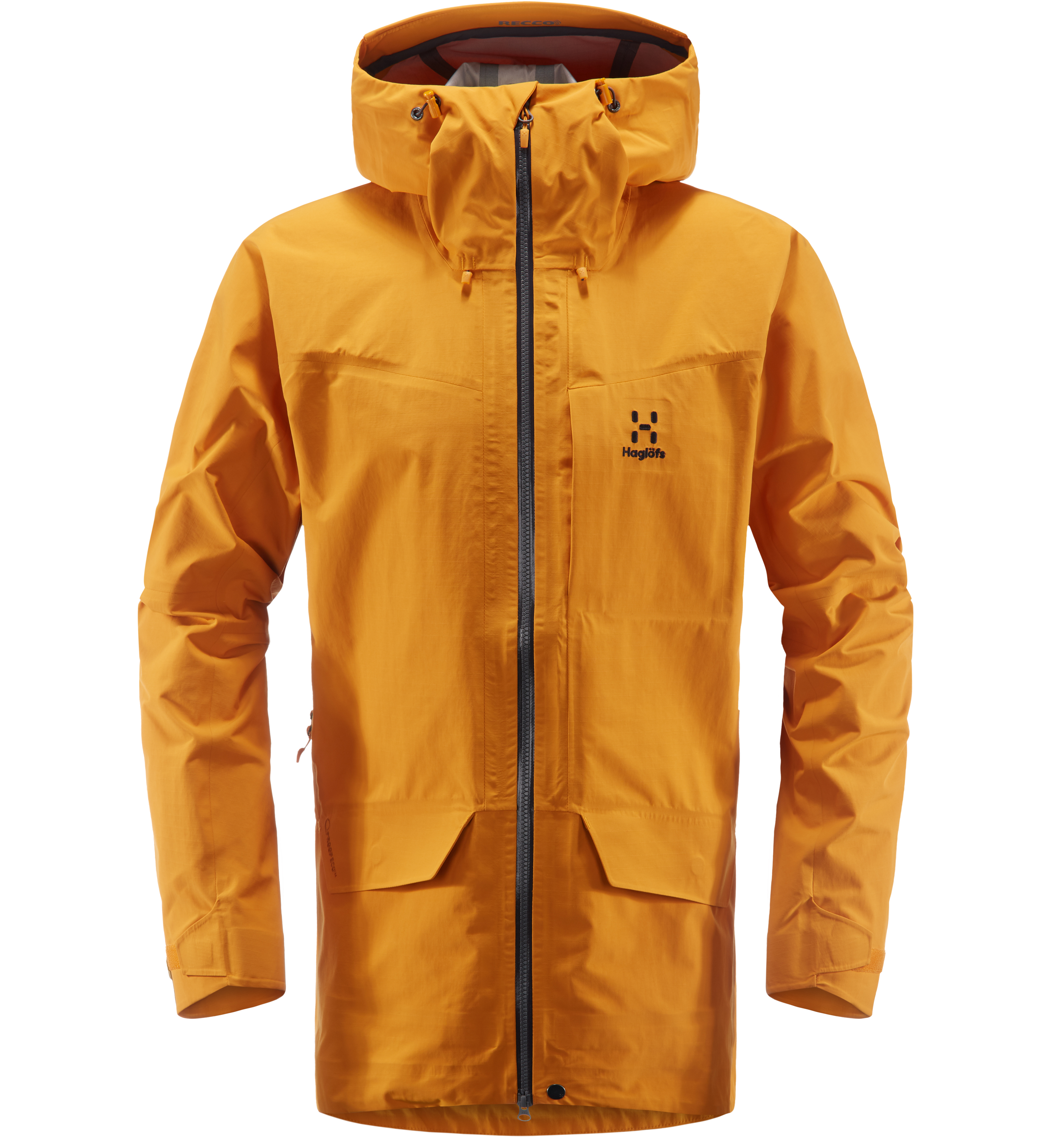
Features
- Fabric: 3-layer, PROOF™ ECO fabric. 100% recycled Polyamide, rugged, dull, big-square ripstop weave face, laminated to a microporous Polyurethane membrane and a tricot backer
- 204 g/m², bluesign® approved Hydrostatic head: >15,000 mm; Moisture Permeability (inverted cup): >15,000 g/m²/24h
- Treated with a fluorocarbon-free DWR to protect from water and dirt
- 3-way adjustable hood with reinforced peak
- Underarm pit zips with water repellent zippers for ventilation
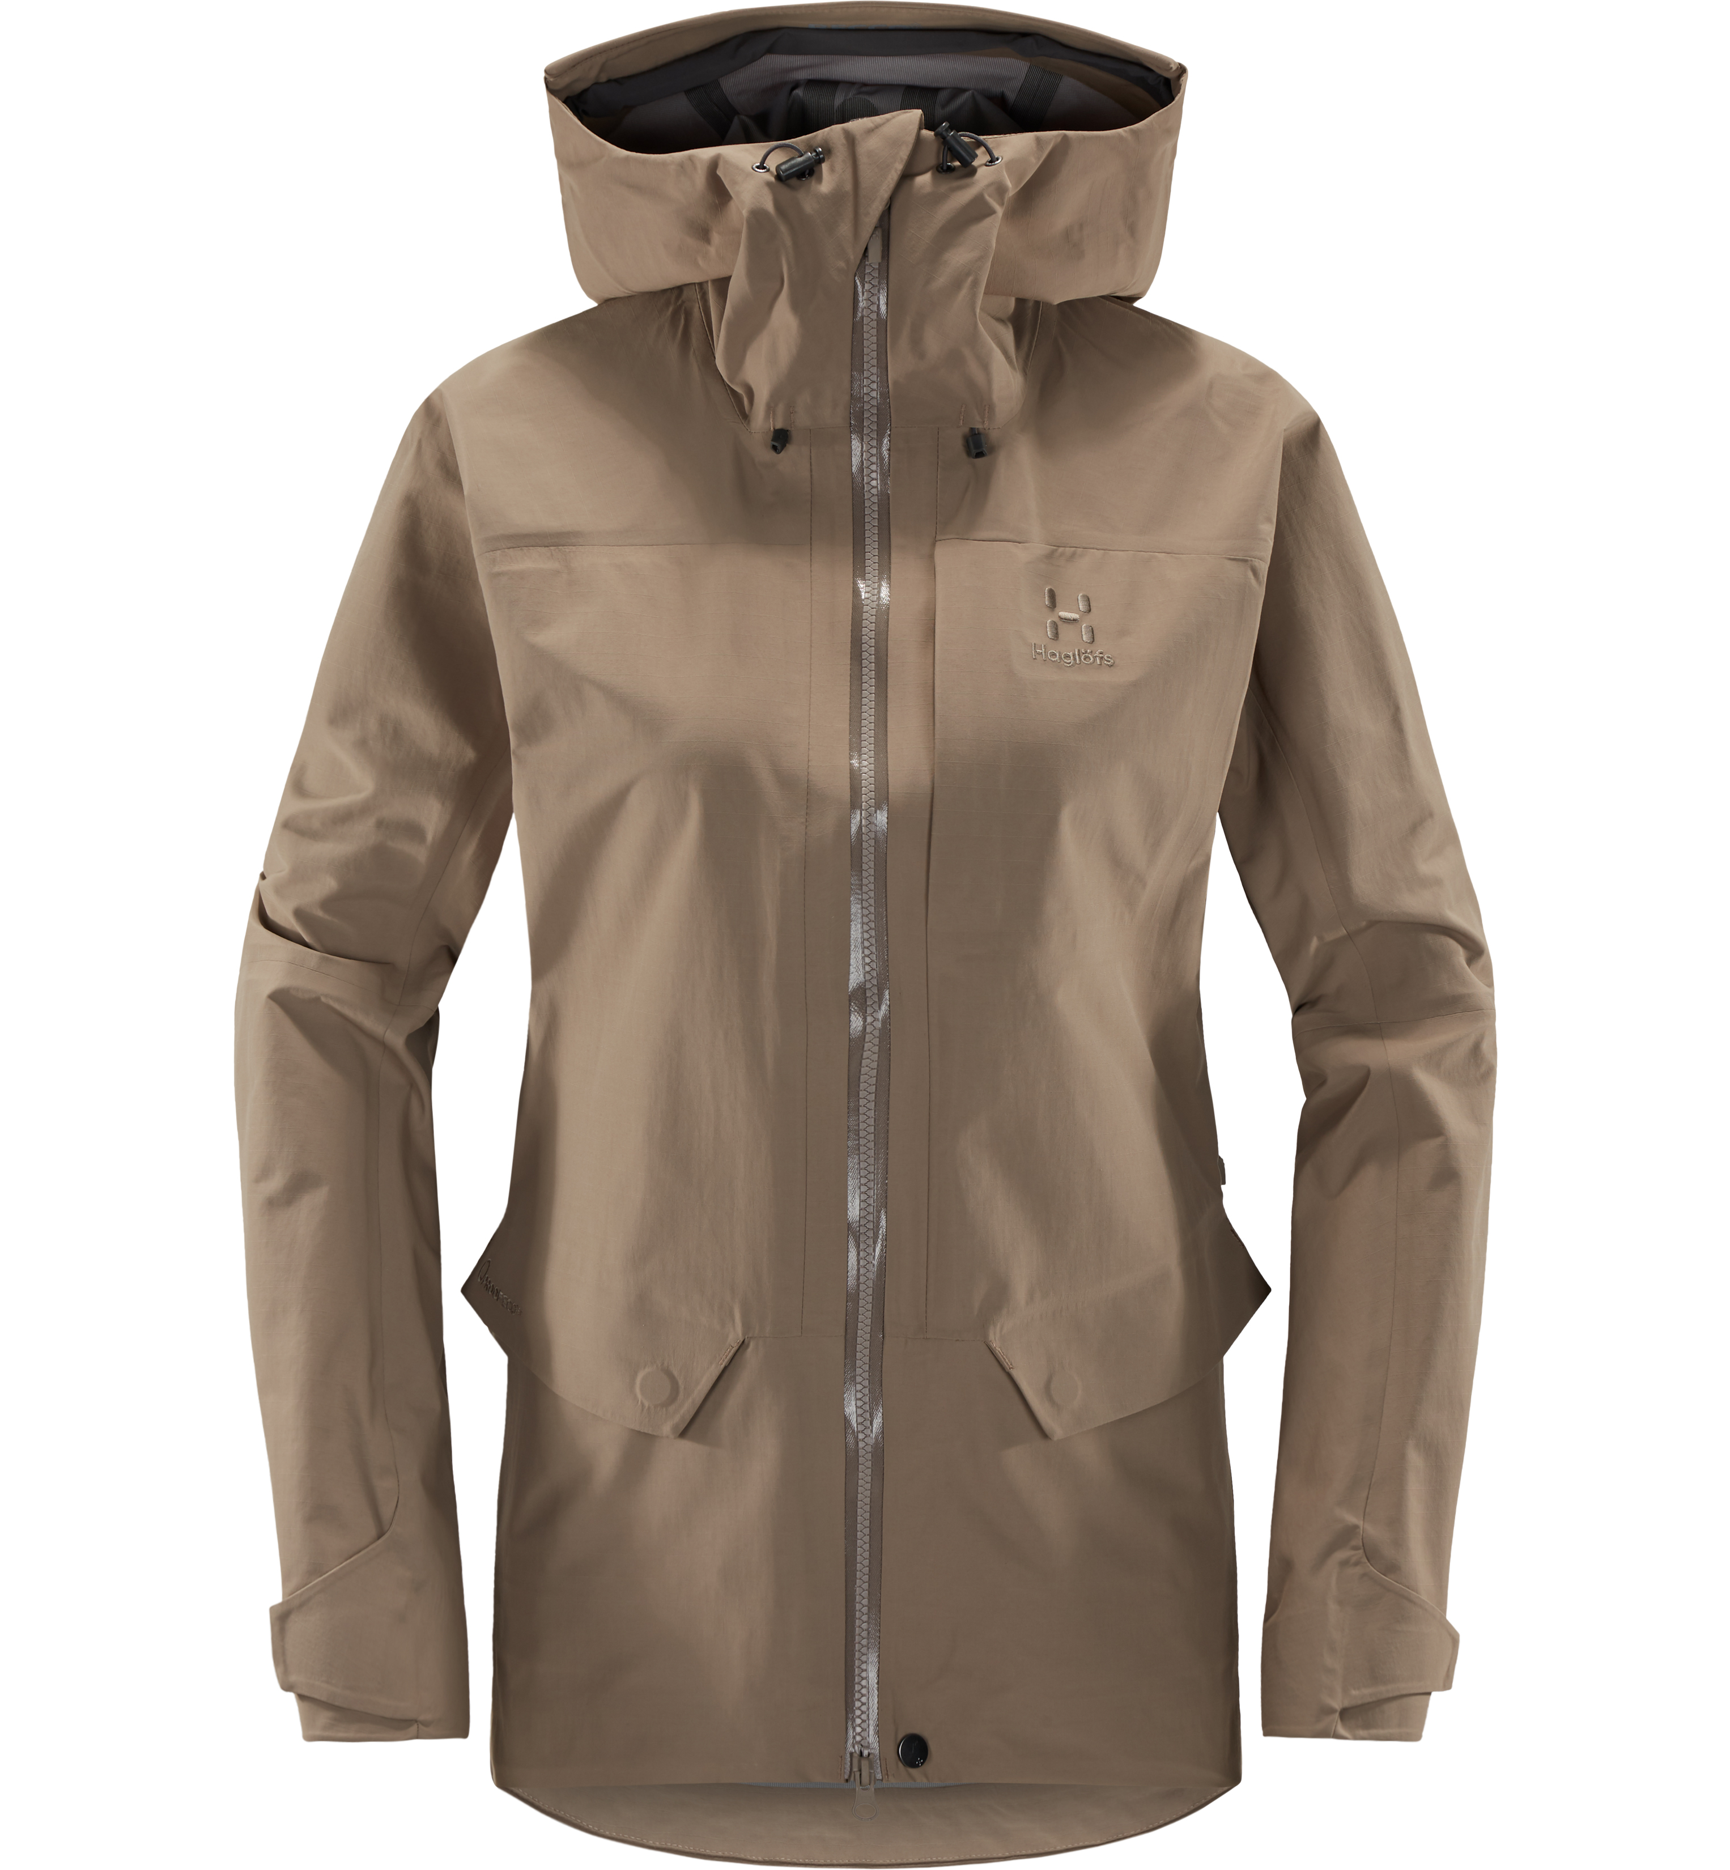
- Two storm hand pockets with snap buttons, and one zippered chest pocket
- Articulated sleeves and a dropped rear hem with single-hand adjustment
- Snap button to placket at bottom hem
- Ultrasonic welding for smoother feeling​
- RECCO® reflector in brim
- Centre back length: 83 cm (men’s size L) and 74,5 cm (women’s size M)

