PRESS RELEASE
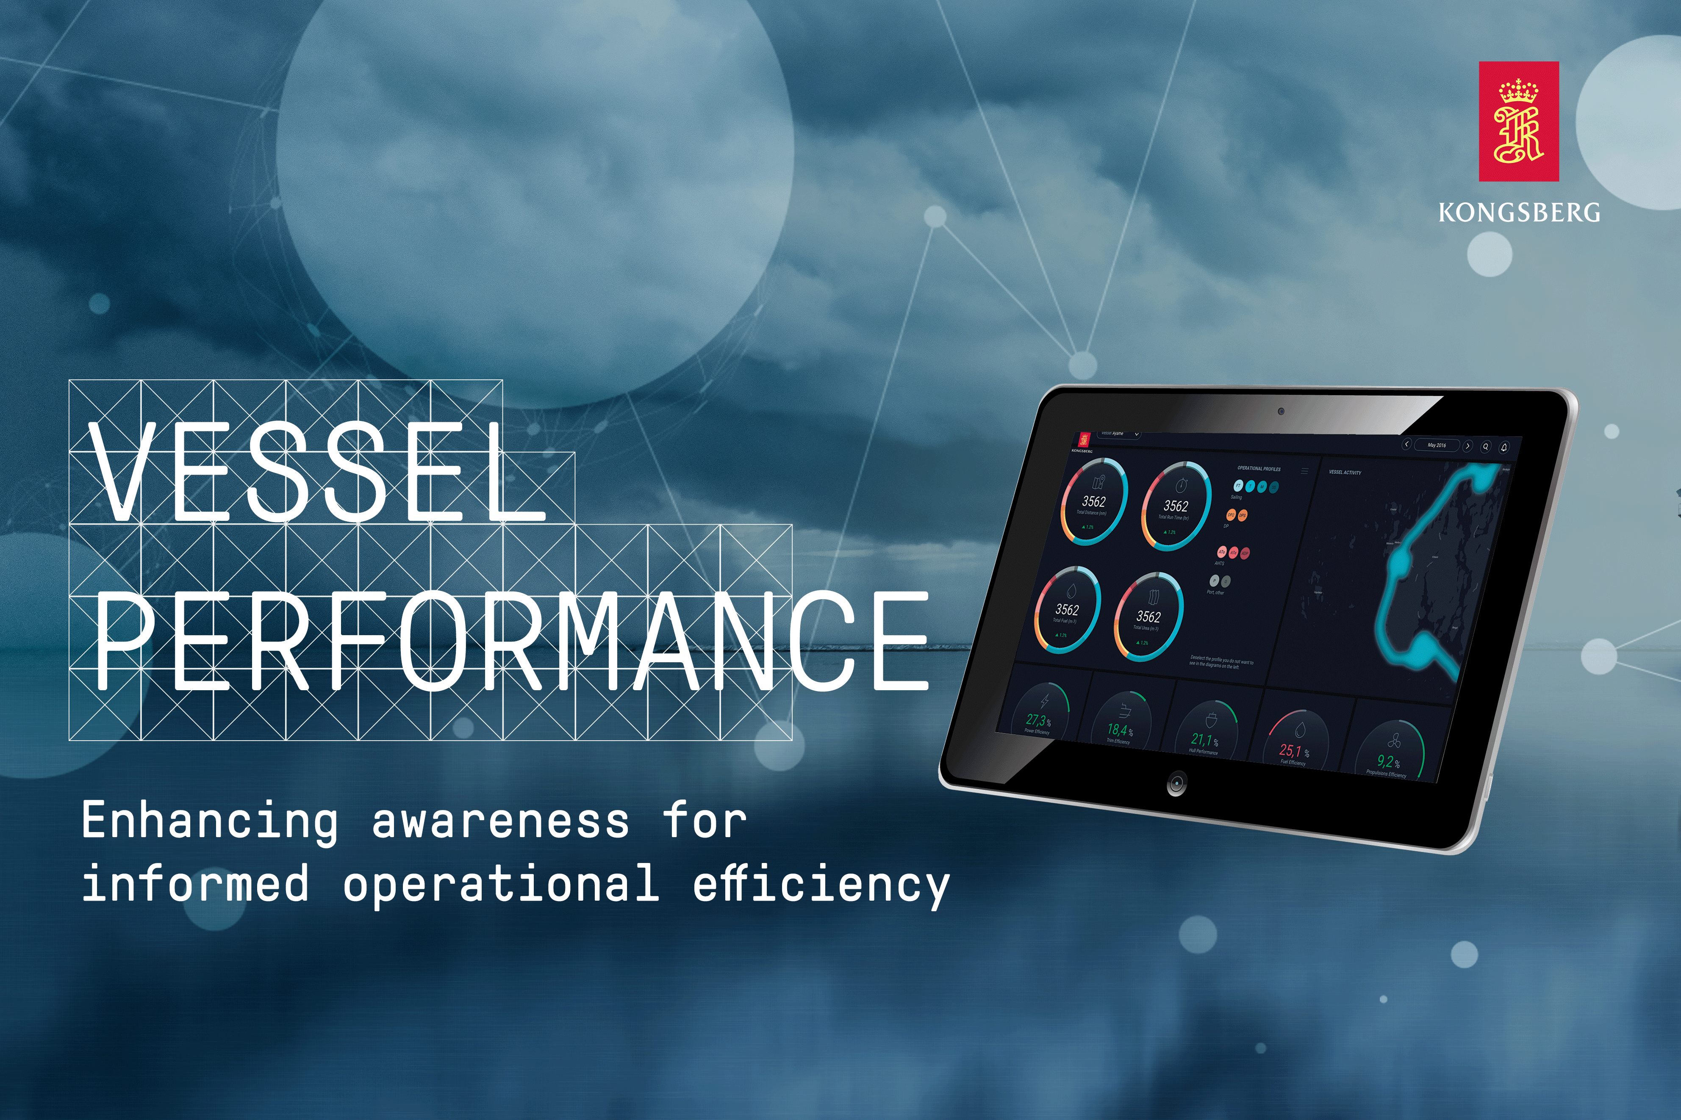

KONGSBERG launches performance application for Vessel Insight users
(Oslo, February 5th, 2020) Ship owners and operators using Vessel Insight can now improve performance and reporting, and reduce fuel and energy consumption through the new KONGSBERG application Vessel Performance. Users will also achieve increased transparency and awareness about vessel emissions.
The Vessel Performance application collects contextualized data from the ship using KONGSBERG’s data infrastructure solution, Vessel Insight. The data is used to generate real-time value for users, with tools for reducing fuel consumption and unnecessary running of equipment, optimizing equipment maintenance windows, and simplifying reporting according to up-to-date regulatory requirements.
“Aside from getting access to contextualized data from your vessels, one of the main benefits of using Vessel Insight is the immediate access to value-adding applications. Vessel Performance will increase the value for customers who are Vessel Insight users and help them reduce costs, utilize their assets better and stay compliant with new regulations,” says Vigleik Takle, SVP Maritime Digital Solutions at Kongsberg Digital.
Vessel Performance reduces system and information complexity, improves ship and office communication and operational awareness. All information from the application will be available in the cloud, on the vessel and onshore. The application provides details on fuel consumption and overall energy efficiency levels, benchmarked against historical performance, allowing the crew to exploit opportunities to minimize fuel usage and emissions. Vessel Performance is highly customizable and can be configured to meet specific customer needs across a wide range of vessels.
“KONGSBERG’s vast experience in vessel and equipment design places us in a leading position in the development of unified applications, delivered seamlessly via Vessel Insight,” says Bård Bjørløw, EVP Global Sales and Marketing at Kongsberg Maritime. “By making efficiency data easily available, Vessel Performance will facilitate vessel and fleet operations, enabling decisions in real time.”
Vessel Performance is immediately available for purchase and use in the Kognifai Marketplace.
For further information, please contact:
Mathilde Magnussen, Vice President Communications & Marketing
Kongsberg Digital
Tel: +47 456 78 255
Email: mathilde.magnussen@kdi.kongsberg.com
Gunvor Hatling Midtbø, Vice President Communication
Kongsberg Maritime
Tel: +47 992 14 209
Email: gunvor.hatling.midtbo@km.kongsberg.com
David Pugh
Saltwater Stone
Tel: +44 (0)1202 669244
Email: d.pugh@saltwater-stone.com

KOnGsberg
KONGSBERG (OSE-ticker: KOG) is an international, knowledge-based group delivering high-technology systems and solutions. We work with clients within the: oil and gas industry, merchant marine, defence and aerospace. KONGSBERG has 11,000 employees located in more than 40 countries, creating a total revenue of NOK 22.5 billion in 2018. KONGSBERG has three subsidiaries, Kongsberg Digital, Kongsberg Martime and Kongsberg Defence & Aerospace.

