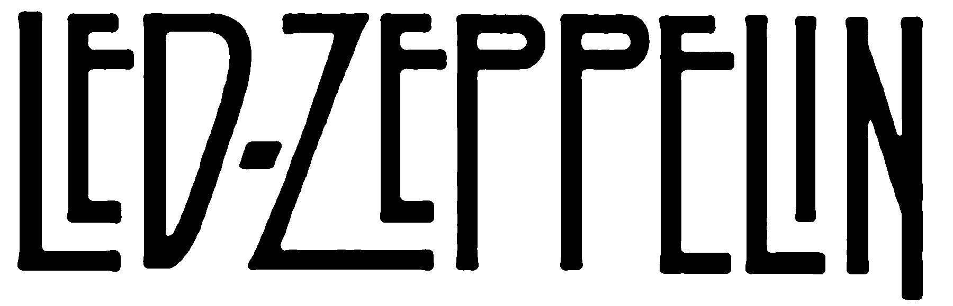
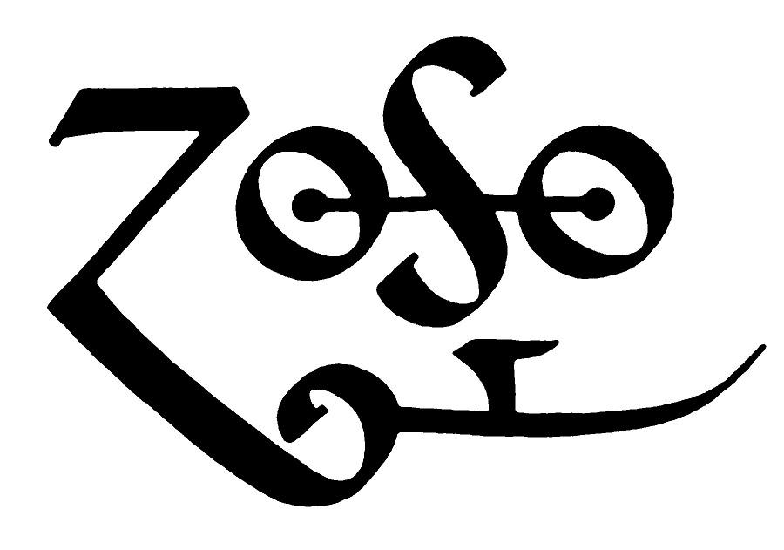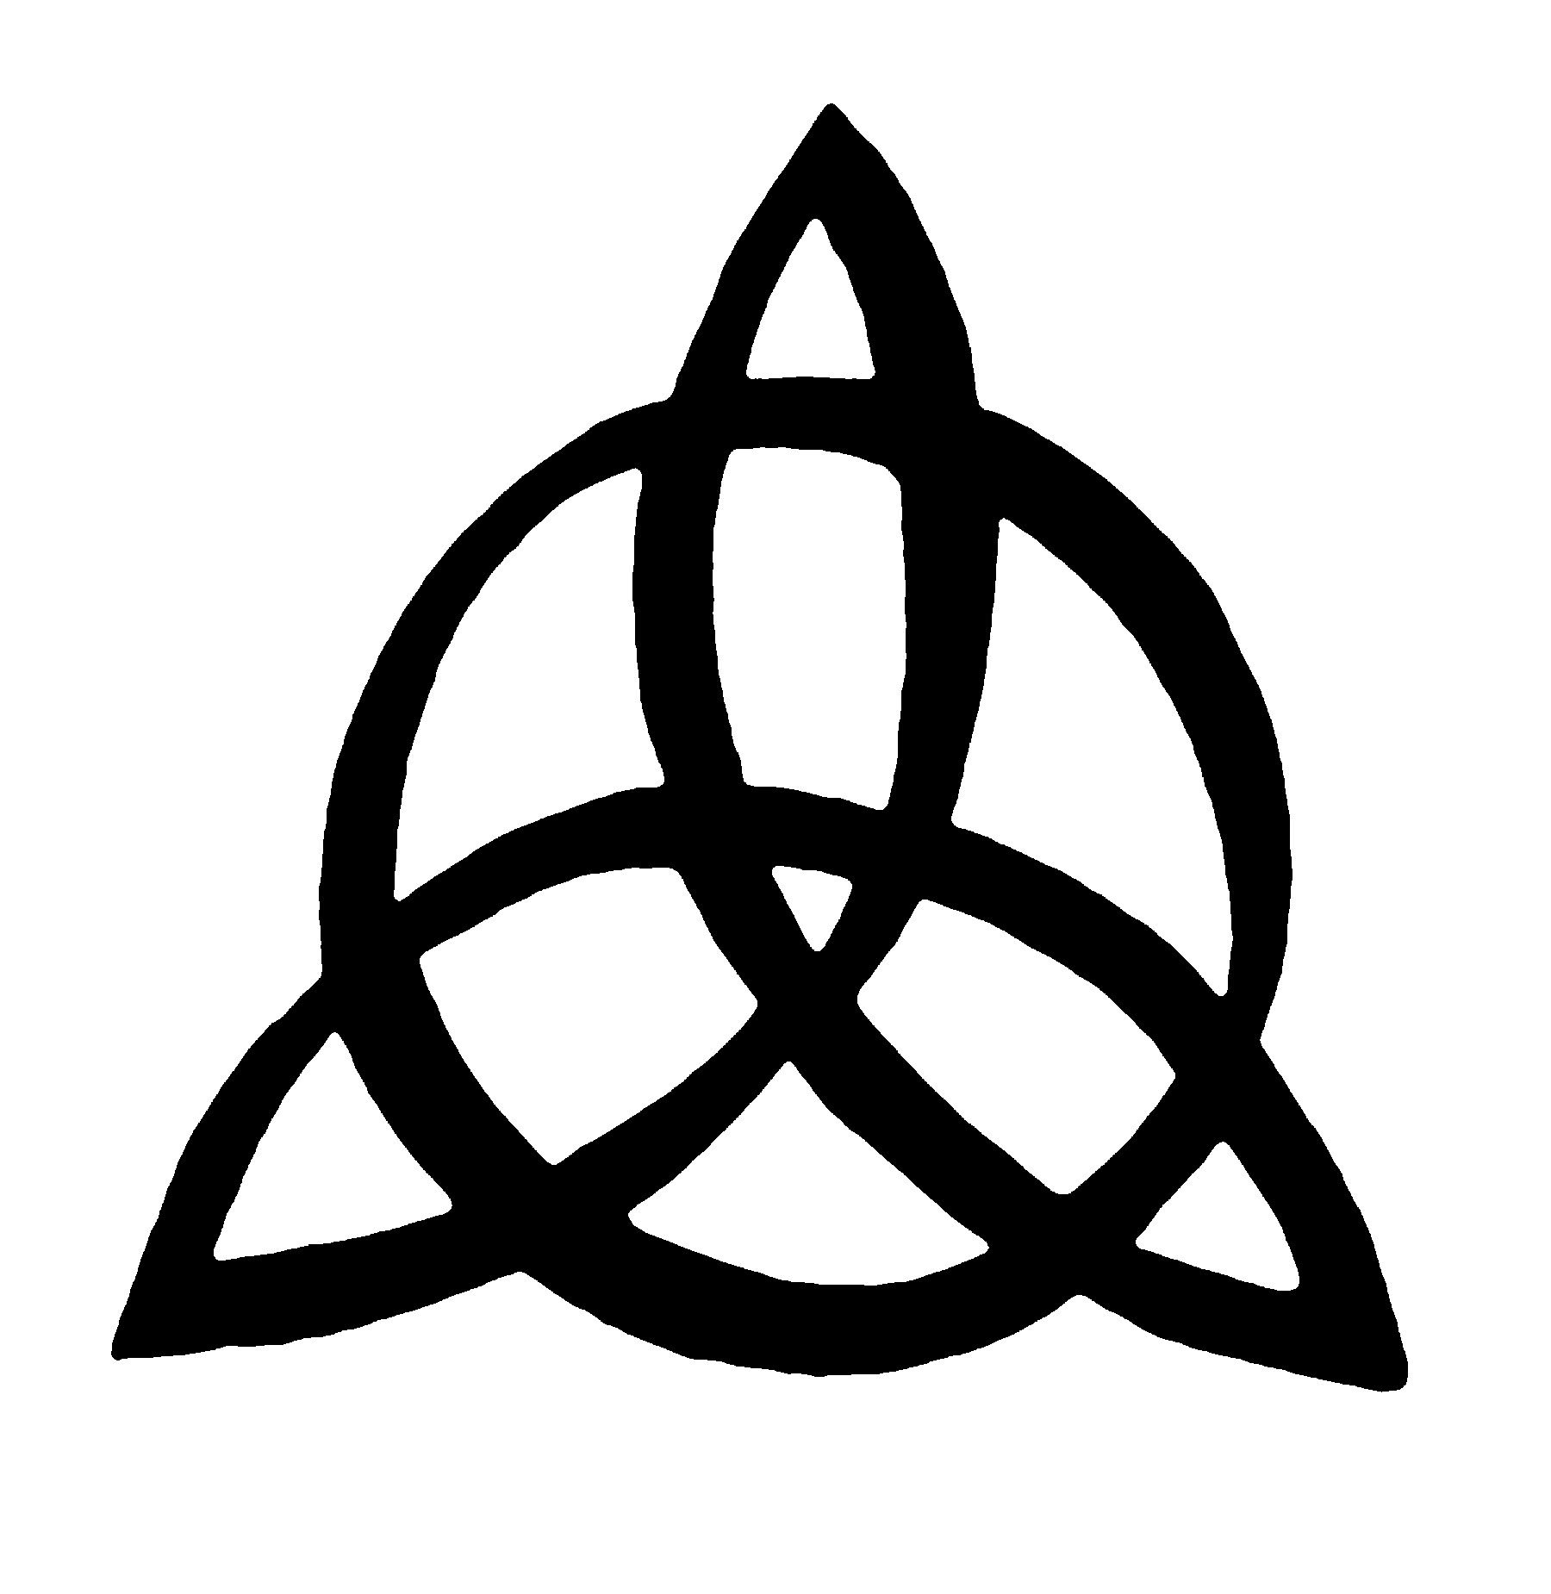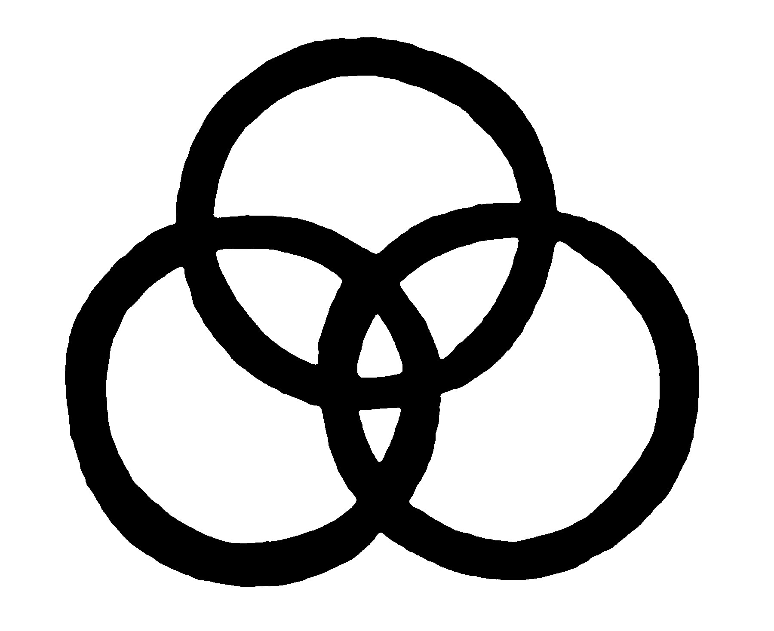

TRIBUTE TO AHMET ERTEGUN
NOVEMBER 26, 2007
O2 ARENA, LONDON

Harvey Goldsmith Announces A Tribute Concert To The Late Ahmet Ertegun In Aid Of The Ahmet Ertegun Education Fund

(London, September 12, 2007) – One of the most eagerly awaited concerts of the decade will celebrate the life and work of Ahmet Ertegun, founder of Atlantic Records and much missed mentor to some of the greatest names in music.

Profits from this amazing show will go to the Ahmet Ertegun Education Fund which provides students with annual scholarships to universities in the UK, USA and Turkey.

In addition, a music scholarship open to all will be established at Ravensbourne College in the UK.

The incomparable Led Zeppelin will headline the tribute to the man who founded Atlantic Records in 1947.

Robert Plant, Jimmy Page and John Paul Jones will be joined by Jason Bonham, the son of their late drummer John Bonham.

In addition, Pete Townshend, Bill Wyman and the Rhythm Kings, Foreigner and Paolo Nutini, all touched by Ertegun's guiding hand over the years, will play on the night. Paolo was the final British artist that Ahmet mentored.

It will be a tribute from UK artists that Ertegun worked with in a 60 year career.

Tickets - £125

Due to the anticipated overwhelming demand for this concert, tickets will be available by ballot only.

Fans should register their names at www.ahmettribute.com

Names will then be chosen at random. There will be seating and standing tickets and fans will be able to express a preference at the website.
more…

Ahmet Ertegun Tribute Concert/Pg. 2

Due the expected unprecedented demand, tickets will be limited to 2 per successful applicants per household.

Note to Editors:
Tickets will not be available from any other source. Please do not take adverts or publicise any company who claims to have tickets. They will not be given any. Please advise the public not the purchase tickets from any unscrupulous source.

Tributes to Ahmet

Mica Ertegun, Ahmet's wife and president of The Ahmet Ertegun Education Fund, commented: "Ahmet attributed his success to his excellent education, and his ability to recognize innovative artists that touched us all. It was his wish to endow music and liberal Arts scholarships that would enable gifted children to reach their highest creative potential. The Ahmet Ertegun Education Fund was founded with that goal. He would be very proud that Led Zeppelin have chosen to re-unite and headline a benefit concert in his name featuring so many of his friends. I would like to thank all of the artists for their generous contribution to help make Ahmet's vision a reality."

Robert Plant, Led Zeppelin: "During the Zeppelin years, Ahmet Ertegun was a major foundation of solidarity and accord. For us he WAS Atlantic Records and remained a close friend and conspirator - this performance stands alone as our tribute to the work and the life of our long standing friend."

Mick Jones, Foreigner: "Ahmet's combination of charm, humour, irreverence and above all his great passion for music made getting to know him one of the brightest highlights of my life."

Paolo Nutini: "Meeting Ahmet Ertegun in New York 2 years ago was a complete honour. He touched my life with his amazing personality and opened a few doors when I was starting my career. He even invited me to sing with Ben E King and Robert Plant at Montreux last year as part of a celebration of his musical life. He was a special guy, a real gentleman and it's such a shame he's gone but a massive tribute that all his music lives on - and will do forever. God bless Ahmet."

Harvey Goldsmith CBE: "Ahmet introduced me to America when I first started promoting. He became a friend and was my mentor. Our Industry deeply misses such a giant of music. It is a fitting tribute that these great artists have all come together to perform in his memory. The proceeds of the evening will go to The Ahmet Ertegun Education Fund for student scholarships. One of these scholarships will be for a music student in the UK each year."

Bill Curbishley, Trinifold management: "To have had Ahmet regard me as one of his close friends over the past 40 yrs was indeed a rare privilege. To be involved in setting up this event, plus a music trust in his name and in his spirit is also a great honour and privilege for me."

more…

Ahmet Ertegun Tribute Concert/Pg. 3

Ahmet Ertegun:

Born in Istanbul, Turkey, in 1923, Ertegun was the son of America's Turkish Ambassador. At 9 years old he was attending gigs in Washington DC featuring jazz greats including Duke Ellington and Cab Calloway. Inspired by what he saw, Ertegun and his brother Nesuhi began to stage their own concerts hosting artists such as Lester Young. In 1947, he formed Atlantic Records with friend Herb Abramson in New York, an independent record label for gospel, jazz and R&B music.

During the 50's and 60's Atlantic grew, signing the likes of Ray Charles, Solomon Burke, Aretha Franklin and The Drifters, patenting the blueprint of soul music. After successfully and uniquely combining blues and soul music from around the world, Atlantic became the definitive rhythm and blues label, paying performers fairly and producing high quality records. Ertegun, as always, was hands on in business and in the studio.

In 1968, Ahmet Ertegun made the magical move into rock by signing Led Zeppelin guiding them through a phenomenal career. In addition, he signed the monsters of 1970s British rock - from the Rolling Stones, through Cream and Genesis.

Ertegun was also the founder and chairman of The Rock and Roll Hall of Fame, to which he was elected in 1987 for his pioneering contributions to popular music.

His most recent signing was UK artist Paolo Nutini whose 2006 debut album 'These Streets' reached number 3 in the UK Album Charts.

Ahmet Ertegun sadly died last year aged 83.

Led Zeppelin:

Led Zeppelin are simply the ultimate rock band.

They produced some of the greatest albums in recording history and are constantly considered amongst the greatest popular musicians of all time, both collectively and individually.

The band formed in 1968, from the ashes of The Yardbirds. When those R&B crusaders disbanded, guitarist Jimmy Page brought in Robert Plant, John Bonham and John Paul Jones and toured as The New Yardbirds.

In 1969, their self-titled debut was released and is regarded as one of the pivotal records in the creation of heavy rock.

Led Zeppelin went on to become the colossal rock icons that we know today, setting new records along the way for fan attendance at their massive gigs, with one of the most memorable at Knebworth in 1979.
more…

Ahmet Ertegun Tribute Concert/Pg. 4

They have sold over 300 million albums worldwide and, in 1995, the band were inducted into the Rock and Roll Hall of Fame joining their mentor Ahmet Ertegun.

Led Zeppelin Catalogue:
Led Zeppelin
Led Zeppelin II
Led Zeppelin III
Led Zeppelin (Untitled)
Houses Of the Holy
Physical Graffiti
Presence
The Song Remains The Same
In Through The Out Door
Coda

Box Set/Remasters
Led Zeppelin Profiled
Box Set II
Complete Studio Recordings
Led Zeppelin BBC Sessions
Led Zeppelin: DVD
How The West Was Won
Mothership (2 disc very best of coming November 12, 2007)
The Song Remains The Same (soundtrack, remixed, remastered and complete coming November 19, 2007)
The Song Remains The Same DVD (coming November 19, 2007)

___________________________________________________________

Ahmet Ertegun Education Fund

The Fund was set up in memory of Ahmet Ertegun by his widow Mica to provide funding for students of Turkish origin in the USA, UK and Turkey.

Needs-based scholarships will be made in the name of and in honor of Ahmet Ertegun to qualified, full time students, attending the following educational institutions: Oxford University (UK), St. John's College (USA) Bogazici University (Turkey) and Ravensbourne College (UK). The scholarship for Ravensbourne College is for music students in the UK and is open to all. Each year, a student's fees will be paid under these scholarships.

The Board of the Ahmet Ertegun Education Fund is:

Mica Ertegun
Phil Carson
Harvey Goldsmith CBE
Bill Curbishley
Taylor Hackford

Ahmet Ertegun Tribute Concert/Pg. 5

For media enquiries:

Outside Organisation
+44 (0) 20 7436 3633

Chris Goodman
Chris.Goodman@outside-org.co.uk

David Cox
David.cox@outside-org.co.uk

Adam Cotton
Adam.cotton@outside-org.co.uk



   

