

Technical specifications.

BMW iX3.

iX3 50 xDrive.
 |  |  |  |  |  | BMW iX3 50 xDrive
Vehicle Category
Drive type / body style |  |  |  | Battery-electric vehicle (BEV) / Sports Activity Vehicle (SAV)
Body
No. of doors / seats |  |  |  |  |  | 5 / 5
Length/width/height (unladen) | mm |  |  |  |  | 4782 / 1895 / 1635
Wheelbase | mm |  |  |  |  | 2897
Track, front/rear | mm |  |  |  |  | 1628 / 1633
Turning circle |  | m |  |  |  | 12.1
Weight, unladen (DIN/EU) | kg |  |  |  |  | 2285 / 2360
Max. load to DIN | kg |  |  |  |  | 540
Max. permissible weight | kg |  |  |  |  | 2825
Max. axle load, front/rear | kg |  |  |  |  | 1305 / 1565
Max. trailer load,  braked (12%)/unbraked | kg |  |  |  |  | 2000 / 750
Max. roofload/towbar download | kg |  |  |  |  | 75 / 80
Luggage comp. capacity | l |  |  |  |  | 520 – 1750
Additional storage comp. under bonnet |  |  |  |  | l | 58
Air resistance | c_{X} x A |  |  |  |  | 0.24 x 2.62
Power Unit
Drive concept |  |  |  |  |  | Electric all-wheel drive, coordinated transmission of the drive torque from two electric motors to the front and rear wheels respectively, as required
Max. system output | kW/hp |  |  |  |  | 345 / 469
Max. system torque | Nm |  |  |  |  | 645
System power-to-weight ratio | kg/kW |  |  |  |  | 6.6
Type of transmission |  |  |  |  |  | Automatic transmission, single-speed with fixed ratio
Electric motors
Motor technology |  |  |  |  |  | Sixth-generation BMW eDrive technology:  electrically excited synchronous motor at the rear axle, asynchronous motor at the front axle, each sharing a housing with the power electronics and transmission; generator function for recuperating energy
Front Electric Motor
Motor designation |  |  |  |  |  | HF1001N0
Peak output to ECE R 85 | kW/hp |  |  |  |  | 123 / 167
at | rpm |  |  |  |  | 4607
Max. torque | Nm |  |  |  |  | 255
at | rpm |  |  |  |  | 0 – 4607
Gear ratio | :1 |  |  |  |  | 8.801
Rear Electric Motor
Motor designation |  |  |  |  |  | HD1002N0
Peak output to ECE R 85 | kW/hp |  |  |  |  | 240 / 326
at | rpm |  |  |  |  | 5000
Max. torque | Nm |  |  |  |  | 435
at | rpm |  |  |  |  | 0 – 5000
Gear ratio | :1 |  |  |  |  | 9.606
High-voltage Battery
Storage technology |  |  |  |  |  | Lithium-ion
Installation |  |  |  |  |  | Underfloor
Voltage | V |  |  |  |  | 698.9
Energy capacity, net | kWh |  |  |  |  | 108.7
Charging time, 0 – 100 % charge |  |  |  |  |  | 11h at 11 kW (16 A / 230 V, three-phase AC, wallbox)
Charging time, 0 – 100 % charge |  |  |  |  |  | 5h 45m at 22 kW (32 A / 230 V, three-phase AC, wallbox)
Charging time, 10 – 80 % charge |  |  |  |  |  | 21 min at 400 kW (800 A, DC, fast-charging station)
Additional range after 10 minutes of  DC charging (max. charging rate) ¹⁾ |  |  | km |  |  | 309 – 372
Charging
Max. charging rate  AC, three-phase | kW |  |  |  |  | 11.0 (optional: 22.0)
Max. charging rate  DC | kW |  |  |  |  | 400

 |  |  |  |  |  |  |  |  | BMW iX3 50 xDrive
Bidirectional Charging
Vehicle-to-Load, max. rate (AC) |  |  |  |  |  |  | kW |  |  |  | optional: 3.7
Vehicle-to-Home, max. rate (DC) |  |  |  |  |  |  | kW |  |  |  | 11.0
Vehicle-to-Grid, max. rate (DC) |  |  |  |  |  |  | kW |  |  |  | 11.0
Driving Dynamics and Safety
Suspension, front |  |  |  |  |  |  |  |  |  |  | Double-joint spring strut axle in lightweight aluminium-steel construction with torque arm and anti-roll bar. Trapezoidal shear panels forming connection between axle subframe, high-voltage battery and body
Suspension, rear |  |  |  |  |  |  |  |  |  |  | Five-link axle in lightweight aluminium-steel construction with separately arranged springs and dampers
Brakes, front |  |  |  |  |  |  |  |  |  |  | Vented disc brakes, with single-piston floating callipers
Brake disc size |  |  |  | mm |  |  |  |  |  |  | 330
Brakes, rear |  |  |  |  |  |  |  |  |  |  | Vented disc brakes, with single-piston floating callipers
Brake disc size |  |  |  | mm |  |  |  |  |  |  | 345
Driving stability systems |  |  |  |  |  |  |  |  |  |  | Standard: Heart of Joy integrated drivetrain and driving dynamics management, integrated braking system, DSC incl. ABS, ASC and DTC (Dynamic Traction Control), CBC (Cornering Brake Control), Dry Braking function, Fading Compensation, Start-Off Assistant, HDC (Hill Descent Control), trailer stability control
Safety equipment |  |  |  |  |  |  |  |  |  |  | Standard: airbags for driver and front passenger, side airbags for driver and front passenger, interaction airbag between driver and front passenger, head airbags for front and rear seats, three-point inertia-reel seatbelts on all seats with belt tensioner and belt force limiter in the front, crash sensors, tyre pressure indicator
Steering |  |  |  |  |  |  |  |  |  |  | Electric Power Steering (EPS)  with Servotronic function
Steering wheel turns (lock to lock) |  |  |  |  |  |  |  |  |  |  | 2.8
Tyres, front/rear |  |  |  |  |  |  |  |  |  |  | 255/45 R20 105W XL
Rims, front/rear |  |  |  |  |  |  |  |  |  |  | 8.5J x 20 light-alloy
Performance
Acceleration 0–100 km/h |  |  | s |  |  |  |  |  |  |  | 4.9
Top speed |  |  | km/h |  |  |  |  |  |  |  | 210 (electronically limited)
Off-road Characteristics
Angle of approach/departure |  | ° |  |  |  |  |  |  |  |  | 18.6 / 20.2
Breakover angle |  | ° |  |  |  |  |  |  |  |  | 15.9
Ground clearance (unladen) |  |  |  |  | mm |  |  |  |  |  | 176
Fording depth (at 5 km/h) |  | mm |  |  |  |  |  |  |  |  | 400
Consumption / Range (WLTP combined)
Electric power consumption  as per EnVKV |  |  |  |  |  | kWh/100 km |  |  |  |  | 17.9 – 15.1
Attainable electric power cons.  in individual configuration |  |  |  |  |  | kWh/100 km |  |  |  |  | 17.9 – 15.1
Electric power consumption  motorway ²⁾ |  |  |  |  |  | kWh/100 km |  |  |  |  | 22.7 – 19.4
Range as per EnVKV |  |  |  |  |  | km |  |  |  |  | 679 – 805
Attainable range in individual configuration |  |  |  |  |  | km |  |  |  |  | 679 – 805
Environmental Characteristics
Pass-by noise |  |  |  |  |  |  | dB(A) |  |  |  | 65
Emission rating |  |  |  |  |  |  |  |  |  |  | Electric vehicle
CO₂ class(es) as per EnVKV |  |  |  |  |  |  |  |  |  |  | A

Specifications apply to ACEA markets/data relevant to homologation applies in part only to Germany
All figures are provisional as at the start of production in November 2025.
All of the stated equipment features, technical data and fuel/electric power consumption and emissions figures relate to the offering in the German market. The figures refer to a vehicle with basic configuration in Germany. These may vary depending on the wheel/tyre size and items of optional equipment selected.
Official electric power consumption and range figures were determined based on the prescribed WLTP measurement procedure and are in accordance with the Pkw-EnVKV. Further information can be found at www.bmw.de

¹⁾ The extra range added after ten minutes of high-power charging was calculated in accordance with ISO 12906 based on the WLTP cycle. Both this and charging performance are dependent on vehicle equipment, the battery’s charge level and age, battery temperature, the individual driving profile, use of auxiliary consumers, the ambient temperature and the charging station’s available charging power.
²⁾ Corresponds to WLTP Extra High

Exterior and interior dimensions.

BMW iX3.

iX3 50 xDrive.

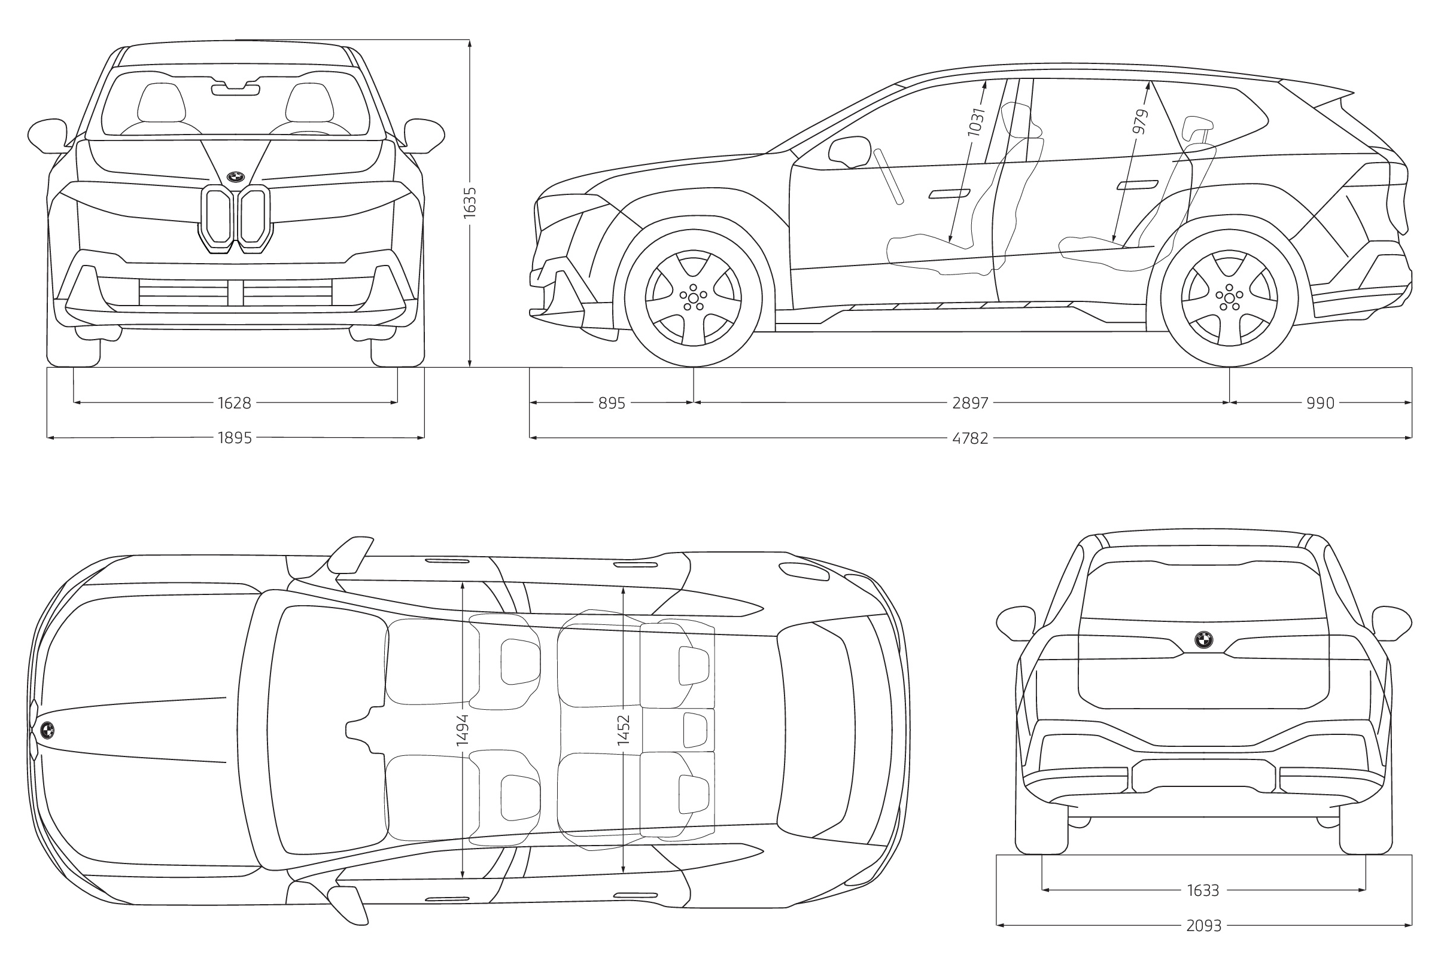

The dimensions indicated in the technical drawing are in millimetres and may vary depending on the model and items of optional equipment fitted.

BMW iX3.

iX3 50 xDrive with M Sport package.

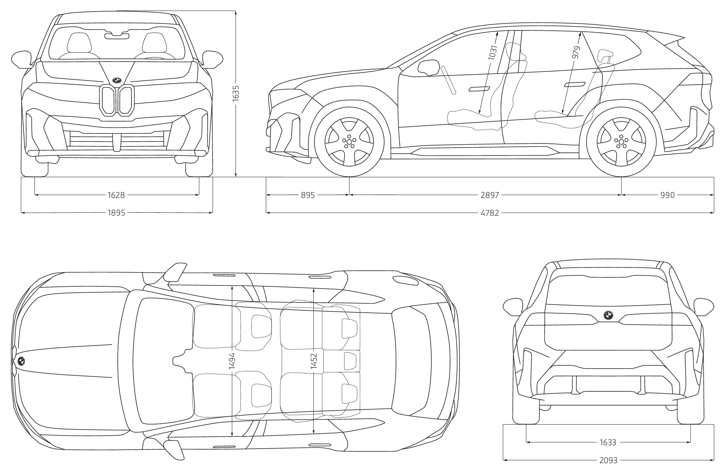

The dimensions indicated in the technical drawing are in millimetres and may vary depending on the model and items of optional equipment fitted.

