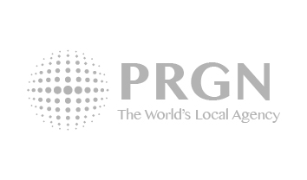

Coast communicates Portugal’s hot real estate market

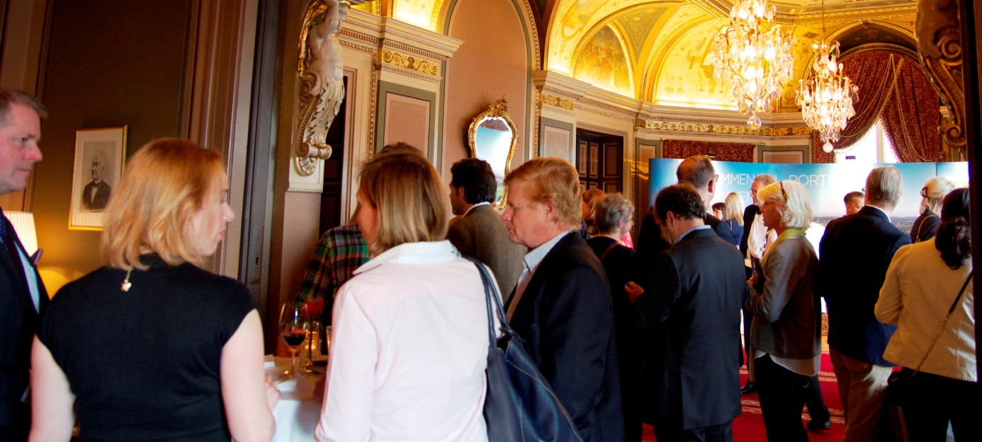
Stockholm, June 9, 2014; Coast Communications, has through its PRGN office in Lisbon, for the Portuguese resort organization APR, staged an event in Stockholm at Grand Hotel on May 13. The theme of the event was the housing market in Portugal.
"We were surprised by the overwhelming interest among key stake holder groups," said Karl Rickhamre, MD Coast Communications AB. "We had to hire four halls of the planned two at Grand Hotel in Stockholm, and run multiple briefings with some of the guests during the evening alongside with cocktails which rolled on for the other guests."
Property Land Spirit in Portugal has developed well from relatively low levels. Among the guests were tax experts, financial experts, house brokers and potential buyers.
"APR has recently conducted presentations in Paris, London and Oslo on the opportunities in Portugal right now," says Christina Rytter, MD Coast Communications DK. "The event is a testament to our strength to work seamlessly across borders. Half of Coast’s project team came from our office in Copenhagen and the other half from our office in Stockholm. Meanwhile, our PRGN agency in Lisbon was deeply involved in the work."
This was the first event where Coast Communications Denmark acted as lead agency for the Coast Group.

Team Coast:
Christina Rytter, Client Leader
Victoria Elmgren, Project Assistant
Lone Schönnemann, Graphic Design
Karl G. Rickhamre, Senior Consultant

Further informtion:
Karl G. Rickhamre
M: +46 709 549 109
T: + 46 8 402 98 80
E: kg.rickhamre@coast.se

