MANFROTTO PRESENTS DIGITAL DIRECTOR

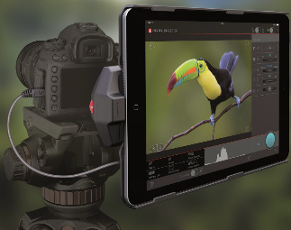
May 2015: Manfrotto, world leader in the photography, imaging equipment and accessories industry, announces the arrival of Digital Director, the only Apple Certified interface that helps users intuitively manage their photo and video workflow, from setting the camera to sharing pictures via a tethered iPad application. Digital Director is a ground-breaking development from Manfrotto that provides accurate assistance with real time monitoring, superior efficiency post-production management, and a great level of integration into the workflow. At NAB 2015, the National Association of Broadcasters show held in Las Vegas last April, the Manfrotto Workflow Management Processor has conquered international footlights and attention and its innovative features have been awarded, making it the Most Innovative Product of NAB 2015.

Digital Director is the ideal companion for pro and hobbyist photographers who are serious about videography and are Apple addicted.
This innovative MFi (Made for iPad Certification) product is designed to make shooting photos and videos much smarter: by simply plugging the USB cable into the camera and turning on the App, photographers and videographers are ensured a reliable, high-performance connection between their Canon or Nikon DSLRs and their iPad Air/Air 2.
A dedicated CPU (micro-processor ARM® Cortex®-A8) embedded in Digital Director, together with dedicated Software (APP) and firmware, provides an interface between the two devices, which enables the camera protocols to be fully understood and controlled by the iPad via a cable. Furthermore, Digital Director enables the user to place the camera even in the most awkward or difficult to reach positions and conveniently control it remotely.

COMPLETE AND INTUITIVE WORKFLOW CONTROL
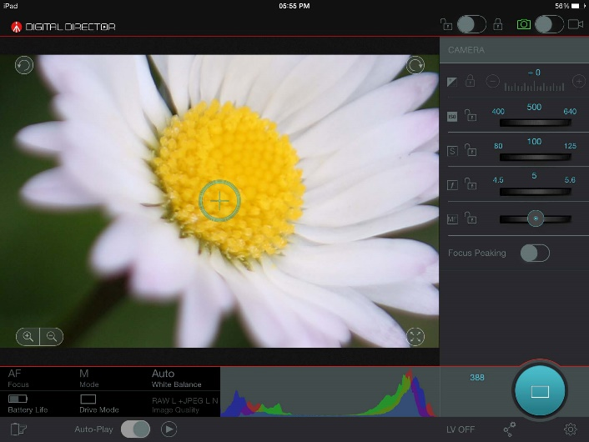
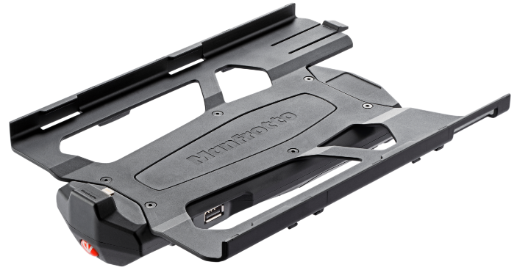
Photographers and videographers can now enjoy a more detailed, enhanced control interface thanks to a much bigger and higher quality display: indeed, Digital Director turns the iPad Air into an external monitor taking full advantage of its High Definition Retina display. The dedicated Digital Director App enables all the key parameters of Canon and Nikon DSLRs to be monitored and dynamically modified in real time (Exposure, ISO, Shutter Speed, Aperture, Manual Focus, White Balance, Image Quality, Focus Camera/Drive Modes, Battery status), allowing photographers and videographers to concentrate on creativity instead of settings. The App enables remote shooting via the iPad Retina display with real time “Live View” monitoring and adjustment. The dynamic histogram and audio level display allows greater control, whilst the Focus control is guaranteed thanks to the Interactive Focus and Focus Peaking, which can be used to select the focus point anywhere on the screen. The digital zoom magnifies the selected focus point to ensure crisply accurate focus.

QUICK & SMART CHECK AND POST-PRODUCTION
Thanks to Digital Director, users now have total control of their workload and are able to download their images onto an iPad and check the high-resolution files. All the image’s characteristics, such as focus, can be checked simply using standard iPad “gestures”. Digital Director also allows users to intuitively manage post-production from the iPad: they can work on an image, crop and rotate it, modify exposure, contrast and brightness, check histogram and Exif information, rate and save it – from inside the app. Users also have total control of their files, from image ratings to file organization (albums, shoot profiles and connection profiles).

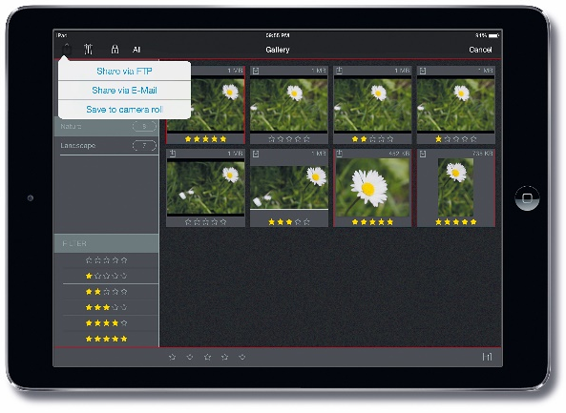
IMMEDIATE CONTENT SHARING
Digital Director allows users to immediately share their images, direct to FTP, by E-mail and on social networks.
Digital Director is an innovative tool reflecting Manfrotto’s constant commitment to innovation, research and development.

For more information, please visit www.manfrotto.com

--------------------------------------------------------------------------

Manfrotto (Vitec Group)
Manfrotto is the world leader in the design, production and distribution of professional products for photography, video and entertainment. The company was founded in 1972 based on Lino Manfrotto’s experience, and its mission has always been to support and simplify the work of reporters, photographers and producers. The Imagine More project adds to this historical mission the idea of fuelling the enthusiasm of weekend photographers and supporting the surge of new amateurs. Part of the UK-based Vitec Group since 1989, Manfrotto has now become a worldwide presence. In its eight key markets – Italy, France, Germany, the United Kingdom, China, Japan, Hong Kong and the United States – it is represented by its own direct distribution system, Manfrotto Distribution, whereas in 80 other countries sales are handled by independent distributors
Contacts
MANFROTTO PRESS OFFICE
Address:
Principal contact:
Phone:
Email:

