PAXYMER newsletter
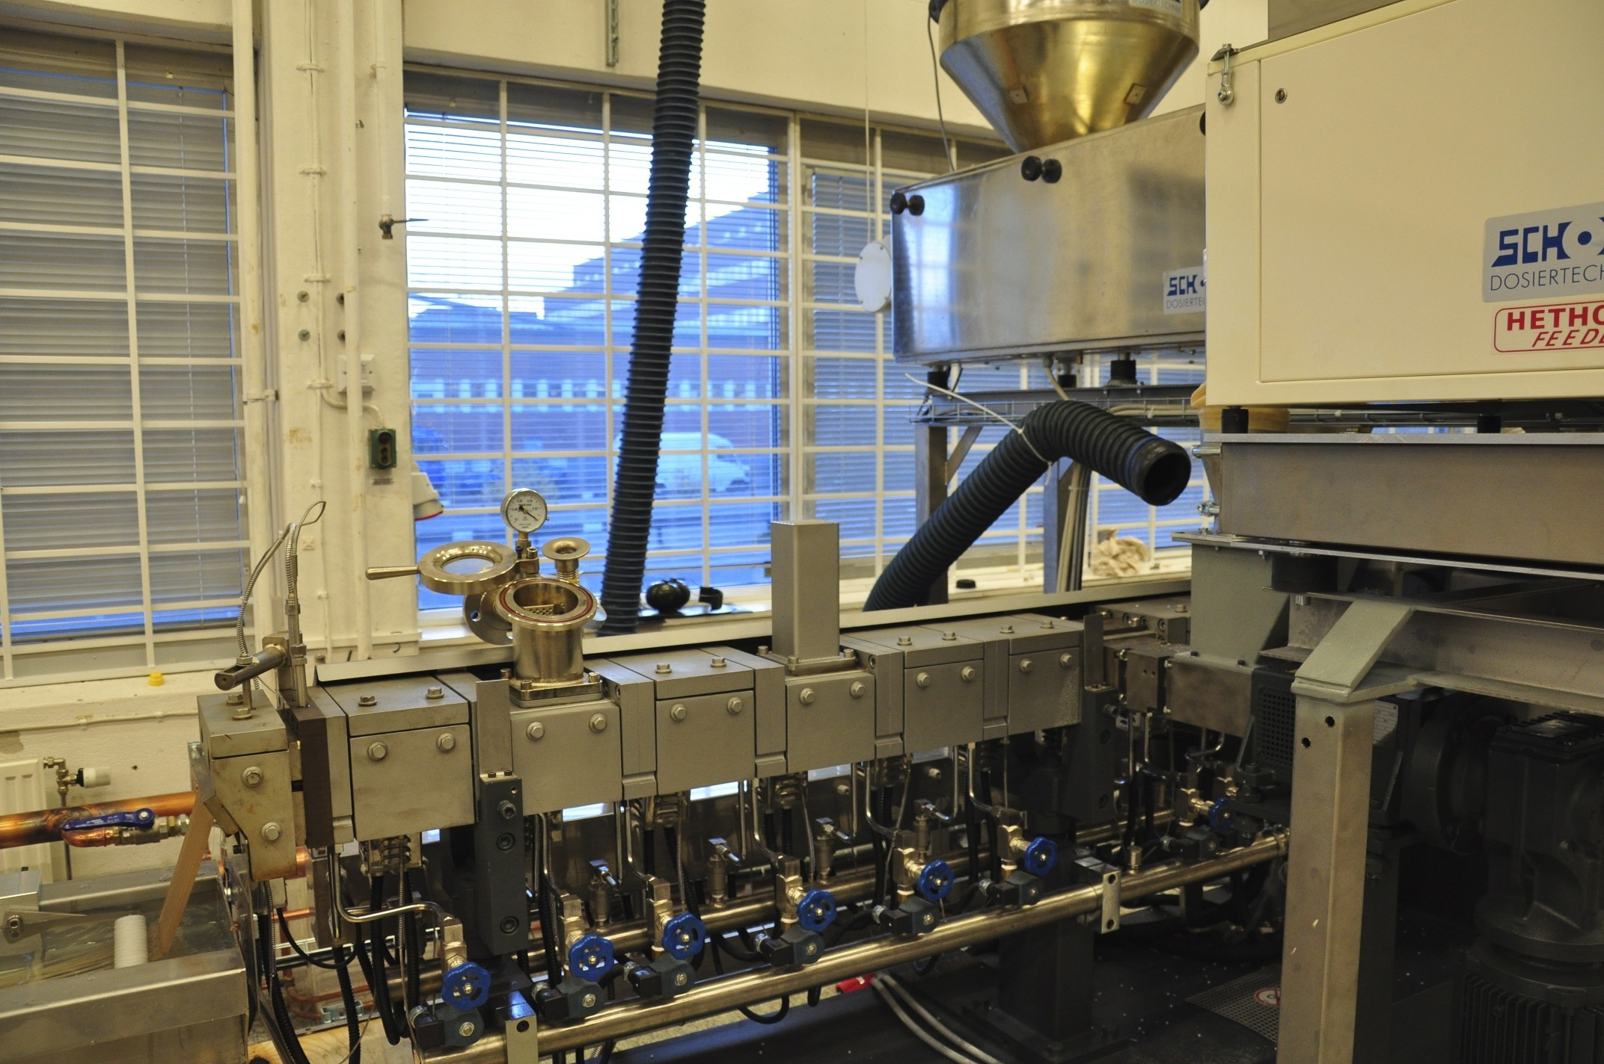
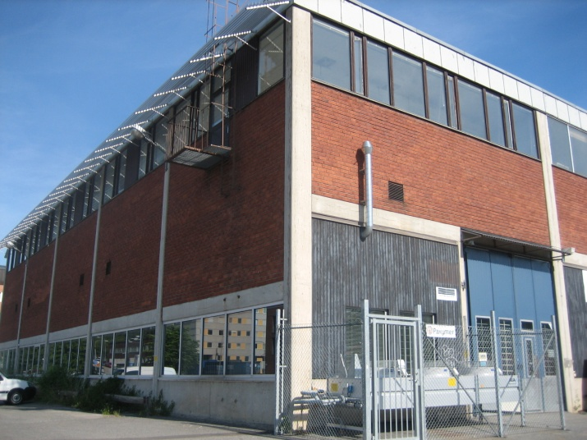
Newsflash
Paxymer® “a big step closer to a sustainable society” states 3rd party audit
Patented halogen free flame retardant system for polyolefin’s Paxymer just scored excellent marks in an environmental Assessment performed by Jegrelius the Institute for Applied Green Chemistry in Sweden. After having been selected to participate in the unique project, the report addressing the chemical risks, environmental impact and a life cycle perspective strongly recommends Paxymer as a ‘green’ solution.
Read more: the Jegrelius report
Precaution makes sense!
Recently WHO presented data regarding the dangers of exposure to certain chemicals and ICCA reciprocated by accusing the report of failing to meet the standards for sound scientific work. There has also been much commotion in the United States of America regarding the advocacy for a ban on brominated flame retardants by Dr Arlene Blum where the dynamic is very similar.
Paxymer believes that instead of speaking of good science or bad science we should really be considering precautionary science.
Chemistry is a complex subject and in the normal case there is a fair amount of guesswork when introducing new substances despite any test requirements. A good chemist can however normally anticipate issues depending on different material classes.
Paxymer advocates the precautionary principle: if it is possible to avoid substances with persistent, bio-accumulative and/or toxic properties in some form, one should.
Paxymer has this principle as a core value and our struggle to substitute and eliminate bromine and other hazardous substances stem from this conviction.
/Amit Paul (MD of Paxymer AB)
The new furniture flammability standard (TB117-2013). The standard has been under construction for six years and will finally be implemented. It will mean safer and healthier furniture and baby products in California. The new regulation will be implemented in fall 2013. The standard is an adjustment towards more realistic fire testing and consist of three steps: Cover fabric test (1), barrier materials test (2) and resilient filling material test (3). Compared to the previous test this, more holistic, testing procedure requires you to fulfill the standard upfront or you will fail. What we see is that an increasing number of standards takes more realistic scenarios into account. This promotes new solutions on the market that are non-hazardous and address the whole burning process. The new furniture flammability standard
BFRs found in dust in houses, in couches and in children!
Coming back to the furniture standard in California TB117 from a different perspective. This standard is believed to be a major driver of chemical flame retardant use in residential furniture in the U.S. There have been a number of studies of the health effects of brominated flame retardants (BFRs) because of this standard. For a more extensive but very short summary of three of the studies click here. The conclusions are: From the Dust in houses survey “Results highlight the evolving nature of FR exposures and suggest that manufacturers continue to use hazardous chemicals and replace chemicals of concern with chemicals with uncharacterised toxicity”. From the couches study “Given these results, and the potential for human exposure to FRs, health studies should be conducted on the types of FR’s identified here” From the Childrens study “The study, the largest to date, contributes to growing evidence suggesting that PBDE’s have adverse impact on child neurobehavioral development”
WHO is developing framework for identification of Endocrine disruptors
WHO recently presented a report “Global assessment of the state-of-the-science of endocrine disruptors” where identifying and evaluation criteria are suggested. The researchers summarize a number of illustrating examples from various studies on adverse effects from chemicals with these properties. Evidence has shown disruptive effects on neural, reproductive and immune functions as well as carcinogenetic effects. Source: WHO report
Will Sweden be the first country to implement fee on hazardous substances?
The Swedish chemicals agency recently released a halfway report on their work on an “Action plan for a toxic-free society”. They suggest that economic control measures have proven highly efficient to spark change in the past. Producers or importers will be made accountable for the chemical composition of their goods and toxic substances will warrant the tax. The suggested evaluation criteria for taxable substances are persistence, bioaccumulation and toxicity. Source: KemI report
Discussion:
Regardless of the good or bad in the proof presented by the research community most evidence indicates that persistence and bioaccumulation are traits that should be avoided even if toxicity is yet to be proven when new materials are introduced into the market. The brominated solutions that are being introduced currently, polymerised or not, have these traits and should therefore according to the precautionary principle be considered seriously before being put into use. Economic control measures are one way to catalyse substitution by forcing economic accountability on the users of hazardous substances. Paxymer believes that governments must initiate change; assigning societal cost to the products causing them is a start towards pushing the industry towards use of better alternatives.
We welcome you to use and refer to the information in this newsletter and are grateful if you mention the source.
Editor: Ann-Christin Paul, ann-christin.paul@paxymer.se
If you do not wish to receive our newsletters please reply to this e-mail: info@paxymer.se with the Subject: “Unsubscribe” and you will be removed from our mailing list.

