Results of the clinical study of Ecnaclyn (lactoferrin) in patients with acne vulgaris

A lot of teenagers, but also adults is suffering from acne vulgaris, the increased formation of sebum and subsequent bacterial colonization of the skin (mainly by Propionibacterium acnes). This results in the keratinization of the cells and obstruction of the sebaceous glands, redness of the skin and formation of comedones and impurities.
In this document we summarize the results of lactoferrin administration in patient suffering from acne papulopustulosa (grade I-IV). We evaluate an effect on both non-inflamatory and inflammatory acne lesions, on tolerance of a preparation and on satisfaction of patients.

What are the main mechanisms of action of lactoferrin (Praventin™)?

One of the crucial factors underlying the development of acne is a bacterium called "Propionibacterium acnes". Antimicrobial activity of Praventin™ against these bacteria has been proved by numerous experiments in vivo and in vitro.
It has both a bacteriostatic /inhibiting the growth and reproduction of bacteria/ and bactericidal /killing/ effect. Bacteriostatic effect is mediated by scavenging of iron ions, representing important bacterial growth factor, from the mucosal surfaces, the bactericidal effect is mediated by the direct damage of the bacterial cellular wall and liberation of lipopolysaccharides.

Other mechanism of action of Praventin™ to fight acne is a direct interference with activity of the immune system and influence on immune response /modulation of production of interferon γ, interleukin Ib, interleukin 6, tumour necrosis factor α (TNF-α), interleukin 4, 5 and 10./

The promotion of antioxidative defence of the complexion /reduction of lipid peroxidation/ and binding of A lipids from the lipopolysaccharides from the disintegrated bacteria is also indispensable.

Results of surveillance of Ecnaclyn made by Walmark
Patients with diagnosed acne over 10 years of age were included in the study. The patients used 1 tablet of Ecnaclyn daily for 8 weeks and underwent three examinations – when entering the study, three weeks later and after eight weeks of application. At each visit the number of comedones was evaluated (closed non-inflammatory white pimples or open black comedones) and of papulopustules (inflammatory lesions – pimples). On closing the study, the patients evaluated their satisfaction with the product using a 1-5 degree scale (1 – very satisfied, 5 – unsatisfied) and also potential adverse reactions were recorded during the application. The study included 25 patients.
As early as 3 weeks later, the number of both comedones and papulopustules statistically significantly decreased from the average number of 17.3 to 11.9 and from 21.6 to 9.3 respectively (p<0.05) which after 8-week application further statistically significantly decreased to 5.4 and 5.2 respectively (p<0.05).
Final subjective evaluation of the patients´ satisfaction with Ecnaclyn using a 1-5 degree scale (1 best, 5 worst):
degree 1: 80%, degree 2: 12% and degree 3: 8%.
During the product application, no study participants encountered any adverse reactions.

Graph1: Average number of comedones and papulopustules by the individual visits

Graph 2: Final subjective evaluation of the patients´ satisfaction with ECNACLYN using a 1-5 degree scale

Picture: Examples of stutus before and after 8-week consumption of ECNACLYN
- Status before consumption | - Status after consumption
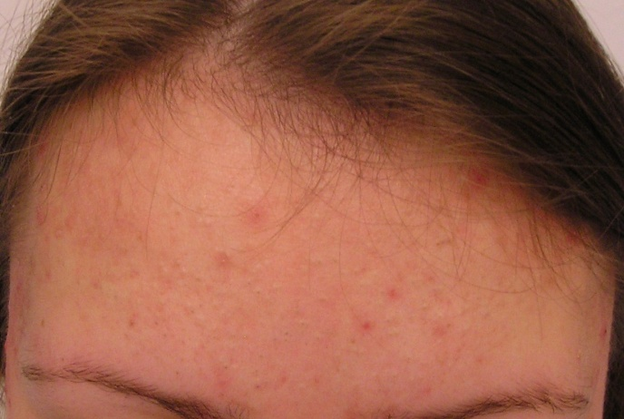 | 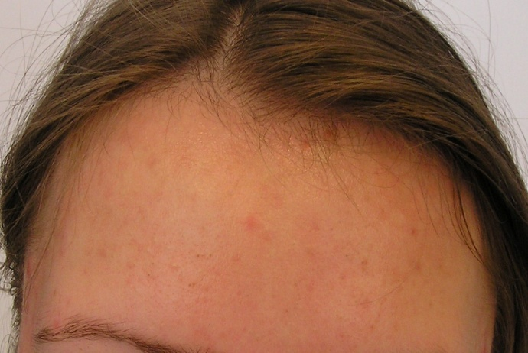
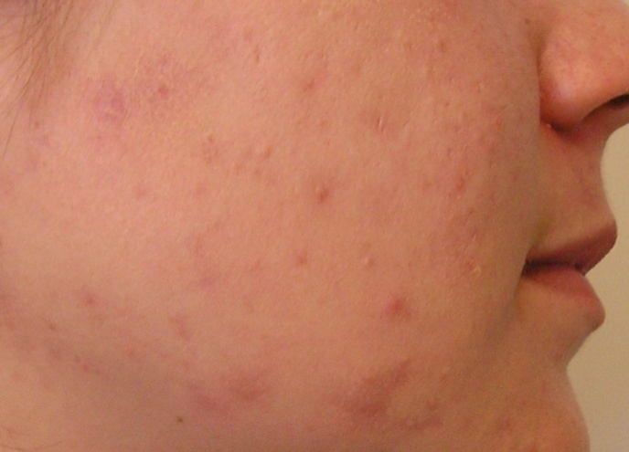 | 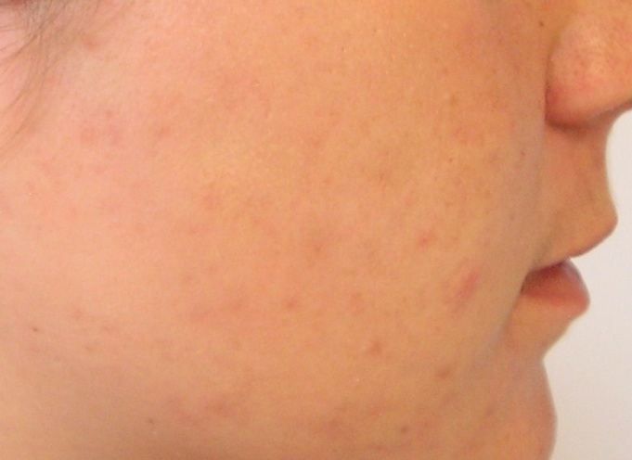
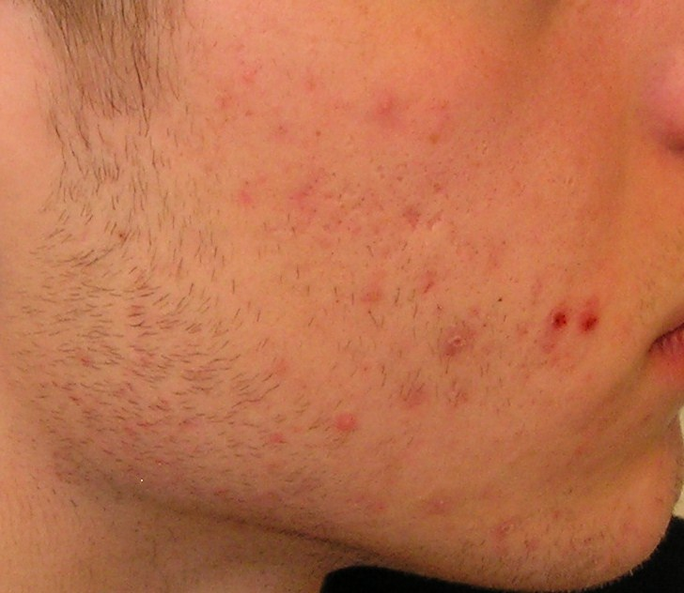 | 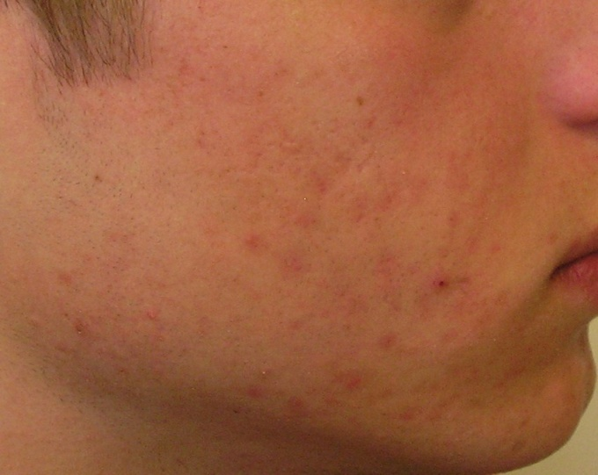
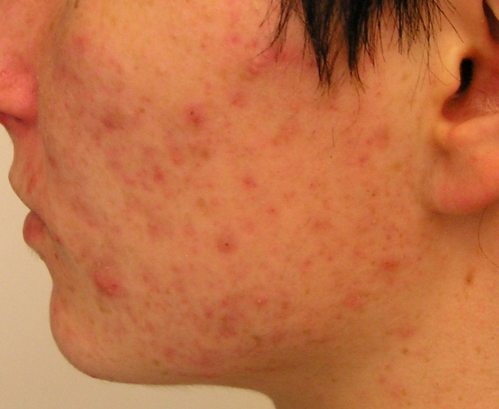 | 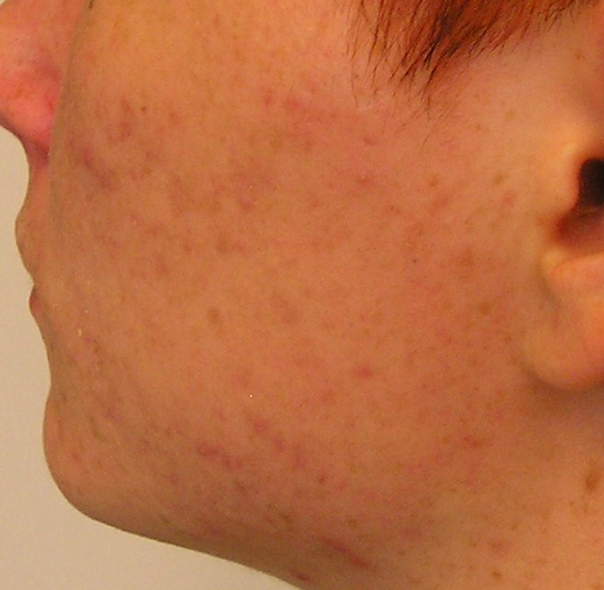
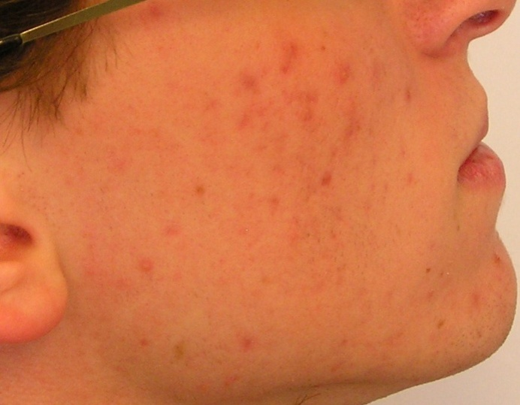 | 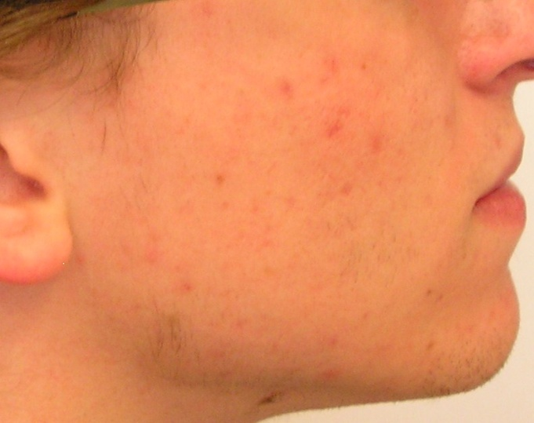

Conclusion
During Ecnaclyn application, the number of comedones and papulopustules in the acne patients statistically significantly decreased as early as after 3 weeks and after 8-week use it further statistically significantly dropped. According to their evaluations, 80% of the patients were very satisfied with the product.

Ecnaclyn has been checked by the Swedish Medical Agency.
More informations in Swedish are available at www.ecnaclyn.se.

References:
- Rulcova J., Heinrich J., Paliková I.: [The results of the clinical study of Acneon (lactoferrin) in patients with acne vulgaris.] Dermatol. praxi 2010; 4(4): 202-204.
- Aktan, S. Ozmen, E., Berna, S. (2000). Anxiety, depression, and nature of acne vulgaris in adolescents. Int. J. Derm. 39 (5). 354-357.
THE PUBLICATION REPRESENTS A SUMMARY ARTICLE ON ACNE, EXISTING TREATMENT MODALITIES AND INFLUENCE OF SOME FACTORS ON ACNE DEVELOPMEMT IN ADOLESCENTS.

- Acne Percentage: AHRQ Evidence Reports, Management of Acne Volume 1 2001
REPORTS FROM ACNE STATISTICS

4. (2004, December). TRU projects teens will spend $169 billion in 2004. www.teenresearch.com
REPORT FROM THE ORGANIZATION FOCUSED ON MARKETING TARGETED AT THE YOUNG PEOPLE, STATISTICS OF CONSUMERS' EXPENDITURES

5. Caccavo, D., N. M. Pellegrino, M. Altamura, A. Rigon, L. Amati, A. Amoroso, and E. Jirillo. 2002. Antimicrobial and immunoregulatory functions of lactoferrin and its potential therapeutic application. J Endotoxin Res 8:403-17.
REVIEW ARTICLE ON LACTOFERRIN, ITS ANTIMICROBIAL AND IMMUNOMODULATORY PROPERTIES AND ITS USE IN THE TREATMENT

6. Valenti, P., F. Berlutti, M. P. Conte, C. Longhi, and L. Seganti. 2004. Lactoferrin functions: current status and perspectives. J Clin Gastroenterol 38:S127-9.
REVIEW ARTICLE ON LACTOFERRIN, PRESENT STATE OF ITS USE AND ITS PERSPECTIVES

7. Yamaguchi, H., S. Abe, and N. Takakura. 2004. Potential usefulness of bovine lactoferrrin for adjunctive immunotherapy for mucosal Candida infections. Biometals 17:245-8.
A STUDY FOCUSED ON LACTOFERRIN FROM BOVINE MILK IN THE TREATMENT OF MUCOSAL INFECTIONS CAUSED BY CANDIDA YEAST

8. Farnaud, S., and R. W. Evans. 2003. Lactoferrin--a multifunctional protein with antimicrobial properties. Mol Immunol 40:395-405.
STUDY ON ANTIMICROBIAL EFFECTS OF LACTOFERRIN

9.Teraguchi, S., H. Wakabayashi, H. Kuwata, K. Yamauchi, and Y. Tamura. 2004. Protection against infections by oral lactoferrin: evaluation in animal models. Biometals 17:231-4.
EVALUATION OF LACTOFERRIN ACTIONS IN ANIMAL MODELS - PROTECTION AGAINST INFECTIONS BY ORAL LACTOFERRIN

10.Ward, P. P., and O. M. Conneely. 2004. Lactoferrin: role in iron homeostasis and host defense against microbial infection. Biometals 17:203-8.
LACTOFERRIN AND ITS ROLE IN REGULATION OF FREE IRON AND PROTECTION AGAINST BACTERIAL INFECTIONS

11. Brock, J. 1995. Lactoferrin: a multifunctional immunoregulatory protein? Immunol Today 16:417-9.
SUMMARY ARTICLE ON IMMUNOREGULATORY FUNCTIONS OF LACTOFERRIN

12.Cumberbatch, M., M. Bhushan, R. J. Dearman, I. Kimber, and C. E. Griffiths. 2003. IL-1beta-induced Langerhans’ cell migration and TNF-alpha production in human skin: regulation by lactoferrin. Clin Exp Immunol 132:352-9.
REGULATION OF ANTIINFLAMMATORY FACTORS IN HUMAN SKIN USING LACTOFERRIN - THIS STUDY DIRECTLY CONFIRMS THE EFFECT OF LACTOFERRIN IN THE SKIN AND THUS PRESENTS ONE OF THE MECHANISMS TO POSITIVELY INFLUENCE THE CONDITION OF THE SKIN IN ACNE

13. Kimber, I., M. Cumberbatch, R. J. Dearman, D. R. Headon, M. Bhushan, and C. E. Griffiths. 2002. Lactoferrin: influences on Langerhans cells, epidermal cytokines, and cutaneous inflammation. Biochem Cell Biol 80:103-7.
EFFECT OF LACTOFERRIN ON VARIOUS IMMUNOMODULATORY FACTORS IN THE SKIN

14. Chiba, K., K. Yoshizawa, I. Makino, K. Kawakami, and M. Onoue. 2000. Comedogenicity of squalene monohydroperoxide in the skin after topical application. J Toxicol Sci 25:77-83.
INFLUENCE OF OXIDATION PRODUCTS OF SQUALENE ON ACNE DEVELOPMENT (LACTOFERRIN REDUCES SQUALENE OXIDATION)

15.Downing, D. T., M. E. Stewart, P. W. Wertz, S. W. Colton, W. Abraham, and J. S. Strauss. 1987. Skin lipids: an update. J Invest Dermatol 88:2s-6s.
REVIEW ARTICLE GENERALLY ABOUT THE FUNCTION OF VARIOUS LIPID COMPOUNDS IN THE SKIN

16.Saint-Leger, D., A. Bague, E. Cohen, and M. Chivot. 1986. A possible role for squalene in the pathogenesis of acne. I. In vitro study of squalene oxidation. Br J Dermatol 114:535-42.
SQUALENE OXIDATION AND ITS POSSIBLE ROLE IN ACNE DEVELOPMENT - IN VITRO STUDY

17. Saint-Leger, D., A. Bague, E. Lefebvre, E. Cohen, and M. Chivot. 1986. A possible role for squalene in the pathogenesis of acne. II. In vivo study of squalene oxides in skin surface and intra-comedonal lipids of acne patients. Br J Dermatol 114:543-52.
OXIDATION PRODUCTS OF SQUALENE IN SKIN SURFACE AND INTRA-COMEDONAL LIPIDS IN ACNE PATIENTS

18. Product webpages: www.ecnaclyn.se

