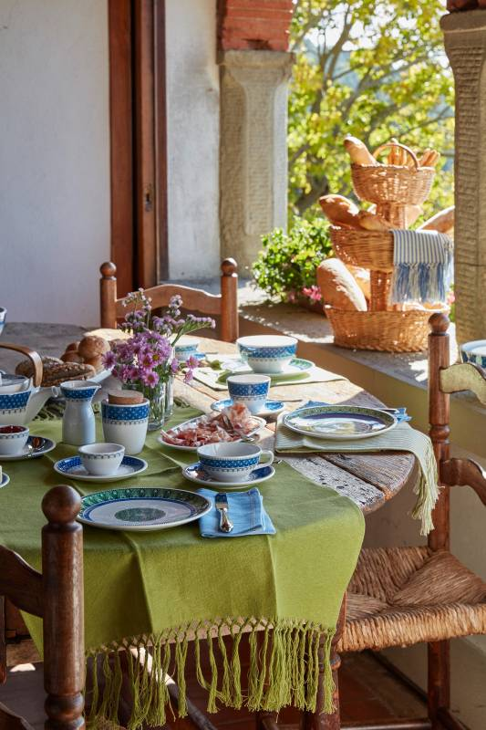
Press images for download

Traditional ceramic art has never been more modern – Casale Blu: the new décor on Artesano Original

The new Casale Blu collection from Villeroy & Boch is a good example of how contemporary a century-old design template can be. It's simple when you know how. The new décor on the successful design of Artesano Original takes lovers of a contemporary country look to southern Europe, to be precise to Italy. Here, in the Umbrian town of Deruta, traditional hand-painted ceramics have been produced since the Middle Ages. The brilliant blue tone of Casale Blu creatively echoes the famous art nouveau majolicas from Villeroy & Boch but is also absolutely on-trend, picking up on the penchant for strong blue recently found in product and fashion design.

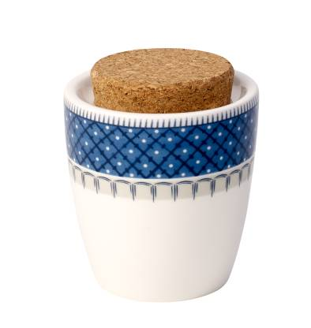
Delicate details and selected colour compositions
The Casale Blu décor is based on hand-painted patterns that have been reproduced using modern lithographic techniques. The impression of hand-painting underscores the particular charm of the series, which is further complemented by the colour composition. The basic design is dominated by the colours blue, white and a delicate green, giving all the individual pieces a fresh Mediterranean flair. In addition to this blue décor, four additional décors have been applied to three selected articles: breakfast plates, bowls and handled mugs are available in the décors Alda, Bella, Carla and Dorina, also displaying elegant tones of green. The four additional décors can be combined with the basic design to conjure up individual accentuations, while the pure white porcelain of Artesano Original provides an opportunity to tone down the colours on the table.

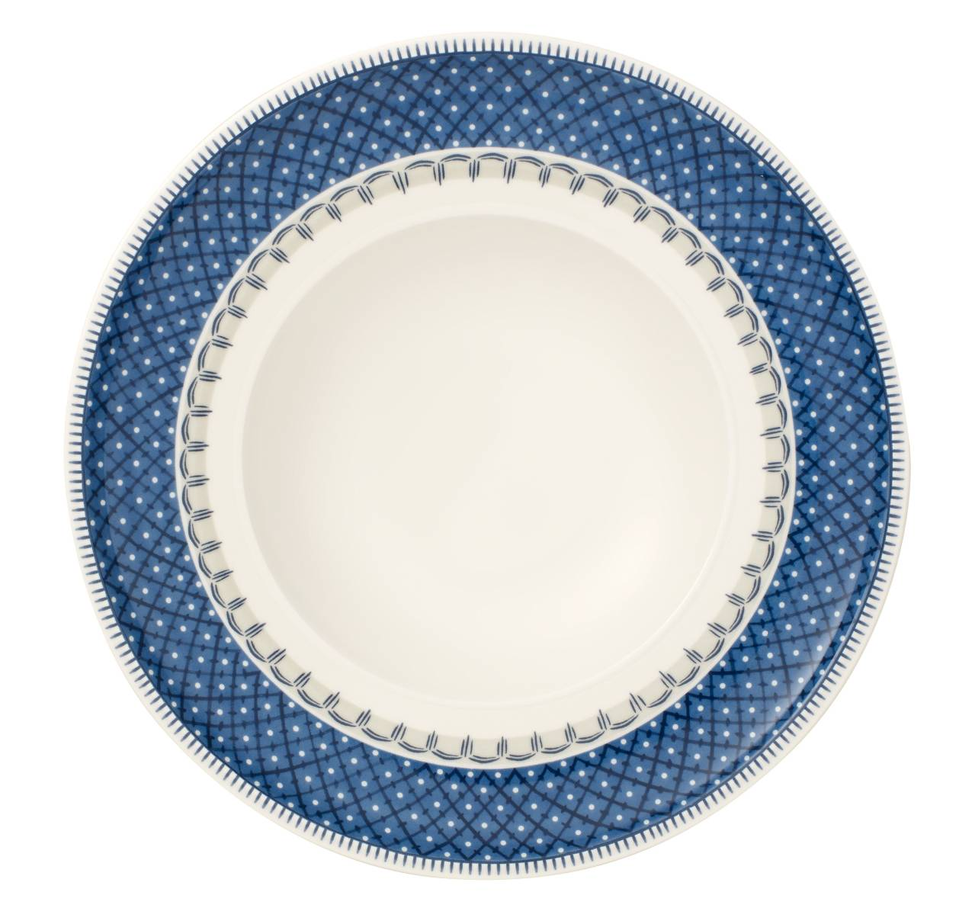
Artesano Original: further developing the original
The distinguishing design characteristic of Villeroy & Boch's well-loved Artesano Original collection is its distinctive flat rim. Artesano Original thus unites an exacting design language with perfect craftsmanship to create a flexible, multifunctional collection for everyday use. The material mix of ceramic, acacia wood and cork breathes life into Artesano Original, lending the collection a unique tension and complementing the great craftsmanship of the concept.
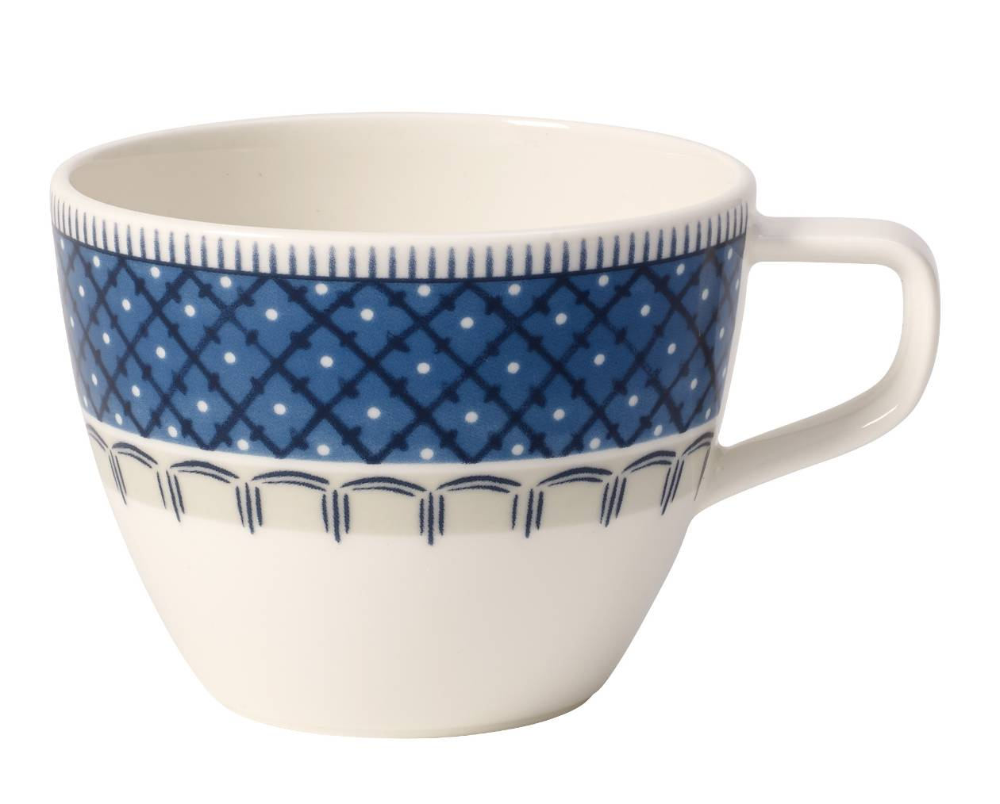
Product information:
- Premium Porcelain
- decorated using lithographic techniques
- dishwasher safe

Price information – examples:

Product (article no) Price
Flat (2620) 219 NOK
Deep (2700) 219 NOK
Side (2640) 199 NOK
Mug (9651) 179 NOK
Cup & Saucer (1290) 239 NOK
Bowl (1900) 199 NOK

For further information please contact Rebecca Duvemyr
PR & Communication Manager Nordics
Tel.: +46 (0) 76-135 83 62
Mail: rebecca.duvemyr@gustavsberg.com

Villeroy & Boch
Villeroy & Boch is one of the world's leading premium brands for ceramic products. The family business, which was founded in 1748 and is headquartered in Mettlach/Germany, stands for innovation, tradition and exceptional style. As a renowned lifestyle brand, Villeroy & Boch offers products from the sectors Bathroom and Wellness and Tableware, and is active in 125 countries.

