Hold your breath… and jump into a new Exodus adventure
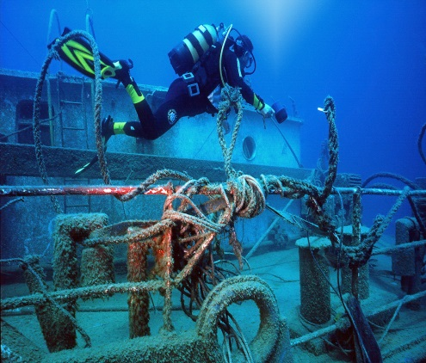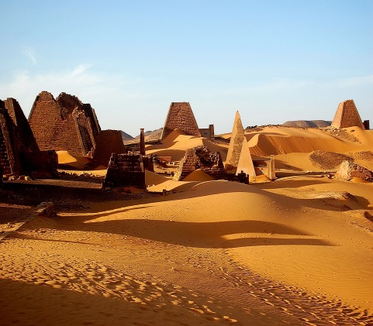
Exodus launches new 2015 ‘Discovery and Adventure’ holidays to Sudan, Haiti and the iconic Silk Road
London, XX November 2014: Those looking for an exciting adventure come 2015 won’t be left disappointed by Exodus’ new range of trips. Discovery and adventure are two words that are synonymous with Exodus who, as the UK’s leading adventure tour operator, is introducing some fantastic new and esoteric trips next year to countries such as Sudan, South Korea and Haiti. In total, the 17 new trips showcase incredible variety to a fantastic breadth of destinations that also include Thailand, Burma, Uzbekistan, Kyrgyzstan and Kashgar.
This selection of trips reveals Exodus is at the forefront of adventure travel to off-the-beaten-track destinations, yet to be discovered by mass tourism. Exodus is also expanding its South East Asia product following increasing demand for the destination, with Burma and Vietnam proving especially popular throughout 2014.
Other locations that continue to thrive are Cuba, where guests can experience the country through its food, landscape and salsa, and Jordan where experiences include Bedouin camping in the desert and visiting Petra at night. Globally, Exodus continues to provide excellent product delivery reflected by the fact that 96% of its clients say they would recommend Exodus to their friends.
New trips for 2015 include:
Sudan Desert Explorer – Lose yourself in the vast and beautiful Sahara
Travelling in four wheel drive vehicles, head out into the vastness that is the Sahara where the desert meets the horizon and the sand dunes melt away. As guests cross the desert towards the Nile, Sudan’s lifeblood, they explore the changing face of the desert as well as wandering through ancient Egyptian temples and necropolises, all the while meeting some of the most hospitable people on the planet. Spend time with Nubian villagers in Tombos and meet a nomadic Bisharin family. Become an explorer of old with this adventure in a country that boasts more pyramids than Egypt and where the Blue Nile meets the White Nile. This is a 13 day, adult group trip (min. age 18 years). Prices start from £2,999pp including flights, accommodation (8 nights wild camping), all breakfasts, 11 lunches and 10 dinners. First departure is 13 April 2015.
The Silk Road – Travel the trade route and learn about its fascinating history
This new trip from Exodus is packed full of intrigue and adventure. Covering the most impressive section of this iconic route in two weeks, guests travel through three countries and a kaleidoscope of cultural highlights and landscapes. Follow in the footsteps of merchants, soldiers and pilgrims, and explore the trade routes that connected the great civilisations of the East and West. Visit the ancient towns of Samarkand and Bukhara as well as the remarkable Tien Shan Mountains before heading to Kashgar’s famous Sunday bazaar. This is a 15 day, group trip (min. age 16 years). Prices start from £2,159pp including flights, accommodation, fourteen breakfasts, one lunch and five dinners. First departure is 2 May 2015.
Highlights of South Korea – A dynamic country steeped in history, culture and tradition
South Korea is a country that has a long and vibrant history, rich in culture and tradition. Yet it has also embraced modernity in its own unique way. Visiting the capital Seoul, contrasts starkly with a night spent in an ancient temple, where guests can take part in a traditional Buddhist ceremony. Guests will also visit Jeju Island and all its natural wonders and, sample South Korea’s incredible cuisine that makes this a truly unforgettable trip. This is a 15 day, group trip (min. age 16 years). Prices start from £3,049pp including flights, accommodation, all breakfasts, all transport and listed activities and a tour leader throughout. First departure is 4 April 2015.
Turkey Diving Week – Discover the underwater world of the Turquoise Coast
The base for this week of underwater exploration is Kaş, a laid back but lively town on the Turquoise Coast. Open to all skill levels, clients can earn a PADI Open Water Diver certification as a beginner or, for already certified divers, there is a ten dive package as well as the Advanced Open Water Diver certification. The warm and serene waters of the Turkish Mediterranean are perfect for diving, plus, while ashore there are a multitude of optional activities, including paragliding, canyoning, and mountain biking or for more water fun, sea-kayaking. This is an 8 day, group trip (min. age 16 years). Prices start from £999pp including flights, accommodation, all breakfasts, all transport, listed activities and all dive equipment hire. First departure is 22 June 2015.
Thailand and Burma Discoverer – Experience the magical temples and palaces of these two striking countries
Beat the Burma crowds and visit the remote south of the country as well as Bagan. Taking advantage of a newly opened border crossing between the two countries, there is an excursion to the Bridge on the River Kwai and Hellfire Pass, two important WWII sites. Guests can also explore Bangkok by boat along its network of canals and waterways, and experience the capital of Burma, Rangoon, with its colourful markets and tea shops. This is an 18 day, group trip (min. age 16 years). Prices start from £2,599pp including flights, accommodation, 15 breakfasts, all transport and listed activities and a tour leader throughout. First departure is 5 March 2015.
Ardeche Mixed Activity Week – A variety of adventures amongst spectacular surroundings
The Ardeche region of France is ideal for a multi-activity trip with a spectacular mix of mountains, plateaux and valleys, and of course the 125 mile long river from which it takes its name. Guests will stay in the mediaeval town of Joyeuse heading out to a variety of locations each day. Activities include a challenging high ropes course in the treetops, a cycle through dramatic scenery and, a two day kayak on the Ardeche taking in the immense Pont D’Arc, a 30 metre high natural arch. It’s not all physical though as there is fantastic food to enjoy, this being France after all, and a wine tour. This is an 8 day, group trip (min. age 12 years). Prices start from £1,249pp including flights, accommodation, all breakfasts, all transport and listed activities and a tour leader throughout. First departure is 23 May 2015.
Haiti Revealed - Discover the most culturally rich country in the Caribbean before anyone else
A destination that is ideal for intrepid travellers. Haiti has a fascinating history that includes slave rebellion and Vodou traditions as well as inebriating music and art related to their strong West African roots. Guests on this tour will journey back in time while climbing the mountaintop UNESCO fortress Citadelle Laferrière, explore pristine nature in the mountain peaks of Kenscoff and swim in the cool turquoise waters of Bassin Bleu. This comprehensive itinerary also offers unusual experiences such as taking part in a Vodou ceremony, staying at the heritage Hotel Oloffson and enjoying a night of live music with the local crowd. This is a 12 day, group trip (min. age 16 years). Prices start from £2,399pp including flights, accommodation, transport, all breakfasts, eight lunches and three dinners. First departure is 25 January 2015.
-ENDS-
For more information or to book please visit www.exodus.co.uk or call 0845 863 9601.
Press Information
For more information or to discuss a trip, please contact Arthur Duncan, Carolyn van Vliet, Sara Whines or Natalie Amos at Four bgb on 0203 697 4200. Email: exodus@fourcommunications.com
About Exodus
Celebrating its 40th year, leading adventure tour operator Exodus has a vast range of adventure and activity holidays across seven continents, offering places as diverse and as exhilarating as Kilimanjaro, Machu Picchu, the Ice Hotel and Antarctica.
Whether it is solo travellers, couples, groups or families, Exodus offers an incredible choice of different trips for all ages.
Operating in 90 countries with over 450 tours, Exodus insists on low impact tourism and increasingly looks to bring benefit to local communities.
Activities on offer include walking, trekking, cycling, mountain biking, rafting, kayaking, caving, cross-country skiing, snowshoeing and dogsledding as well as many many more…
Do you have an iPhone, iPad or iPod touch? Then download the new Exodus App for free from iTunes or from the App Store.

