The number of girls on the move at a record high - Pippi Longstocking supports vulnerable but courageous group

This year marks the 75th anniversary of the first published book about Pippi Longstocking. To commemorate this jubilee, The Astrid Lindgren Company and Save the Children are launching the global campaign “Pippi of Today”, a collaboration to create awareness and raise money for Save the Children’s work for girls on the move.

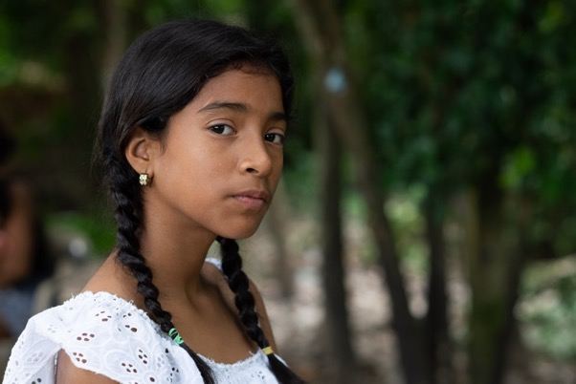
Many companies from all around the world are joining in on the international campaign “Pippi of Today”, which takes place in the Nordics, USA, UK, Germany, France, Spain, Italy, Netherlands and Switzerland among other places. Through limited edition products, events and other initiatives, they are participating to raise money. The money raised during the “Pippi of Today”-campaign will go to Save the Children and support girls on the move.
Image: Luisa*, 12 years from Venezuela. Photograph: Mats Lignell

Olle Nyman, CEO at Astrid Lindgren AB as well as Astrid Lindgren’s grandson, said: “In a world with ever stronger currents of nationalism and xenophobia, we want to highlight our shared responsibility for all children in demonstrating their strength and potential. With the help of Pippi, we want to support the girls who need it most, while also making their voices heard. Save the Children's activities aim to support them, while Pippi serves as an inspiring role model that gives them strength and hope”.

75 years ago, the world’s strongest girl – Pippi Longstocking – came alone to a new town. Today millions of girls are being forced to leave their homes and move, not only to new cities but also to new countries. Girls on the move need to gather all their strength, courage and hope to tackle challenges and find their way to a brighter future. They are the Pippis of Today.

More girls on the move than in a long time
The number of girls on the move has not been this high since the end of the Second World War. Girls comprise an especially vulnerable group among refugees, with unique challenges that are often times forgotten. Girls on the move face a greater risk of being exposed to violence and exploitation, such as sexual abuse and child marriage, in most cases their education is also put on hold.

To shed light on their experiences, Save the Children have interviewed 13 girls who all are on the move. In the interviews, they share what they are going through, what their lives are like now and what they hope for in the future. One of the girls is 12 year old Luisa* one of millions of people who have come from Venezuela to Colombia, because of lack of food, economic hardship and increasing violence in their home country.

Luisa said: “I was sad leaving Venezuela, because I knew I would miss my relatives a lot. But I was also happy, because I was going to see my mum again. We had a big big big hug when I first saw her”.
Inger Ashing, CEO at Save the Children International, said: “Children's rights know no borders. All children should have the same rights, no matter who they are or where they live. Save the Children is excited to partner with the Astrid Lindgren Company to help expand our work for girls on the move. In 2019, we interviewed girls from around the world who are on the move to better understand their experiences and how we can best reach them with the right efforts. However, we still lack sufficient data and knowledge in this area. With the funds raised, we will be able to help fill these knowledge gaps and expand our work, so that every girl survives, learns and is protected.”

*Names have been changed.

Read more about Pippi of Today: www.pippioftoday.com

Facts about girls on the move
More than 70 million people were on the move during 2018, an increase of 2.3 million in comparison with the year before. Over half of them, 53%, are children under 18 years of age. 138 600 children are expected to be completely alone and separated from their parents. Girls are especially exposed without access to safe places, migration paths or support. Sources: UNHCR, Save the Children

Companies participating in the initiative for girls on the move (so far)

Amazon | Gyldendal A/S | Oxford University Press
Apoteket | Happy Socks | Ploegsma
Astrid Lindgrens Värld | Hjelm förlag | Primus
Biscuiteers | Houdini Sportswear | Rabén & Sjögren
Cappelen Damm | Kavat | Rubinstein
Copyrights Asia Ltd. | Kneipbyn | Salani
CPLG Germany | Kókinos | SF Studios
Design House Stockholm | Krabat | Sjöö Sandström
Egmont | Mall of Scandinavia | SMC Korea
Euromic A/S | Maria Nilsdotter | Storytel
Filmstaden | Martinex | Universal Music
Garnelis | Micki | Verlagsgruppe Oetinger
GB Glace | Muurla | WSOY
Grenna Polkagriskokeri | Mynthuset | Åhléns

For more information, please contact:
Cilla Nergårdh, Head of Communications, The Astrid Lindgren Company
cilla.nergardh@astridlindgren.se
+46 (0) 70 938 46 52

Anne Thörngren, Press Manager, Save the Children
anne.thorngren@rb.se
+46 (0) 72-357 67 56

About The Astrid Lindgren Company
The act of Astrid Lindgren is unique and meaningful. She was a convinced humanist. She fought for children’s rights, for equality and for animal’s rights. She stood up for her opinions with civil courage and seriousness as well as humor and love. However, it is as author of children’s books that Astrid Lindgren has made herself famous around the world. The Astrid Lindgren Company is owned by Astrid Lindgren’s children and grandchildren. The business is built on a love for Astrid Lindgren, her involvements and her life works.

About Save the Children
Save the Children is a global children’s rights foundation that has existed since 1919. We fight for children’s right to survive, develop and grow up in safety and we are active in over 120 countries, including Sweden. We are politically and religiously unbound and have the UN’s Convention on the Rights of the Child, UNCRC, as the foundation of all our work.

