LuerJack in Norway - ConceptoMed AS and Vingmed AS signed a marketing, sales and distribution agreement for the hospital market
ConceptoMed AS is delighted to announce a new partner for the Norwegian hospital market.
We have entered into a distribution agreement with Vingmed AS granting exclusive rights for marketing, sales and distribution of the LuerJack syringes in the hospital market in Norway.
The Vingmed Group is a Norwegian based medical company with distribution and services of high quality medical technical products. They strive to have integrated product programs in the Nordic countries, however each company acts independently within its marketplace.
In Norway, Vingmed AS focuses its business within the fields of cardiology, radiology, endoscopy, dialysis, intensive care, anaesthesia, general-, vascular and thoracic surgery. The product range is evaluated with respect to high quality and competitiveness. When choosing suppliers, fast and reliable capacity of delivery and a high level of innovation and continuity are factors of great importance. In addition to our high demands on the products that we represent, we aim to employ the best talents in the market and guarantee confident relations with our customers said Petter Solum, M.D., CEO of Vingmed AS. suppliers.

Visit: http://vingmed-as.no/

This distribution agreement strengthens ConceptoMed’s strategy to become strong in the home market, Norway, offering an alternative to the conventional medical syringe market worldwide.

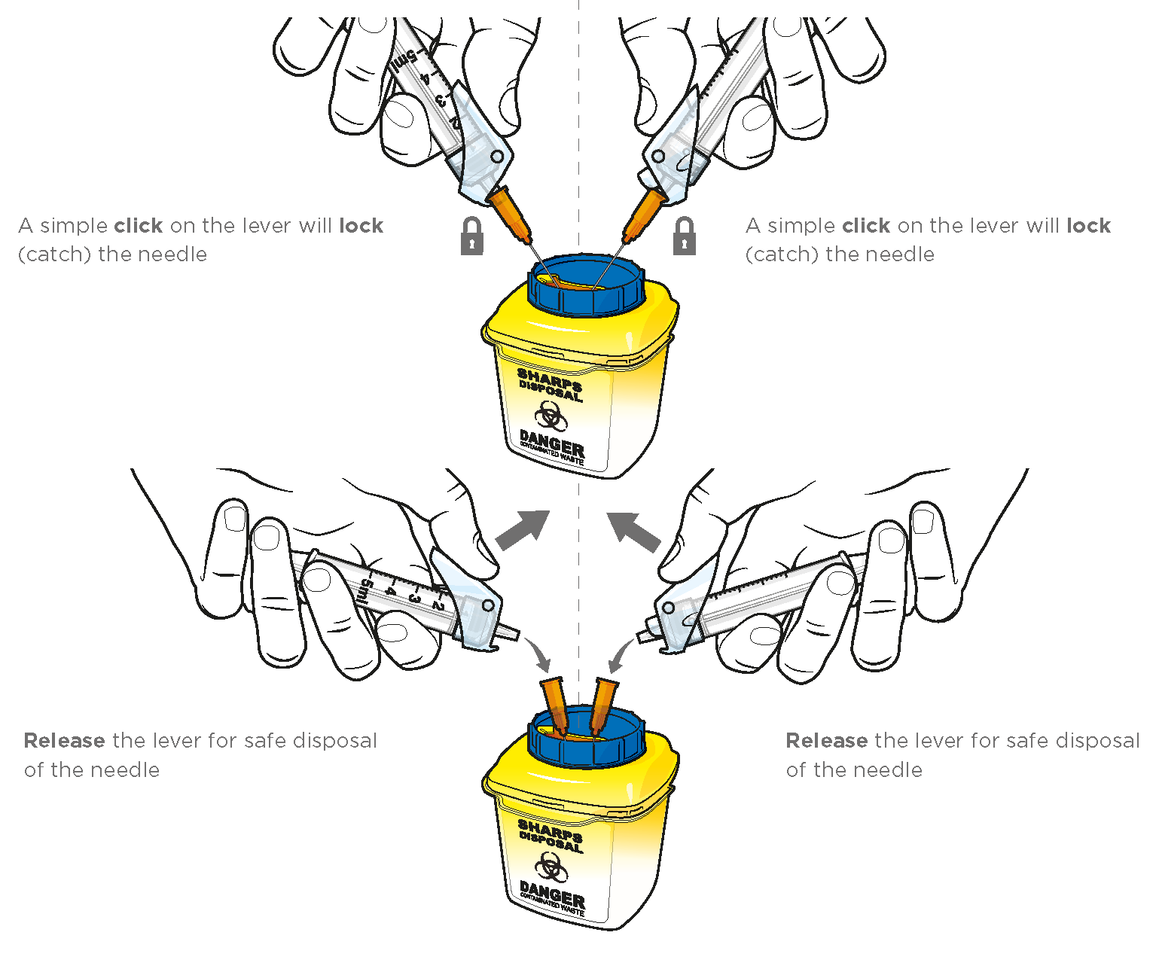
Despite the increased focus on infection control, healthcare acquired injection related infections are still an important issue. The one-handed LuerJack system prevents accidental cross contamination, which is a real and challenge in safe healthcare delivery. The LuerJack syringe is the only syringe designed with a one-handed disconnection capability. Its integrated one-hand ’Click and Release’ function significantly reduces the risk of unintended human error. It enables a fast, safe and more efficient disconnection from the needle or any other medical attachments, and thereby reduces dramatically the risk of needlestick injuries.
Vingmed is the perfect sales, marketing and distribution partner for LuerJack in the Norwegian healthcare market. Their track record of introducing important medical innovations and integrated product programs to healthcare professionals in Norway is outstanding. The salesforce is used to solution selling and successful implementation of new products, as well as selling procedure packs, which is instrumental for LuerJack. “We really look forward to contribute to improving infection prevention and patient safety in our home market”, said Christian Mide, M.D., CEO and co-founder of ConceptoMed.

ConceptoMed AS is a ISO 13485 certified, ambitious medtech company serving the global market with innovative product categories and unique proprietary technology. We create smart medtech systems that empower healthcare professionals and improve patient care. Excellence through simplicity is our code. We are brave, curious and dedicated. We simply care.
Based in Norway, the team is continuously meeting milestones and expanding its activities for international growth.
For more information on the company and career opportunities, see www.conceptomed.com and www.luerjack.com
Follow us on MyNewsdesk and LinkedIn
Luer-Jack® is a registered trademark owned by ConceptoMed AS. The Luer-Jack® technology is widely patent protected throughout the world, currently with > 60 patents (granted and pending) from 8 patent families.
For further info: | Christian Mide, CEO  Petter Solum, CEO  Ann-Christine Jungmar, CCO | christian.mide@conceptomed.com  petter.solum@vingmed-as.no  ann-christine.jungmar@conceptomed.com |  | +47 95 100 720  +47 901 58 368  +46 708 71 46 76

