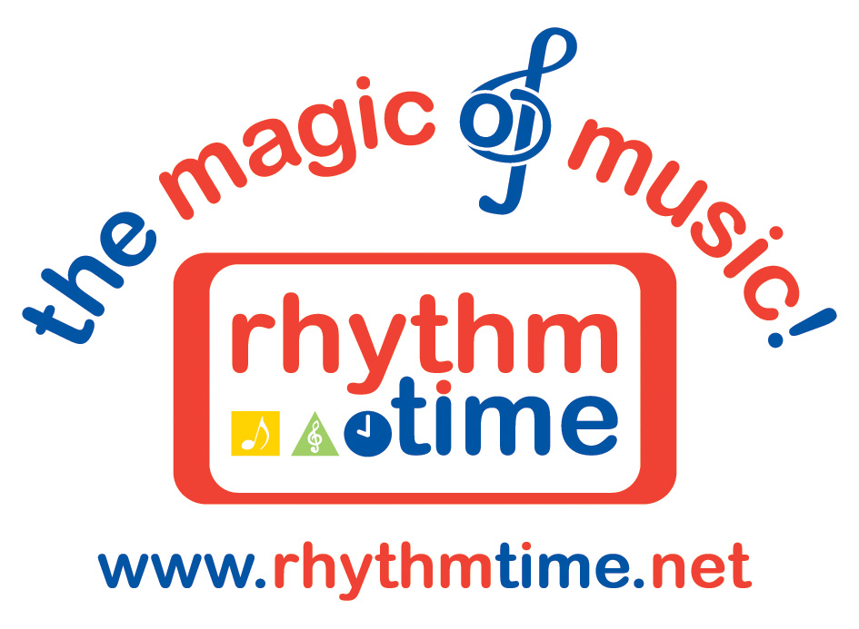P R E S S R E L E A S E
(MUSIC FRANCHISE)

7 March 2012

Rhythm Time Music Franchise Owner Celebrates 1st Birthday

Successful music franchise owner and teacher to babies and young children, Michelle O’Grady, is celebrating her first successful year as a Rhythm Time franchisee.

Last week, all of her babies, toddlers and pre-schoolers in her classes helped her to celebrate with special birthday songs, a cake sale and raffle.

Michelle, previously a teaching assistant for 15 years, set up her local Rhythm Time music franchise in the Tamworth and Sutton Coldfield area a year ago. In that time, the number of babies and young children enjoying her music classes has seen significant growth.

“It’s been a wonderful year meeting all the children and their parents,” she quotes. “It’s amazing to be able to see how music can help a child’s development, from babies right up until they start school. Many of them will go on to learn a musical instrument. I’m also very excited to be introducing additional music classes in Tamworth and Sutton Coldfield and expanding my team further,” she adds.

Rhythm Time’s unique set of music courses have been specifically written by Kathy Doolan (previously Head of Music at a Scottish school and graduate of the Royal Scottish Academy of Music & Drama). The courses have been created to help every child’s development and are aimed at different age groups, specifically: music classes for babies (from birth to 15 months), music classes for toddlers (15 months to 3 years), and music classes for pre-schoolers (3 – 5 years). Kathy is a strong advocate of music being crucial in helping to develop a child’s speech and language from an early age and this forms a key element in all the classes.

Parents are invited to enjoy a free trial session before they decide whether they would like to book up for further sessions.

Rhythm Time is an established company with franchises all over the UK. All of Rhythm Time’s franchisees share a passion for music and a love of working with children. Owning a Rhythm Time music franchise also enables them to enjoy a career that fits around their own family commitments.

Approximately 10,000 children currently attend Rhythm Time classes all over the country.

For a free trial at a Rhythm Time Toddler, Pre-school or Baby music class, or for more information on owning a Rhythm Time music franchise, call 0121 711 4224 or visit www.rhythmtime.net

Ends

Word Count 385

Contact: Sally Soane
Rhythm Time Marketing
0121 711 4224

Information For Editors

From a young age Michelle O’Grady has loved music. She attended Rhythm Time classes with her two children and found the experience highly enjoyable and rewarding.

After 15 years as a teaching assistant, she became a Rhythm Time teacher in 2008. She decided to combine her musical talents and her love of children by embarking on this new career which fits around her family commitments. Michelle bought her Rhythm Time franchise for the area in March 2011.

Rhythm Time was started in the Midlands in 1995 by Kathy Doolan who is a firm believer in the power and importance of music for babies, toddlers and pre-school children. Kathy is a graduate of the Royal Scottish Academy of Music and set up Rhythm Time after having her own children.

Rhythm Time now has franchises all over the UK, operating in 190 areas with approximately 10,000 children attending classes weekly.

Rhythm Time offers three age-appropriate classes for babies (birth to 15 months), toddlers (15 months to three years) and pre-school (three to school age). Children enjoy a wonderful introduction to music and all classes are in line with the Early Learning Goals and Key Stage 1.

Michelle is teaching baby, toddler and pre-school classes, Monday to Friday, across Tamworth and Sutton Coldfield.

