

Press Release
January 2017

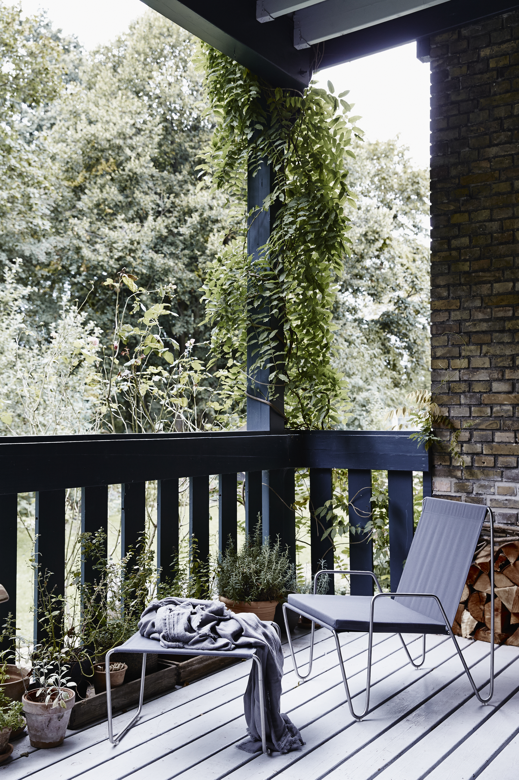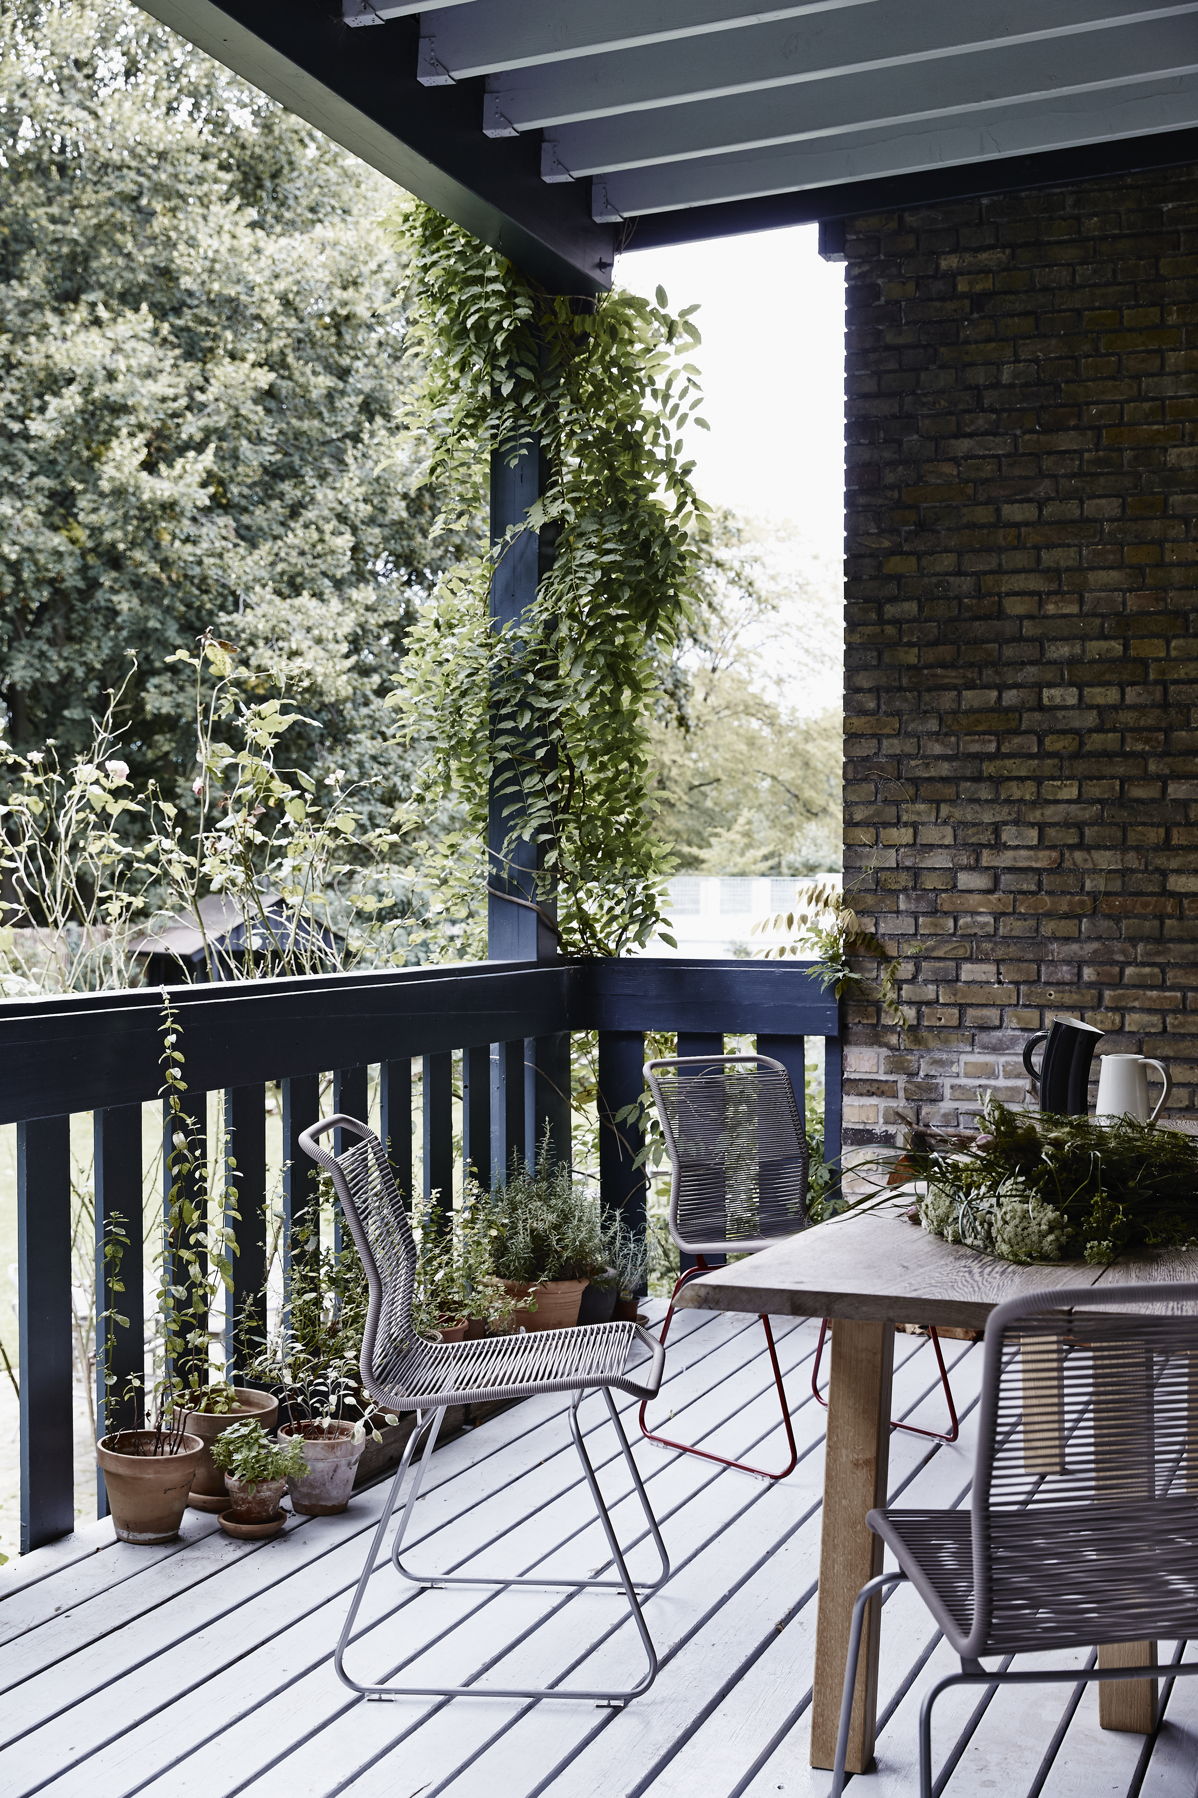

- PANTON SPRING BREAK -
Breaking boundaries was the DNA of Panton. He designed in new materials, created new shapes and challenged the entire colour universe in terms of furniture. This spring Panton is relevant again because he also designed furniture for both interior as well as exterior settings. Move outdoor when the spring season bursts into life with Panton evergreens: Panton Bachelor and Panton One.
Verner Panton One

Verner Panton designed the Panton One in 1955. The light chair in stainless steel can be used both indoors and outdoors. Panton One is available in 4 different heights; as a bar, kitchen, and lounge chair as well as the classic Panton One. The chairs are handwoven with strings of UV-protected polyurethane and a nylon core. The chair is available in 15 different colours. The leg frame is available in stainless steel or lacquered in: Black, Snow or Moulin Rouge. Chairs with lacquered legs are for indoor use only.

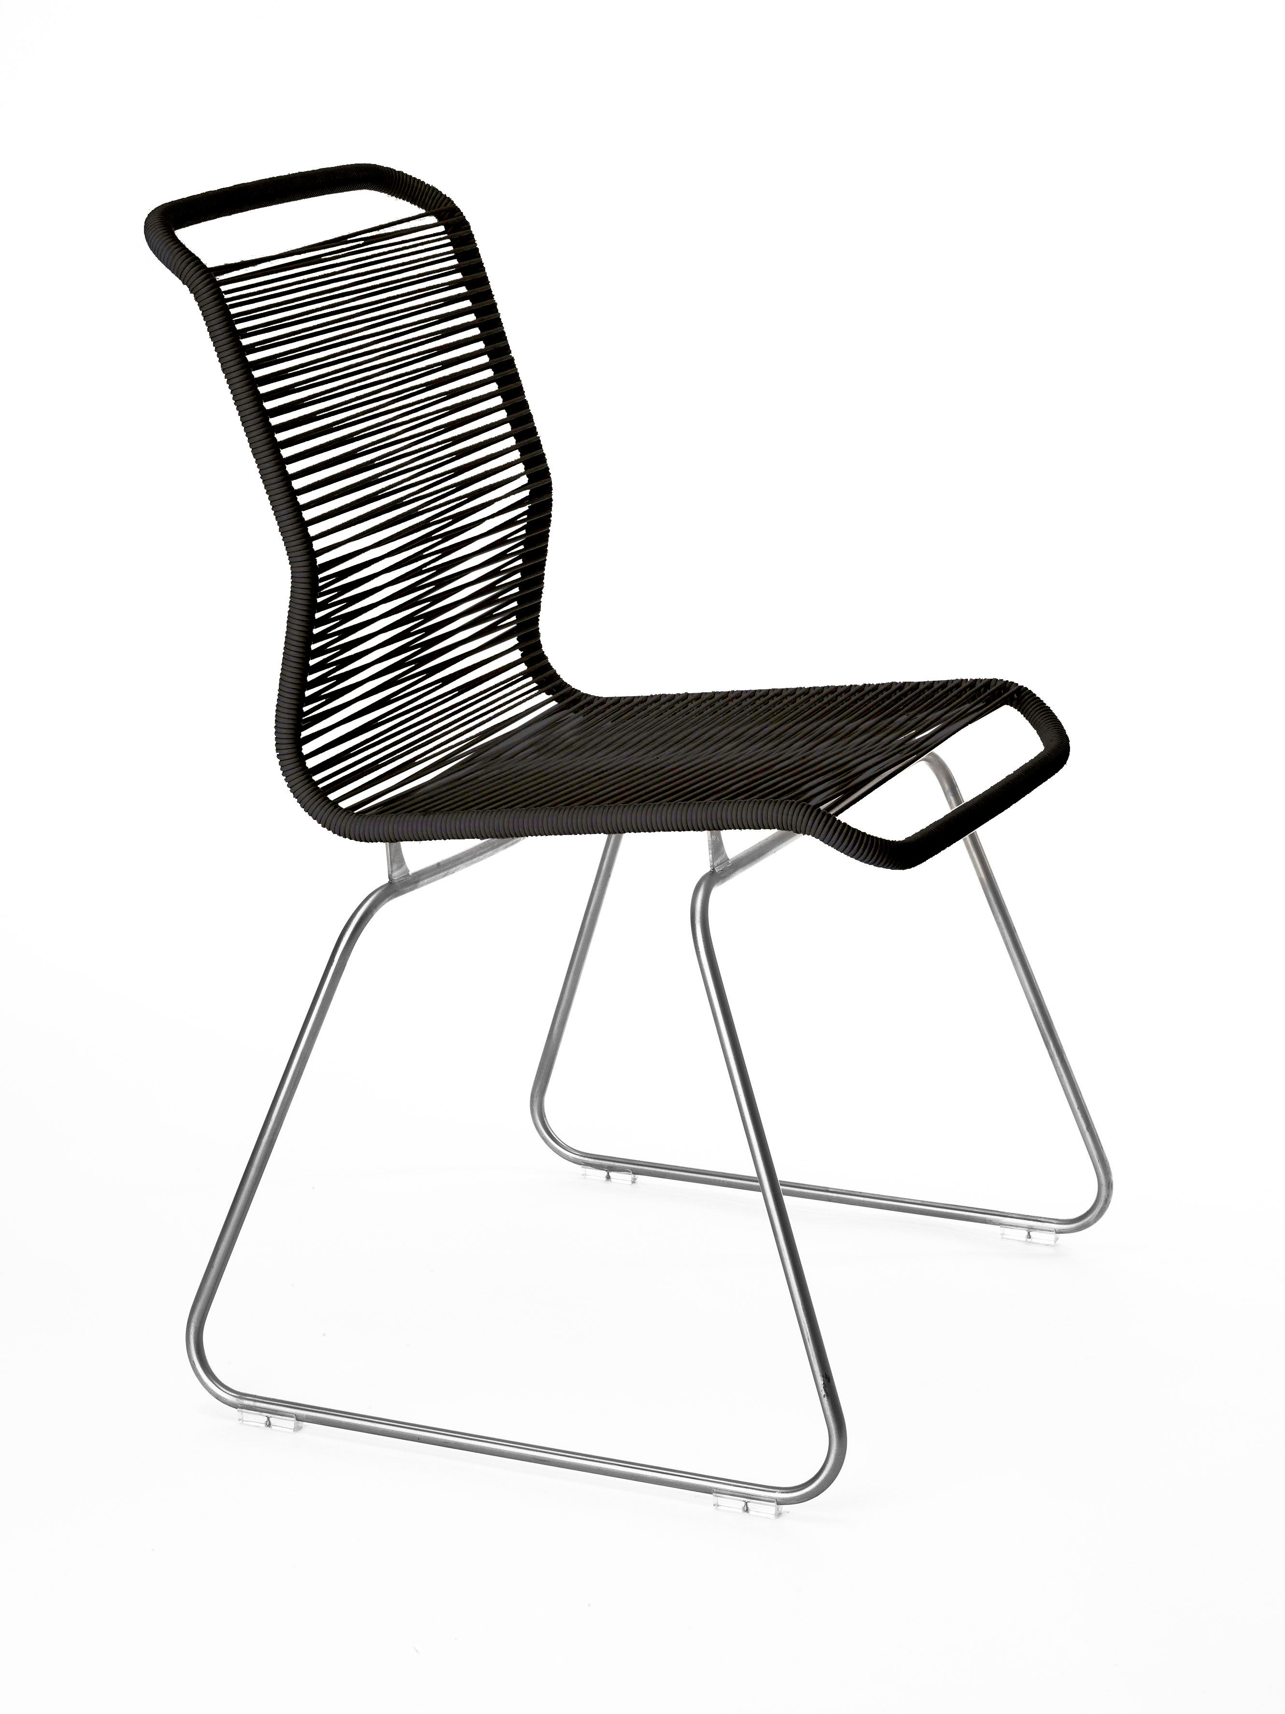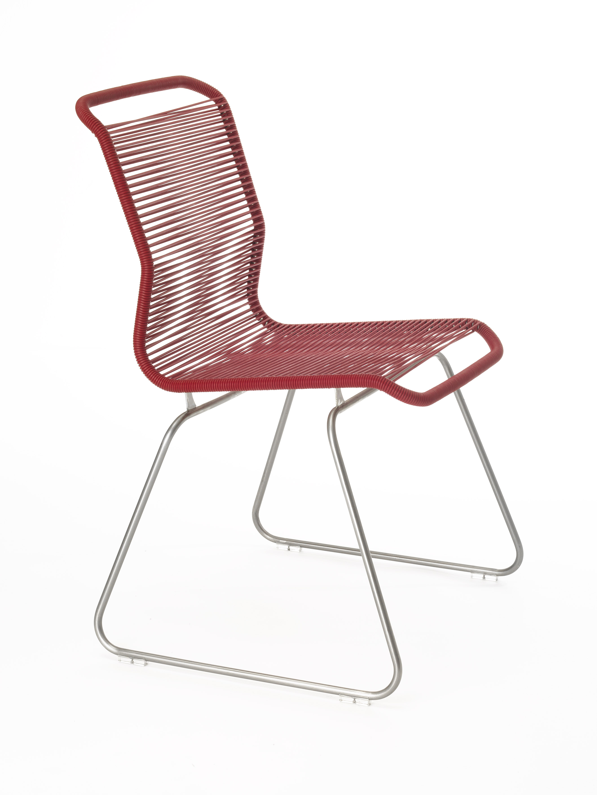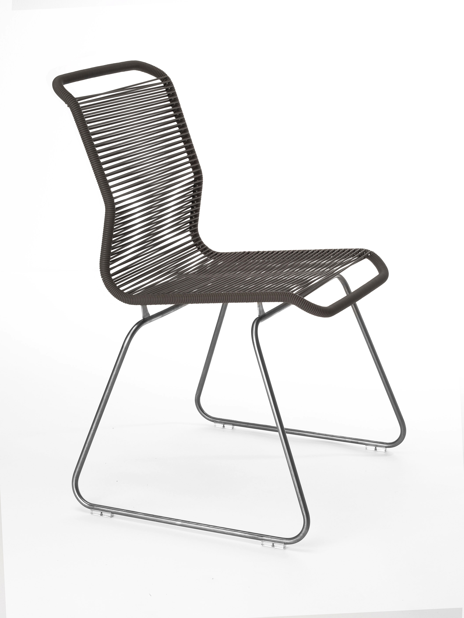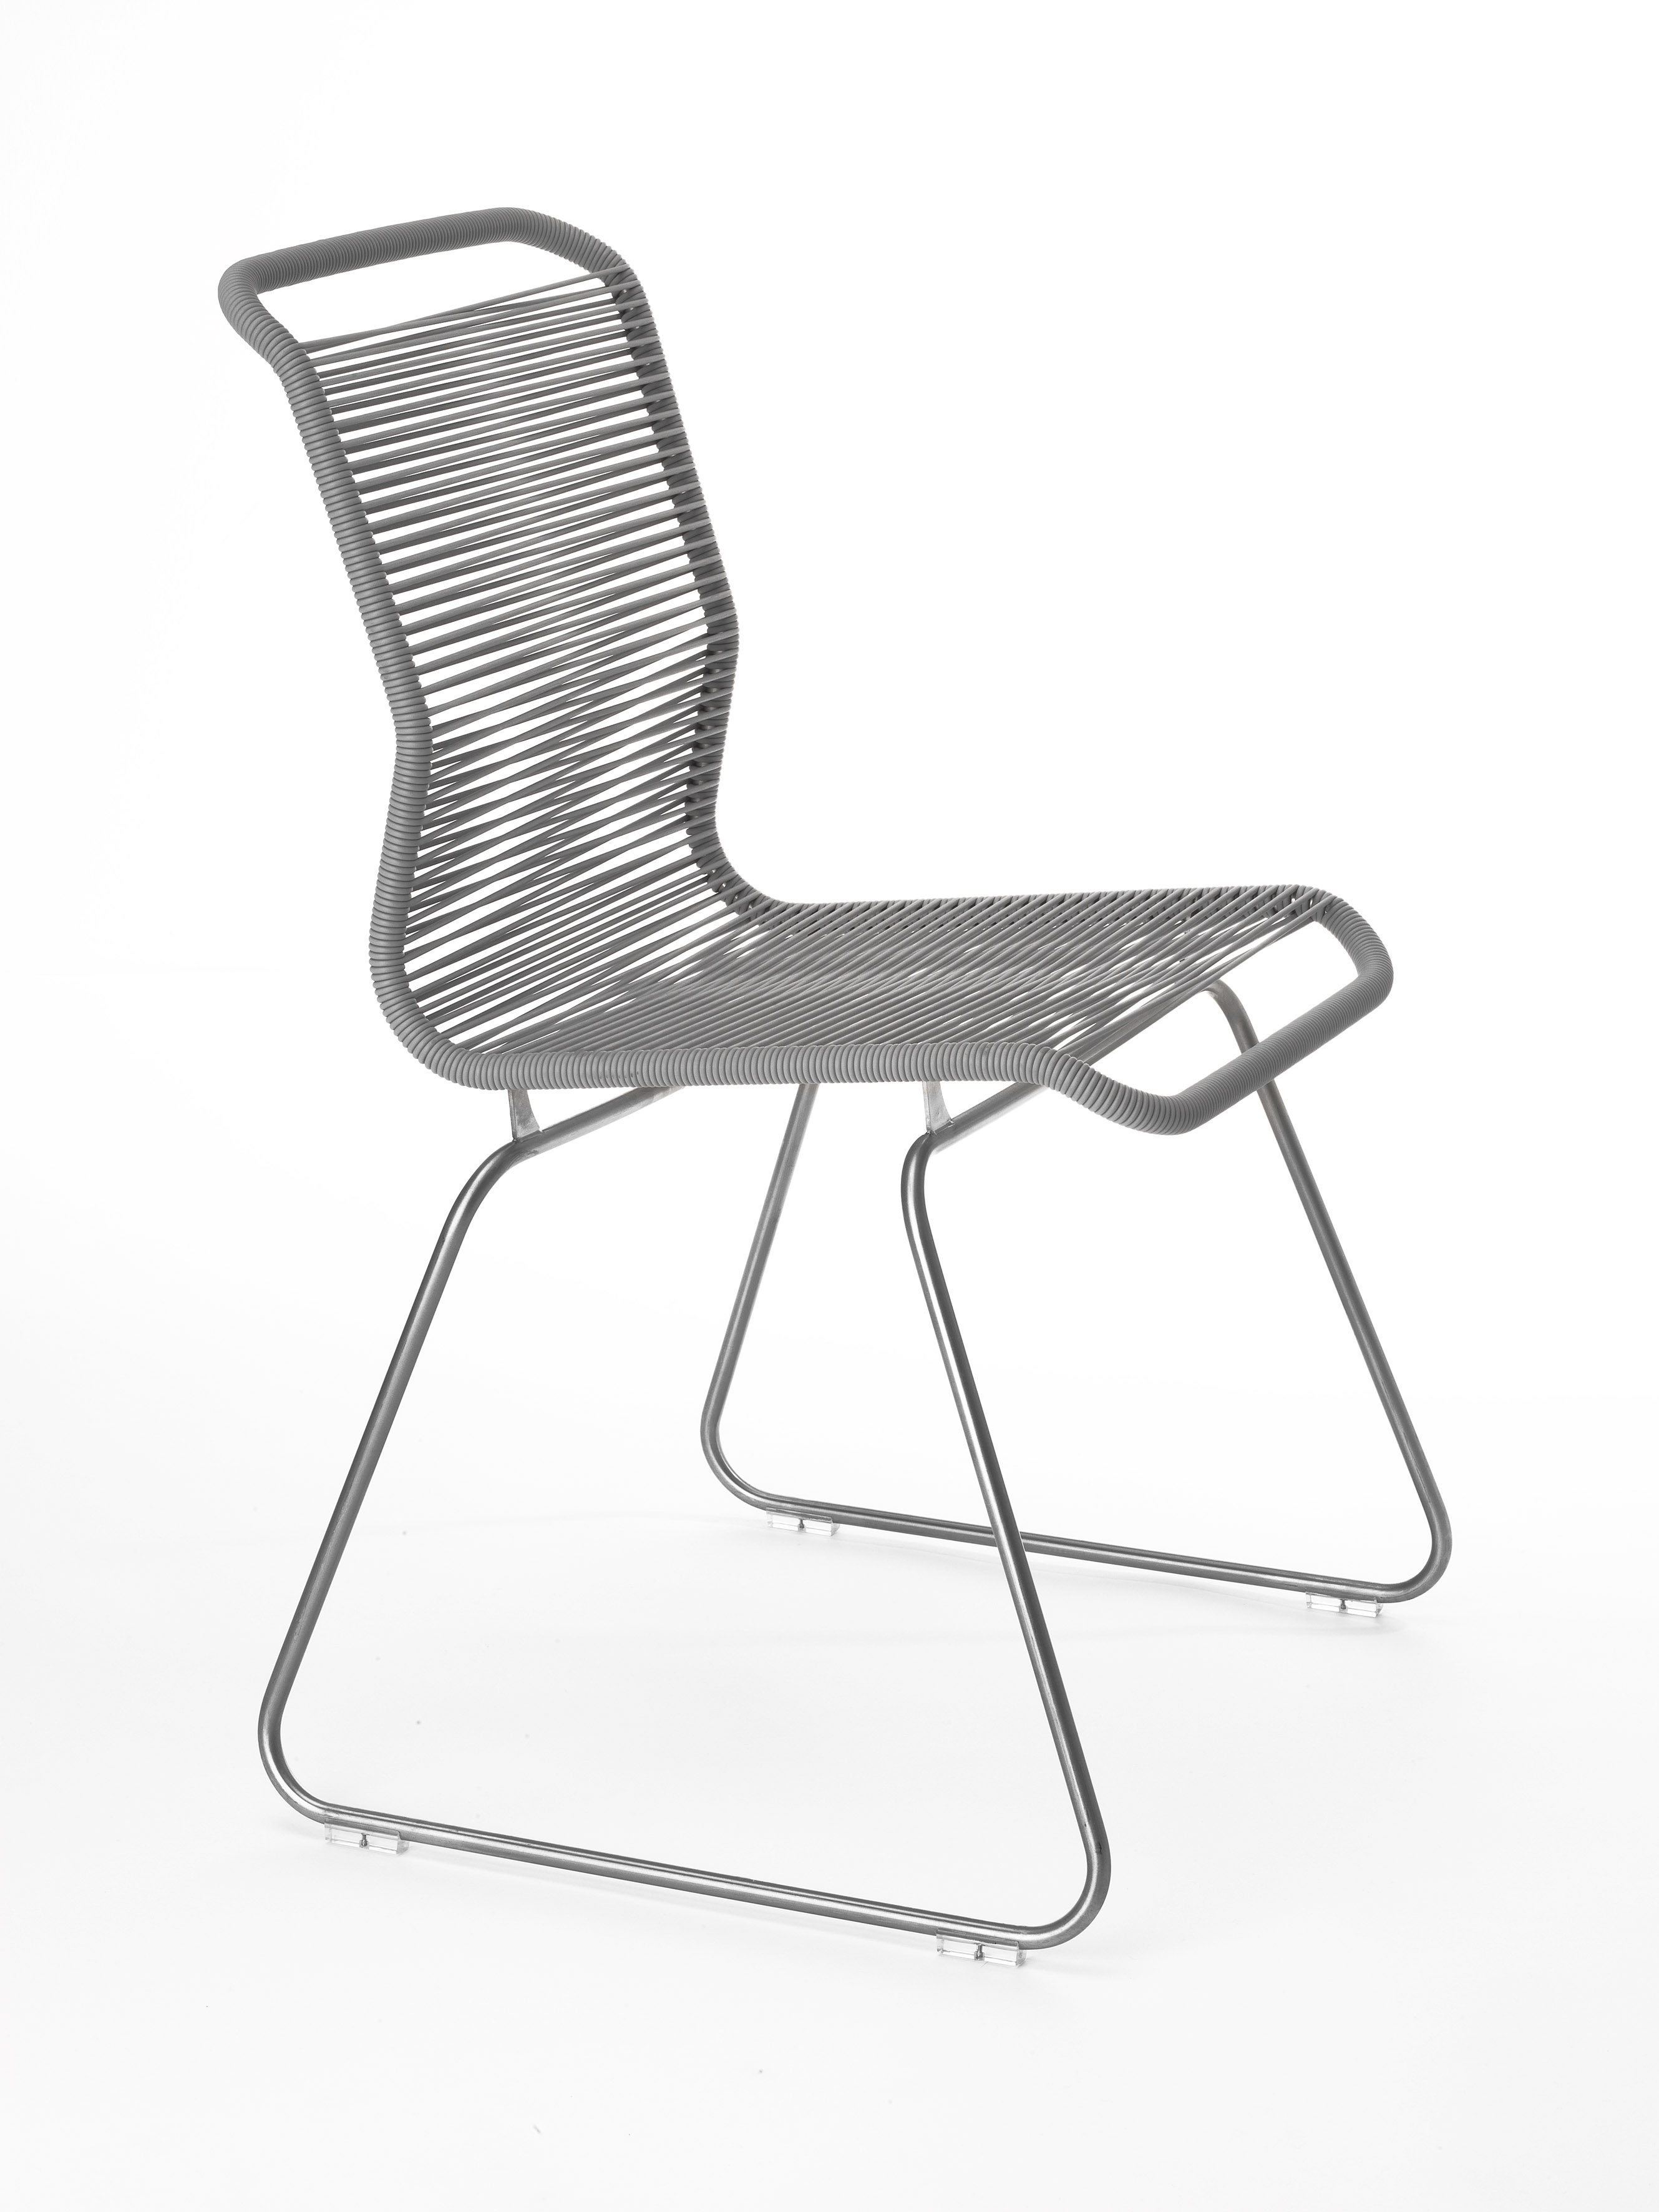
Product facts:
H:87 cm, B: 42 cm, seat height 49 cm
Prices:
Panton One, stainless steel DKK 2.995
Panton One, lacquered steel DKK 2.645
All prices include VAT

Verner Panton Bachelor
Verner Panton designed the Bachelor chair in 1955. Along with the chair, he also designed a stool and a table. The series can be used both indoors and outdoors. Table tops: The table is available as veneer in White Oak, Burned Oak and Black Oak with edges of solid oak for indoor use and as compact laminate in Snow and Anthracite with a black edge for indoor and outdoor use.

The chair and the stool is available in 7 different acrylic colours and in linen canvas: Northern White,
Mango, Wild Rose, Graphic Coast, Arctic Blue, Black Coal, and Nature. The chair can be complemented
with a cushion, available in the same colours as the chair.
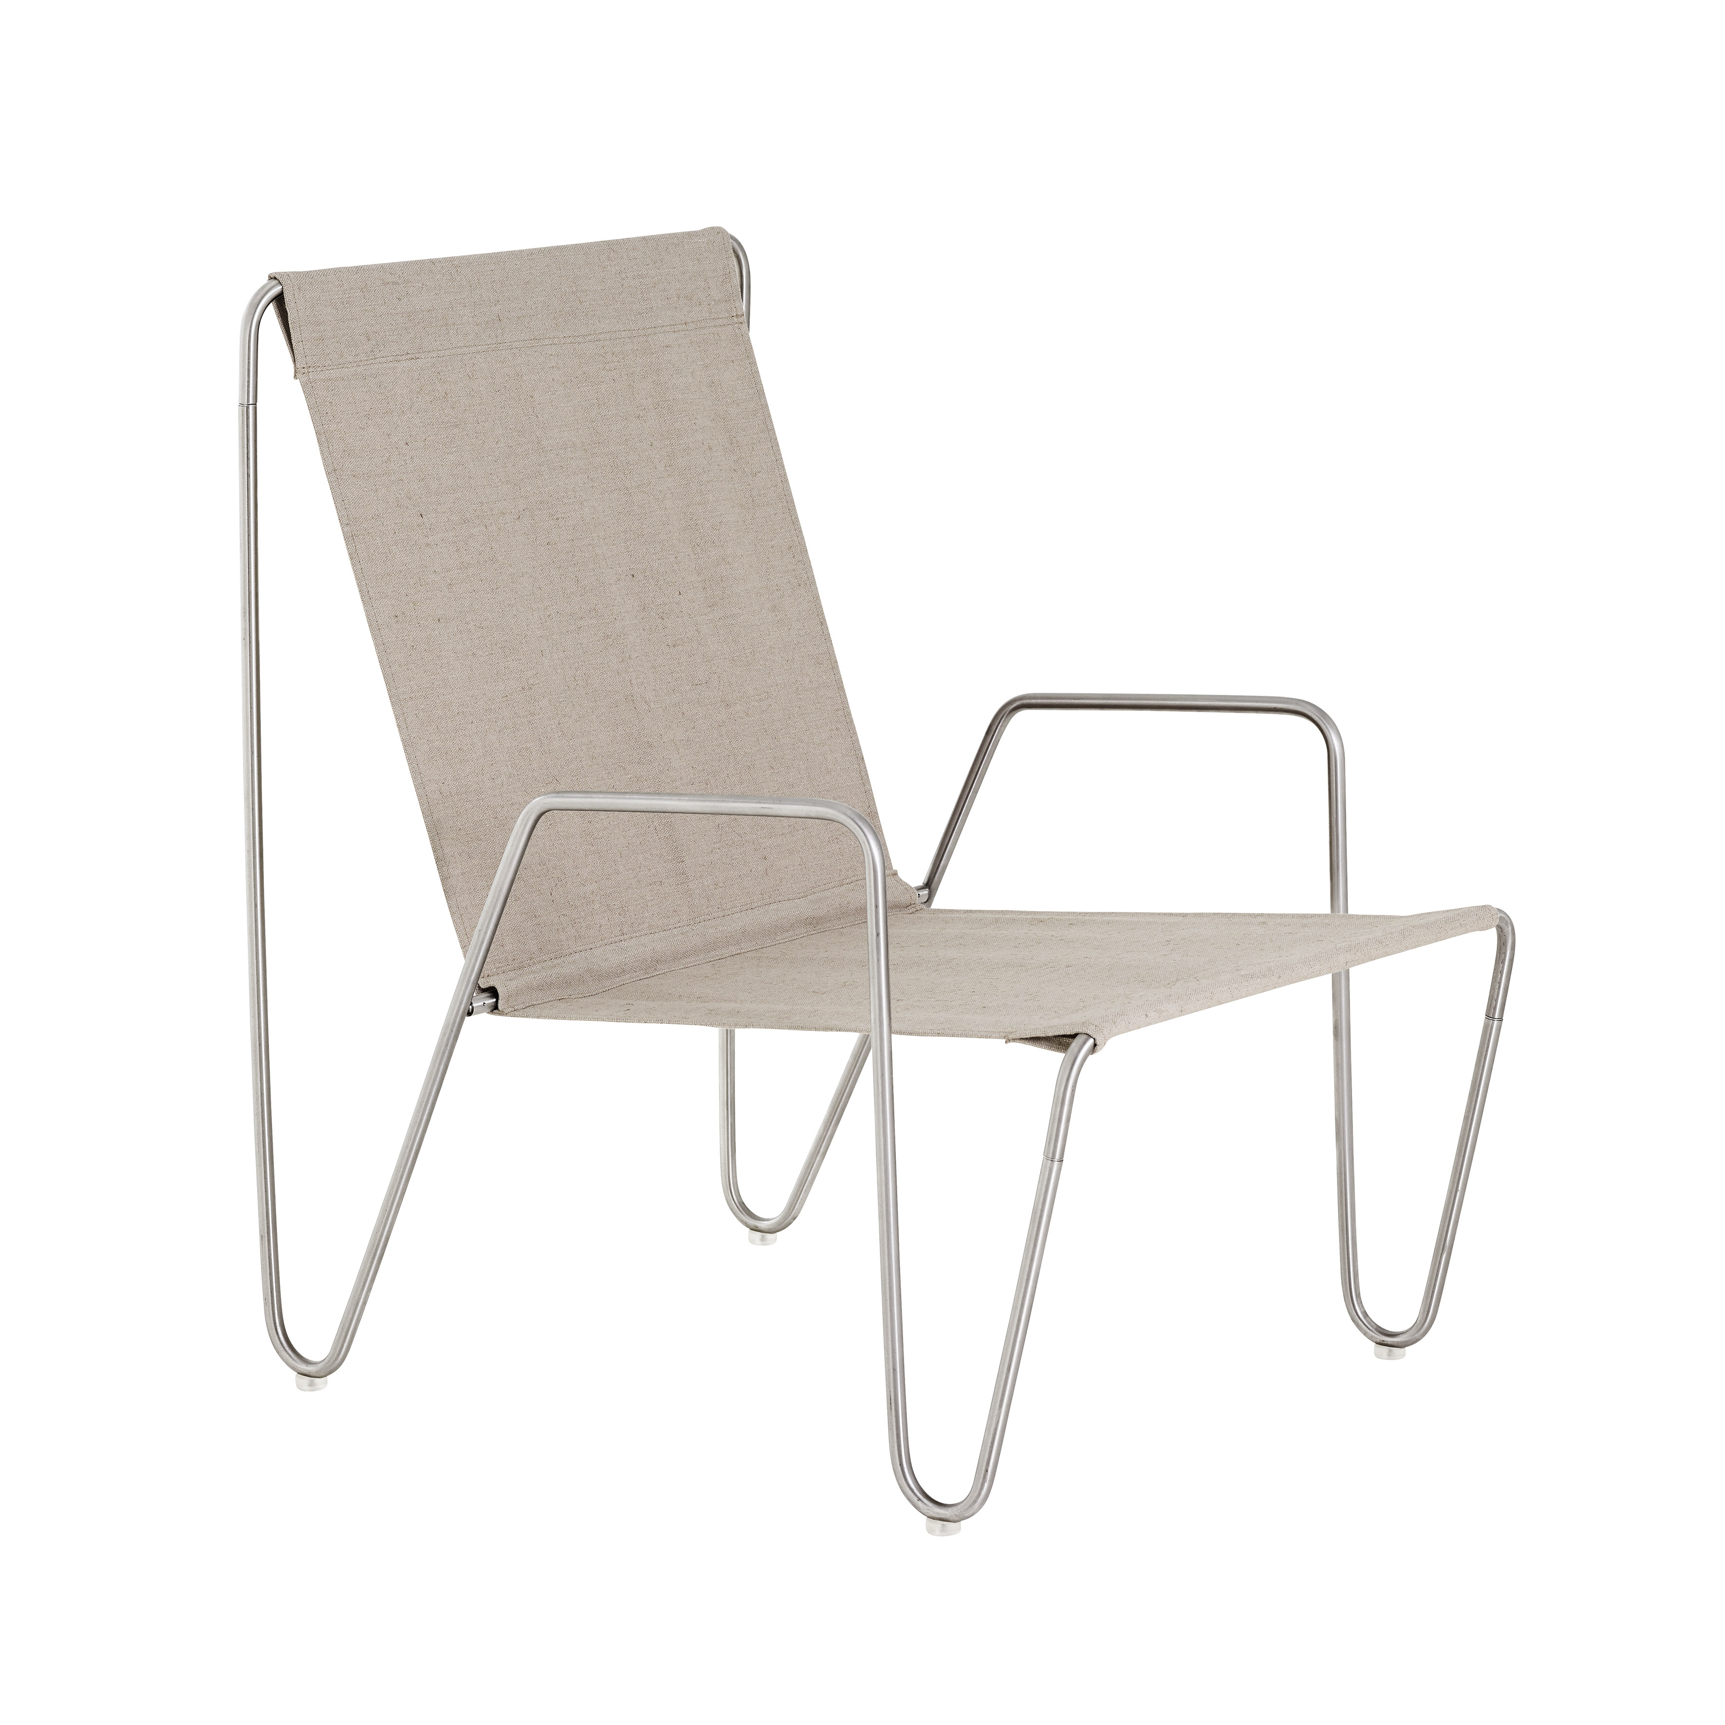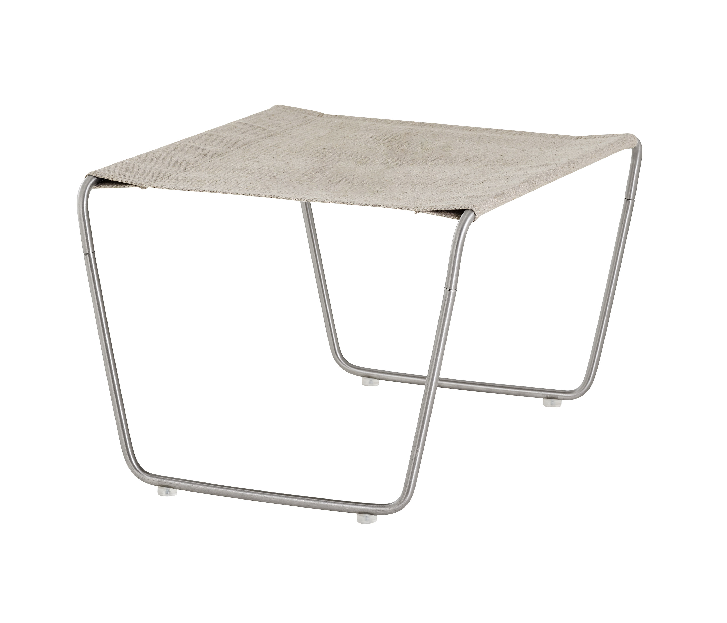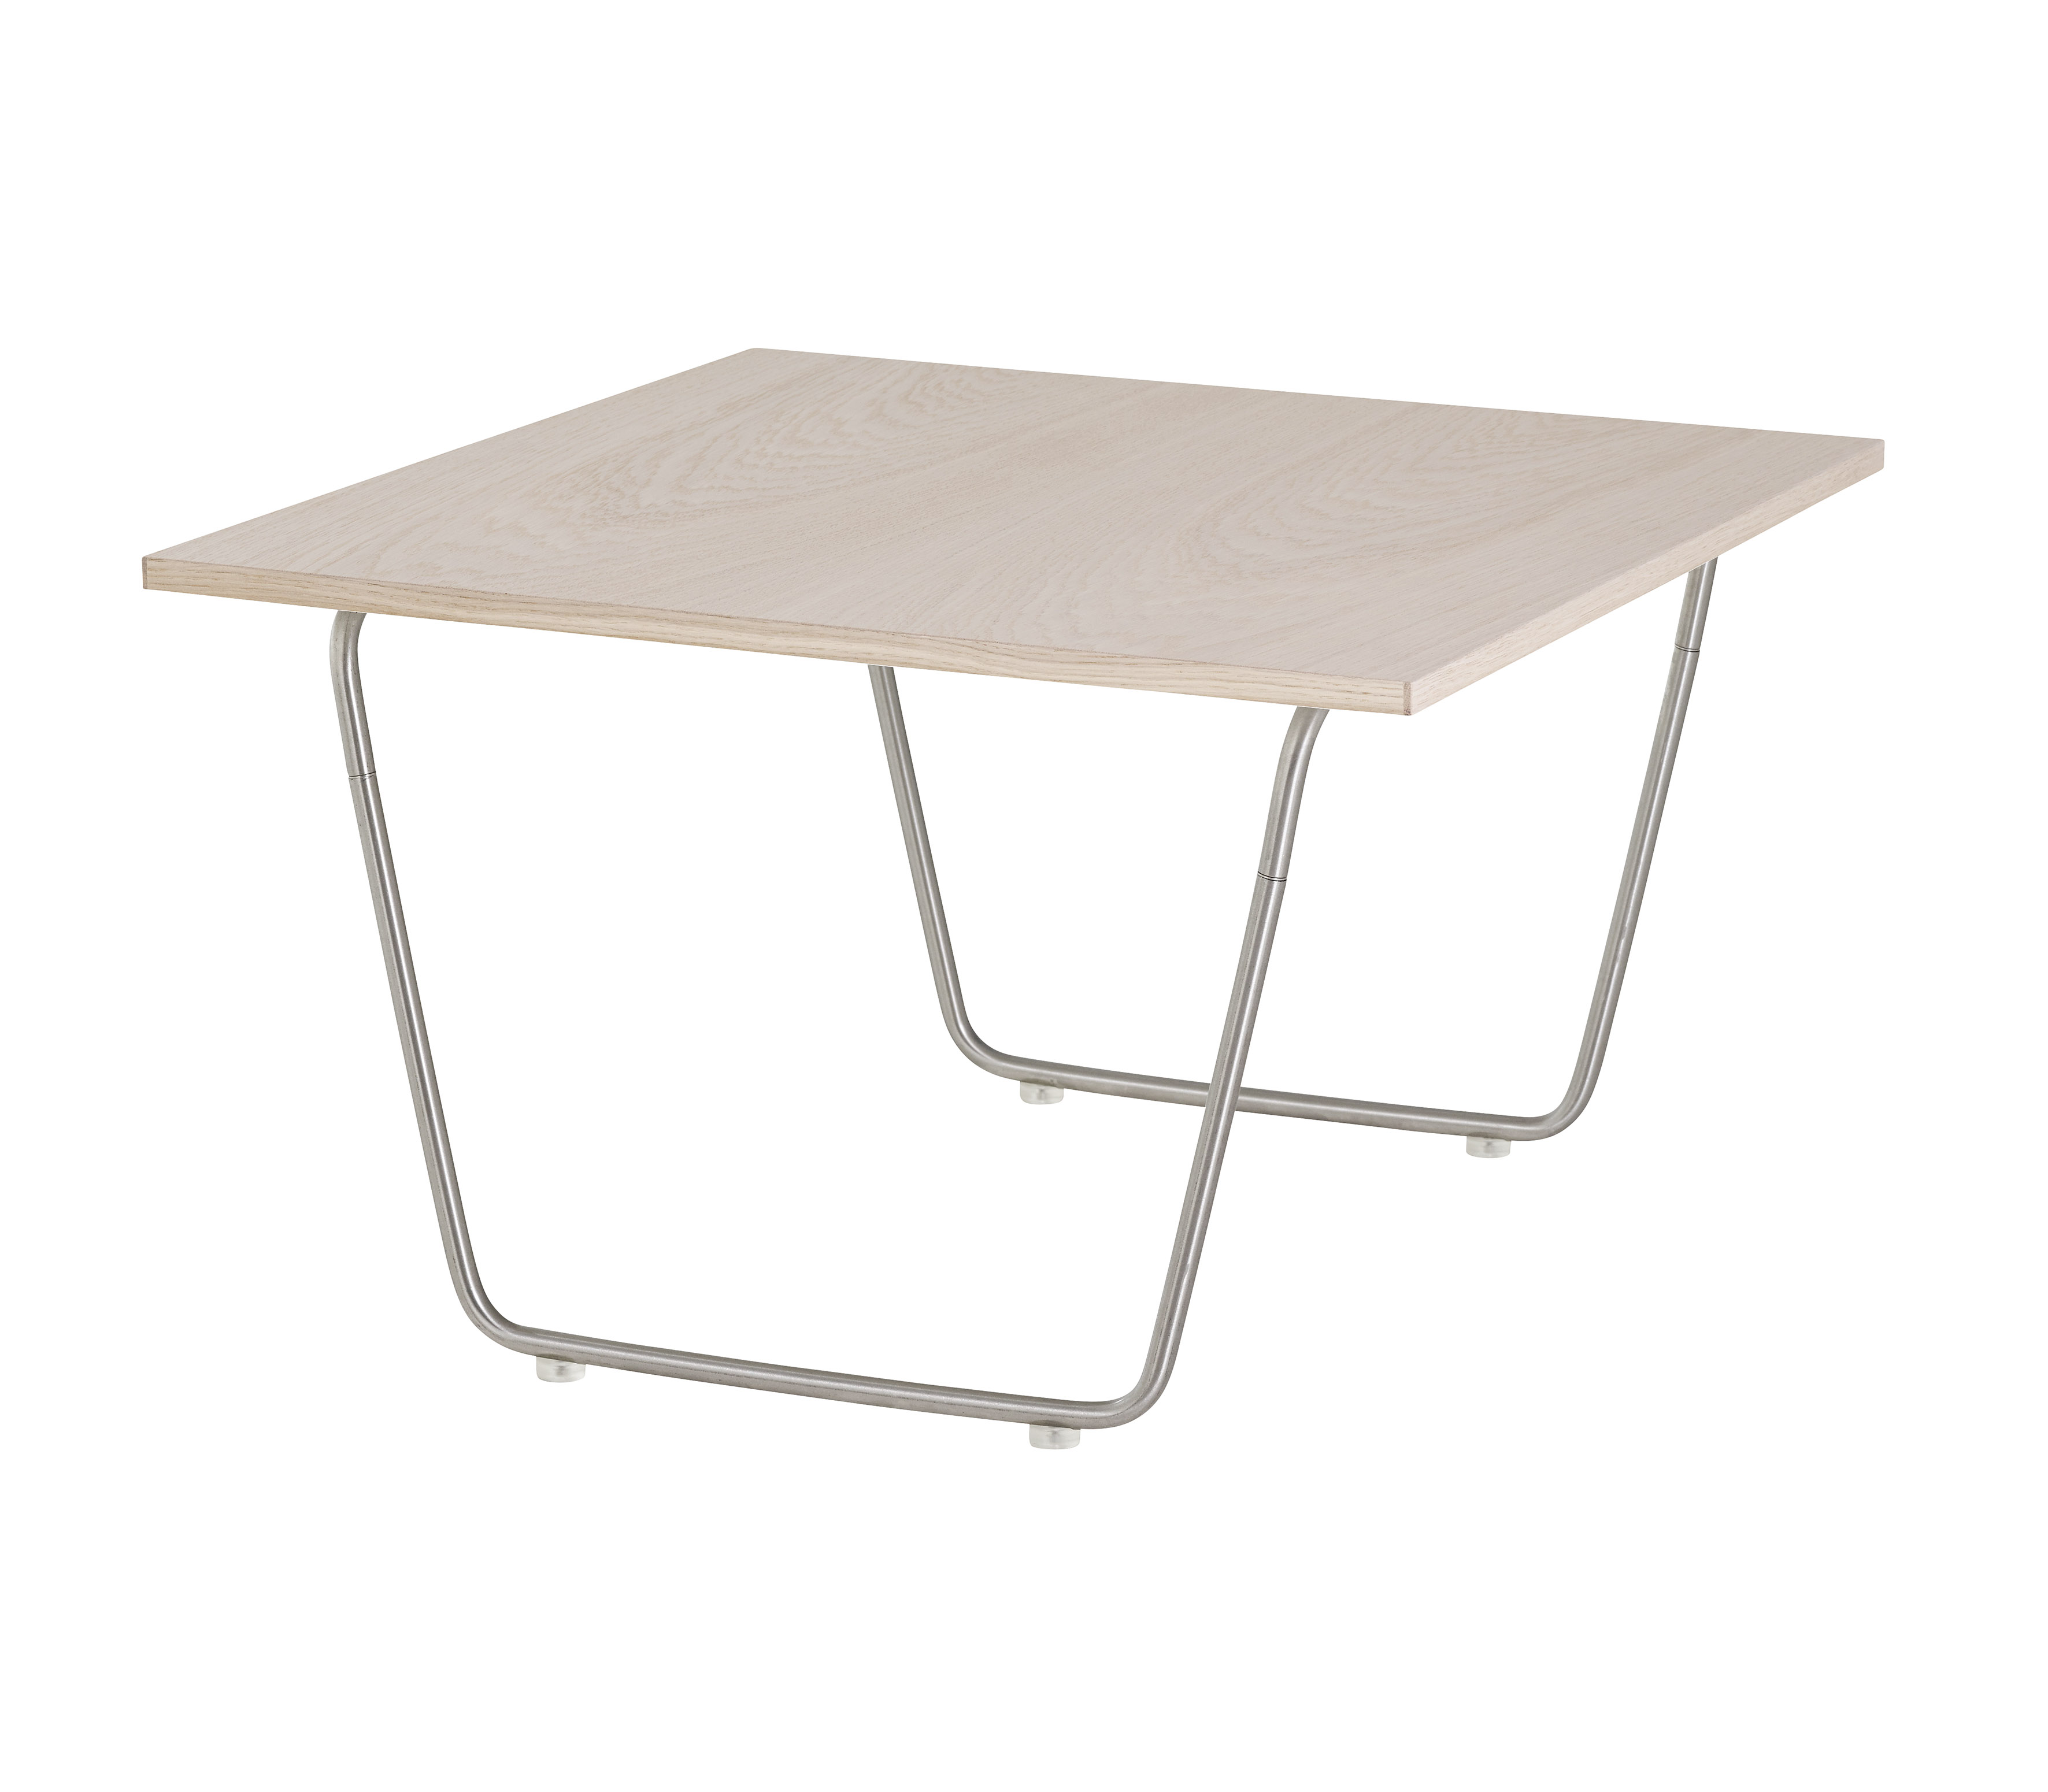
Product facts:
Panton Bachelor: H: 75 cm B: 52 cm, seat height 33 cm
Stool: H: 33 cm x B: 50.5 cm
Table: H: 35 cm B: 60 cm
Prices:
Panton Bachelor, DKK 2,686,-
Panton Bachelor Stool, DKK 1,899,-
Panton Bachelor Table, DKK 2,688,-
All prices include VAT

For further information, please contact:
Montana Møbler A/S
Annette Spanggaard
Mail: as@montana.dk
Mobile: +45 29 26 20 24
Download press releases and images from: www.mynewsdesk.com/dk/montana
For further inspiration, please see montana.dk

Follow Montana here:



Montana Møbler A/S produces and supplies storage and shelving systems, tables, and chairs for homes and modern office environments. The Montana shelving system is designed by Peter J. Lassen. The flexible modular system and the inspiring colour palette offer freedom to create your own personal room and to personalize your style. Montana’s table and chair series are designed by Arne Jacobsen, Verner Panton, Andreas Hansen, Peter J. Lassen, Joakim Lassen and schmidt hammer lassen design.

