Media Release

FOR IMMEDIATE RELEASE

Spa Botanica launches Herbal Compress Massage

Singapore, 1 July 2013 – Spa Botanica launches Herbal Compress Massage, with a secret blend of herbs and essential oils used in tandem with Spa Botanica’s signature
East-West Blend Massage to melt away tension and relax the body.

Inspired by traditional Thai methods practiced for centuries, Spa Botanica’s Herbal Compress Massage is the new and improved treatment by highly trained and certified therapists.

Using Kaffir lime leaves and Javanese grapefruit, among other herbs and essential oils, the herbal blend is compressed into a ball wrapped with muslin cloth and steamed gently to wake the aroma and fuse the mixture. The heat from the compress is inviting and relaxing, tailored to each individual’s heat tolerance. It is then rolled on the skin using long strokes to provide a sense of calmness. Following the hot compress, each part of the body is treated to the East-West Blend Massage for full effectiveness in loosening up stiff muscles.

The Spa Botanica Signature East-West Blend Massage is designed in accordance to traditional techniques used in Oriental and Occidental cultures. Special detox oil consisting of eucalyptus and ginger is used in this deep tissue massage. Targeting the different pressure points that require attention based on each person’s lifestyle and health, the treatment eases knots in muscles and increases energy flow in the body.

Perfect for high energy individuals with hectic schedules and stressful jobs, this treatment is designed to relax tight muscles and stimulate blood circulation in the body.

At S$280++ per person, the Herbal Compress Massage (2 hours) is now open for reservations.
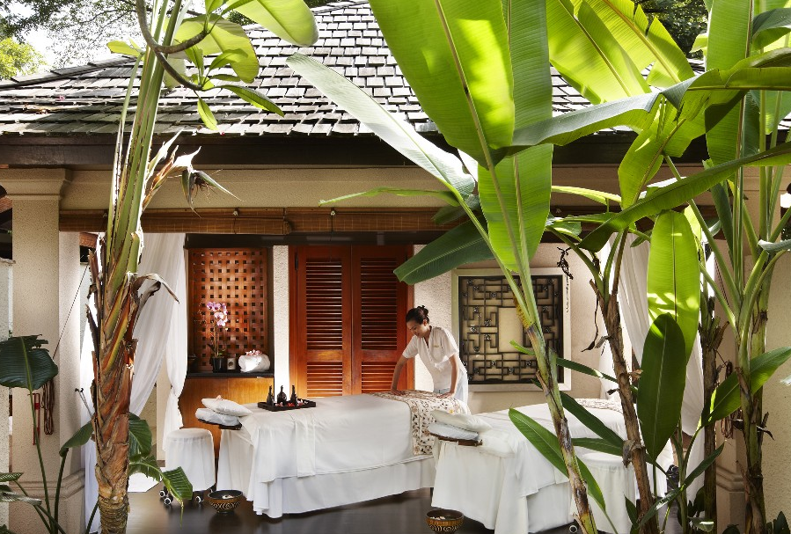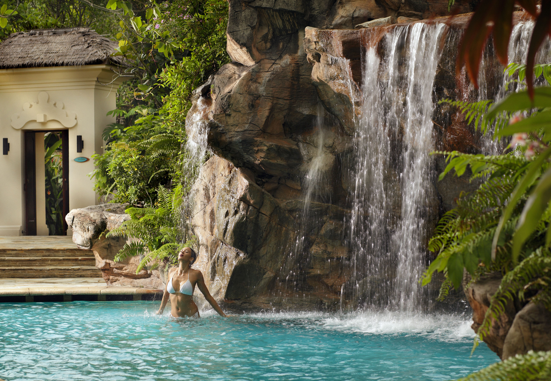

For reservations, please contact Spa Botanica at +65 6371 1288 / 1318 or email spabotanica@thesentosa.com. Opening hours are from 10am to 10pm, Monday to Sunday.
For more information, please visit www.spabotanica.sg.

About Spa Botanica
Singapore’s first garden destination spa, Spa Botanica at The Sentosa, A Beaufort Hotel is built on the concept of a botanical garden. With state-of-the-art facilities like the region’s first mud pools, float pools with cascading waterfalls, labyrinths, steam baths and Vichy showers, Spa Botanica harnesses the rich botanical resources of the region to create a truly healing and rejuvenating spa experience. Continually ranked among both local and international media such as Condé Nast as one of the top destination spas in Asia, Spa Botanica is an ultimate haven for luxury and indulgence.

About The Sentosa, A Beaufort Hotel
The Sentosa, A Beaufort Hotel is a five-star luxury property on Sentosa Island which boasts elegant low-rise architecture and plush interiors designed by Ed Tuttle. This 215-room hotel is a stylish, tranquil sanctuary situated on 27 acres of lush tropical greenery, and home to internationally acclaimed Spa Botanica and The Cliff, the hotel’s award-winning fine dining restaurant.

The Sentosa is owned by Beaufort Hotels and managed by HKR Asia Pacific Pte Ltd, a wholly owned subsidiary of Hong Kong public listed company, HKR International Ltd (HKRI). HKRI also owns and manages The Sukhothai Bangkok. For more information, please visit www.thesentosa.com

Media contacts:
Ms Marlene Teo  Marketing Communications Manager  Tel: +65 6371 1400  marlene.teo@thesentosa.com | Ms Candice Chua  Marketing Communications Executive  Tel: +65 6371 1309  candice.chua@thesentosa.com | Ms Abigail Foo  Marketing Communications Executive  Tel: +65 6371 1467  abigail.foo@thesentosa.com

