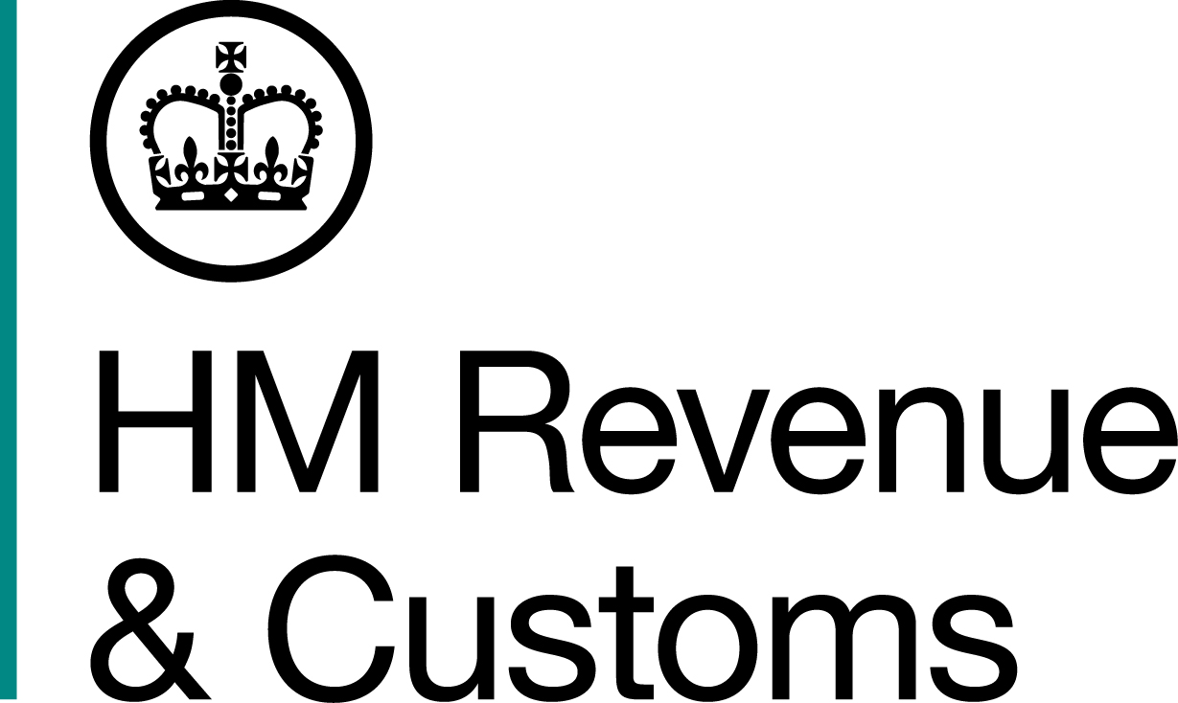
News Release News Release

 | For the attention of News Desks |  | No of pages: 3
 | Date: | 01 October 2018 | Ref: | SW 05 18

Stamp down delivered on VAT scam

A crooked stamps dealer who was convicted of using the identities of dead babies to create illegal passports has been jailed for VAT fraud.

Philip Ryle, 58, of Dovetail Drive, Weston-super-Mare, Bristol, stole more than £300,000 through an intricate web of cash transfers and VAT claims through a string of companies he set up to create a series of fake trades in rare stamps, an investigation by HM Revenue and Customs (HMRC) revealed.

Ryle sold the stamps from one of his companies to another for up to 800% of their true value. The second company would reclaim the VAT while the first company would not pay the VAT owed on the sale leading to Ryle fraudulently claiming £350,000.

Ryle was jailed for five years in 2002 for his part in a passport scam which used the identities of 37 dead British babies to obtain false passports which were then sold to criminals and illegal immigrants, copying a plotline from Frederick Forsyth’s 1971 novel ‘The Day of the Jackal’.

Richard Wilkinson, Assistant Director, Fraud Investigation Service, HMRC, said:

“Ryle is a hardened fraudster who has no problem with lying, cheating and manipulating others to make money. He thought his stamp dealing scam was clever enough to slip through the net, but our investigators ensured that justice was delivered.

“HMRC will pursue tax fraudsters relentlessly to stop them stealing funding from the public services we all rely on. Anyone with information about tax fraud can report it to HMRC online or call our hotline on 0800 788 887.”

Ryle, who was previously convicted under the name Philip Ryall, was the director of five companies and three of them were struck off owing more than £695,000 in unpaid VAT.

He used one of these – Rare Stamps Associates Ltd – to purchase hundreds of stamps from outside of the EU, and sell them at vastly increased prices to another of his companies, UK Philatelics Ltd.

He then sold the stamps for their genuine market value to overseas buyers mainly in the US.

Ryle did not pay the VAT due on for the sales made by Rare Stamps Associates, but still claimed over £300,000 in VAT repayments for UK Philatelics and attempted to claim another £90,000, which was refused by HMRC.

Rare Stamps Associates Ltd was wound up by Ryle in August 2014 but he set up a third company - P.E. Philatelic Exports Cyprus Limited - to carry on the fraud.

He was jailed for three years and eight months at Bristol Crown Court on Friday September 28 having admitted cheating the public revenue at the same court on September 18.

HMRC has begun confiscation proceedings to recover Ryle’s ill-gotten gains.

Information about any type of tax fraud can be reported to HMRC online at https://www.gov.uk/report-an-unregistered-trader-or-business.

Notes to Editors

- Philip Ryle, DOB 10/01/1960, of Dovetail Drive, Weston-super-Mare, Bristol. Ryle admitted cheating the public revenue at Bristol Crown Court on September 18, 2018. He was sentenced to three years and eight months at Bristol Crown Court on Friday September 28.
- Ryle was the sole director of Rare Stamps Limited, UK Philatelics Limited and P.E. Philatelic Exports Cyprus Limited.
- Follow HMRC Press Office on Twitter @HMRCpressoffice.
- HMRC's Flickr channel: www.flickr.com/hmrcgovuk.

Issued by HM Revenue & Customs Press Office

Press enquiries only please contact:

Ed Casson
Tel: 03000 524697
Email: ed.casson@hmrc.gsi.gov.uk

Or

Will Lyon
Tel: 03000 519451
Email: will.lyon@hmrc.gsi.gov.uk

Out of hours: Tel: 07860 359544

Website www.gov.uk/hmrc

