Kongsberg Digital in new partnership with Blue Water

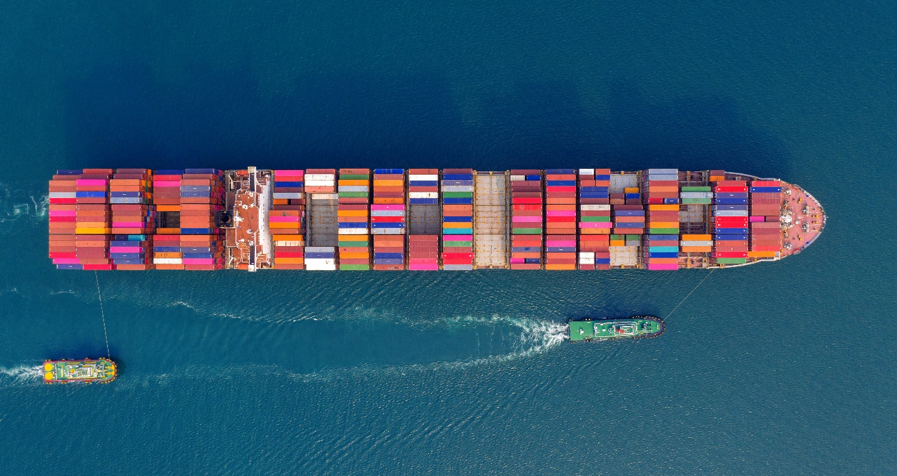
The BOSS solutions for voyage optimization and performance monitoring will be on the Kognifai Marketplace
Asker, Norway, December 1st, 2020 – Kongsberg Digital is pleased to announce a new partnership with Blue Water, to offer complete voyage optimization solutions to Vessel Insight customers.
Blue Water will provide KONGSBERG’s open ecosystem, Kognifai, with voyage optimization and performance monitoring services. Blue Water’s BOSS solution will collect contextualized data from the ship using KONGSBERG’s data infrastructure solution, Vessel Insight. The data is used to generate real-time value for users, with tools for reducing fuel consumption and ease of voyage operations. Blue Water is one of several well-known tech and data businesses collaborating on the platform, which presents a wide variety of live and static maritime information.
"Aside from getting access to contextualized data from your vessels, one of the main benefits of using Vessel Insight is the immediate access to value adding applications. With BOSS Solutions offered on the Kognifai Marketplace, Vessel Insight customers and users will be able to reduce cost through more intelligent and dynamic asset, vessel and fleet management", says Eirik Næsje, SVP Vessel Insight in Kongsberg Digital.
“Blue Water foresees a substantial increment in fuel savings, and ease of voyage operations, for both existing and potential customers through this integration of the latest technologies. The integration of KONGSBERG’s high-frequency sensor data into BOSS allows more accurate vessel modelling and performance analysis. This will not only improve our projections for voyage planning and optimization but also enhance the accessibility of our services through the ‘BOSS on Demand’ feature, embedded in the increasingly well-subscribed KONGSBERG Vessel Insight platform and the Kongsberg Digital marketplace,” says Kumaresh Gupta, Managing Director of Blue Water.

Shell reference
“Shell has set out an ambition to become a net-zero emissions energy business by 2050, or sooner. Vessel Insight and Blue Water/BOSS are two technologies used by Shell Trading and Shipping & Maritime that will help accelerate progress on lowering emissions. Since 2017, Blue Water has closely worked with Shell Trading and Shipping & Maritime to develop the BOSS tool for voyage optimization of its fleet and reducing emissions.”
Read more about the application in the Kognifai Maritime Marketplace here.
Kongsberg Digital and Blue Water invite you to attend their joint webinar ‘Voyage Optimization in the Kognifai Ecosystem,’ to be held at 11am CET on Thursday 3rd December. To register, click here.
Ends
For further information, please contact:

Mathilde Vik Magnussen
VP Communications & Marketing
Kongsberg Digital
Tel: +47 4567 8255
mathilde.magnussen@kdi.kongsberg.com

David Pugh
Saltwater Stone
Tel: +44 (0)1202 669244
d.pugh@saltwater-stone.com
Duncan Wyse
Head of Business Development
Blue Water Trade Winds Pvt Ltd
Tel: +1 669 224 2199
duncan.wyse@bwesglobal.com

About Kongsberg Digital
Kongsberg Digital is a provider of next-generation software and digital solutions to customers within maritime, oil and gas, and renewables and utilities. The company consists of more than 500 software experts with leading competence within the internet of things, smart data, artificial intelligence, maritime simulation, automation and autonomous operations.
Kongsberg Digital is subsidiary of KONGSBERG (OSE-ticker: KOG), an international, knowledge-based group delivering high-technology systems and solutions to clients within the oil and gas industry, subsea, merchant marine, defence and aerospace. KONGSBERG has 11,000 employees located in more than 40 countries.
Web: Kongsberg Gruppen | Kongsberg Digital
Social media: LinkedIn | Twitter | Facebook
About Blue Water
Blue Water Trade winds Pvt Ltd is an Indian company that focuses on maritime energy efficiency areas, harnessing the experience of its professionals from diverse industries. These services are milestone addition to the upcoming ways of saving fossil fuels and reducing environmental impact from emissions; primarily by innovating new methodologies to optimize the fuel consumption across diverse operations.
Optimum voyage planning and monitoring can save upto 5% fuel in a voyage. BOSS seamlessly encompasses a number of related services to make this possible.BOSS combines data models with advanced optimization algorithms to plan a voyage with intelligent weather routing and dynamic speed scheduling. Automatic data logging through our accelerated noon reporting system creates a complete fleet management toolkit for voyage monitoring, vessel performance analysis, bunker claims management and much more!
Web: Blue Water

