Ballstad, 28 March 2014

Red Dot Design Award for ConceptoShield™

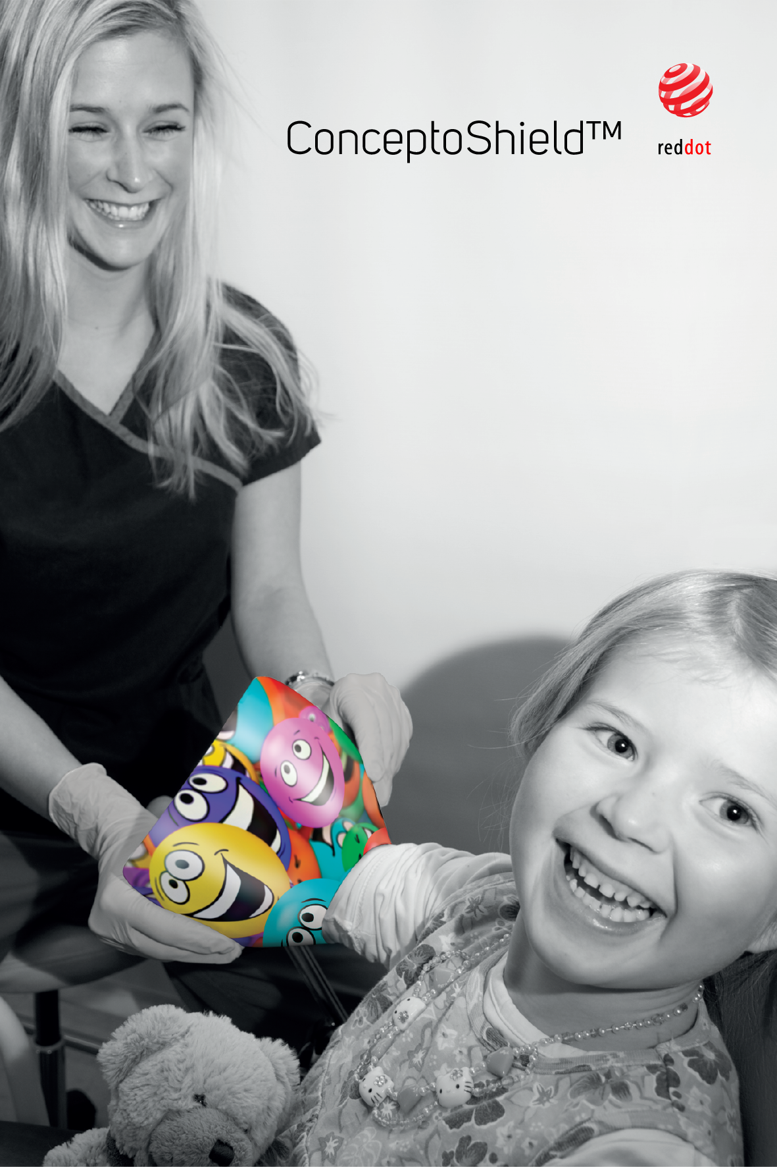
It is now official that ConceptoMed AS has received the prestigious award Red Dot Award, Product Design, for ConceptoShield™.

The product is a medical device for use during phlebotomy, fixation of IV ports, minor surgery and wound care on arms and legs. Engaging graphics offer distraction while the patient avoids being exposed to the view of needles and blood.

ConceptoShield ™ simply creates a better situation - less stressful and more pleasant for both the healthcare professional and the patient.

- ConceptoShield ™ has been created through a constructive and exciting design process together with talented product designers from K8 Industridesign AS in Oslo, Norway. Without the excellent collaboration towards common goals, we would not have been able to reach our full potential, says Christian Mide, Medical Doctor and CEO of ConceptoMed.

Pilots at AHUS and Rikshospitalet have fed into the product development with user input of importance for the development of the medical device.

- It is exciting to note that 8 of 10 patients experience more pleasant procedures when using ConceptoShield ™. The Red Dot Design Award represents a further confirmation that we have succeeded in creating a functional product, says Christian Mide.

The jury of the Red Dot is composed of 40 members. These have judged 4815 contributions submitted by 1,816 companies from 53 countries - before taking a decision on which products that receive the prestigious award for product design.

