Allison Transmission

Allison Transmission in Norwegian refuse trucks:

RenoNorden purchased Mercerdes-Benz trucks with fully automatic powershifting Allison Transmissions
Dec 16, 2009 15:16 CET
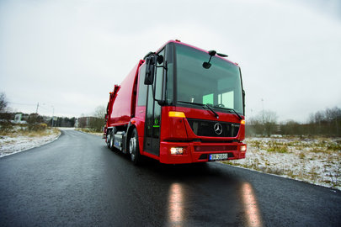
Mercerdes-Benz, Oslo in business with RenoNorden: Purchased refuse trucks with Allison Automatic Powershifting Transmissions
Mercedes-Benz has equipped their Econic CNG with Allisons push button controlled 6-speed Automatic Transmission in chassis which are perfectly suited for refuse collection in cities.
Christian Hjorthøy, Key Account Manager, Bertel O. Steen A/S:
–We are very pleased with this deal with RenoNorden and the Mercedes Econic CNG. Their decision to choose Allison Automatic Transmission was very exciting.
Purchasing a large amount of refuse trucks doesnt happen every day, and we are convinced that the choice of Allison Transmission will prove very succesfull for RenoNorden.
Roy Åsheim, Operations Manager, RenoNorden:
–Refuse trucks are exposed to an extremely large amount of starts and stops, which makes it difficult for a manual or AMT transmission to last in the long run. We simply must have a fully converter automatic transmission.
The transmissions in the MB Econic CNG refuse trucks we bought, also comes with a special feature that suits us just perfect. It´s the Allison Autoneutral which means that the transmission automatically goes in to neutral when you pull the parking brake. That saves fuel. For us, its all about being productive and having a transmission that keeps us out of the work shop.
Nils-Roar Erlimo, Salesmanager Trucks, Mercedes-Benz Norway:
– We congratulate to the choice of Mercedes CNG Econic with Allison Transmissions. Bertel O. Steen has done a very good job with the specifications of the trucks, and we are convinced that RenoNorden will be very satisfied with the trucks and the durability and the operational reliability of the Automatic Transmission.

Allison Transmission, Inc. (Allison) is the premier global provider of commercial duty automatic transmissions and hybrid propulsion systems. Allison products are specified by over 250 of the world’s leading vehicle manufacturers and are used in many market sectors including bus, refuse, fire, construction, distribution, military and specialty applications. Founded in 1915, the Allison business is headquartered in Indianapolis, Indiana, U.S.A. and employs approximately 2,900 people. Regional headquarters with dedicated support staff are located in China, The Netherlands, Brazil, India and Japan. With a global presence in 80 countries, Allison has over 1,500 distributor and dealer locations.
More information about Allison is available at www.allisontransmission.com

