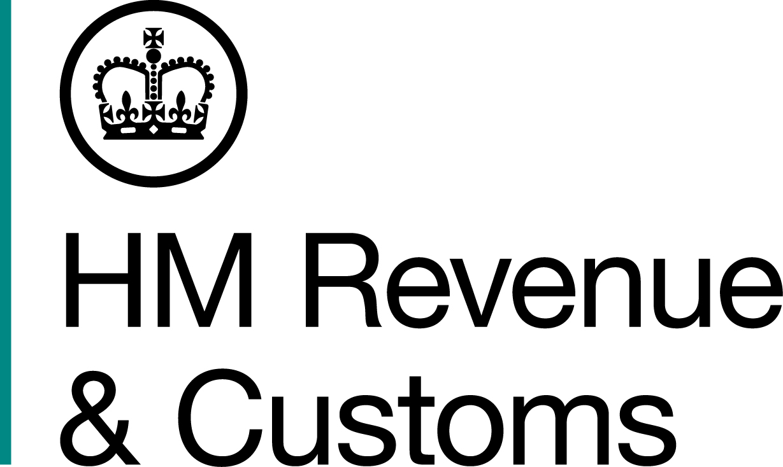
News Release

 | For the attention of News Desks |  | No of pages: |  | 4
 | Date: | 5 April 18 | Ref: | WM 04 18

Ringleaders of tax fraud gang jailed

The ringleaders of an eight-strong gang of labourers from the West Midlands have been jailed for attempting to steal £300,000 through fake tax claims.

The gang, who met through work, submitted fake Self Assessment returns claiming they had paid too much tax and were due repayments totalling £296,193 between 2011 and 2015, a HM Revenue and Customs (HMRC) investigation revealed.

Investigators found ringleaders Mark Thorpe, 39, of Inland Road, Erdington, Birmingham, and Aaron Hayers, 35, of Swan Street, Netherton in Dudley, recruited workmates to carry out the fraud and took a percentage of their claims.

Each gang member registered separately to do their Self Assessment returns online and made multiple amendments, each time increasing the amount they had overpaid to claim larger repayments.

Officers rumbled the men after similarities were noticed across the tax returns, such as all using the same employment details.
Money for three recipients was paid into a bank account of an associate of Thorpe’s, who received a payment of more than £20,000 into a bank account. A further payment of £32,705 was requested, but withheld by HMRC.

A total of £172,441 was paid out to the individuals, and further payments of £118,622 were withheld by HMRC.

Paul Fisher, Assistant Director, Fraud Investigation Services, HMRC, said:

“Thorpe and Hayers led this gang in a relentless and sustained attack on the tax system. HMRC stopped their attempt to steal thousands more from the public purse, but they are now facing over five years in jail.

“Anyone with information about people who may be involved in tax fraud can contact our Fraud Hotline on 0800 788 887.”

Thorpe was sentenced to a 32-month custodial sentence at Birmingham Crown Court on March 2, after he admitted the frauds.

Hayers was handed a 36-month custodial sentence after admitting guilt at the same court last September.

Six of the remaining gang members were also convicted of submitting fraudulent returns:

- Paul Hayers (brother of Aaron), 35, sentenced to nine months in prison, suspended for 18 months.

- Wayne Garratt, 46, sentenced to nine months in prison, suspended for 18 months.

- Colin Wakeman, sentenced to nine months in prison, suspended for 18 months.

- James Cowley, 28, sentenced to 16 months in prison, suspended for two years.

- John Gilligan, 30, sentenced to 12 months in prison, suspended for two years.

- Bernard Richardson, 44, sentenced to ten months in prison, suspended for two years.

Gilligan and Richardson were convicted after a trial, the rest admitted guilt.

Confiscation proceedings to recover their criminal profits are ongoing.

Information about any type of tax fraud can be reported to HMRC online at https://www.gov.uk/report-an-unregistered-trader-or-business.

Notes for editors

- Mark Thorpe DOB: 16/12/1978, of Inland Road, Erdington in Birmingham, was charged with four counts of cheating the public revenue and one count of money laundering. He was sentenced to a 32-month prison sentence at Birmingham Crown Court on 02/03/2018.

- Aaron Hayers DOB: 21/01/1983, of Swan Street, Netherton, Dudley, was charged with five counts of cheating the public revenue. He was sentenced to a 36-month prison sentence at Birmingham Crown Court on 22/09/2017.

- James Cowley DOB: 26/12/1989, of Parry Road, Wolverhampton, was charged with one count of cheating the public revenue. He was sentenced to a 16-month prison sentence, suspended for two years, a three-month curfew, ten days unpaid work and ordered to pay £500 in fines, at Wolverhampton Crown Court on 05/04/2018.
- Paul Hayers DOB: 21/01/1983 of Carlton Road North, Weymouth, was charged with one count of cheating the public revenue. He was sentenced to a nine-month prison sentence, suspended for 18 months, 100 hours unpaid work, and ordered to pay £500 compensation and £510 in fines, at Birmingham Crown Court on 22/09/2017.

- Wayne Garrett DOB: 17/05/1971, of Valley Road, Stourbridge, was charged with one count of cheating the public revenue. He was sentenced to a nine-month prison sentence, suspended for 18 months, 150 hours unpaid work, and ordered to pay £500 compensation and £510 in fines, at Birmingham Crown Court on 22/09/2017.

- John Gilligan DOB: 13/01/1988, of Colyns Grove, Stechford, Birmingham, was charged with one count of cheating the public revenue. He was sentenced to a 12-month prison sentence, suspended for two years with 20 days rehabilitation activity, 150 hours unpaid work, and ordered to pay costs of £1,500, at Birmingham Crown Court on 02/03/2018.

- Colin Wakeman DOB: 14/01/1971, of Princes Road, Stourbridge, was charged with one count of cheating the public revenue. He was sentenced to a nine-month prison sentence, suspended for 18 months, 100 hours unpaid work, and ordered to pay £500 compensation and £510 in fines, at Birmingham Crown Court on 22/09/2017.

- Bernard Richardson DOB: 20/03/1973, of Chinbrook Road, Birmingham, was charged with one count of cheating the public revenue. He was sentenced to a ten-month prison sentence, suspended for two years with 20 days rehabilitation activity, 125 hours unpaid work, and ordered to pay costs of £1,500, at Birmingham Crown Court on 02/03/2018.

- Follow HMRC Press Office on Twitter @HMRCpressoffice.
- HMRC's Flickr channel: www.flickr.com/hmrcgovuk.

Issued by HM Revenue & Customs Press Office
Press enquiries only please contact:

Ashleigh Prince
Tel: 03000 598834 / 07825 026303
Email: Ashleigh.prince@hmrc.gsi.gov.uk
Or
Jemma Smith
Tel: 03000 520184 / 07469021524
Email: Jemma.smith@hmrc.gsi.gov.uk

Out of hours
Tel: 07860 359544
Website www.gov.uk/hmrc

