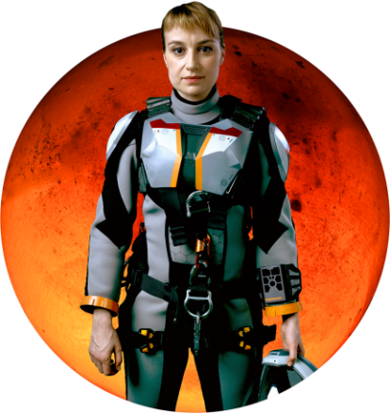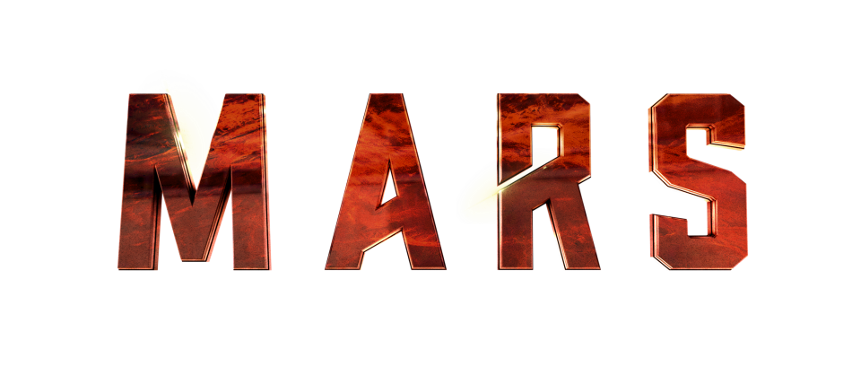

CREW MEMBER: Marta Kamen

ASSIGNMENT: Exobiologist and geologist

NATIONALITY: Russian

NOTES: As a young woman, Kamen witnessed the Chelyabinsk meteor fall in February 2013, which inspired the focus of her Ph.D. — to look for traces of life in Martian meteorites. A pragmatist and realist about practical matters, her even temperament will be invaluable on Mars.

ACTOR BIO: Anamaria Marinca

Anamaria Marinca plays Russian exobiologist and geologist Marta Kamen. Born in Iasi, Romania, Marinca graduated from the University of Fine Arts, Music and Drama in Iasi. In 2005, she won three best actress awards (the BAFTA Television Award, the Royal Television Society Award and the Golden Nymph at the Festival de Television de Monte Carlo) for her role in “Sex Traffic,” a CBC/Channel 4 drama about human trafficking. In 2007, she starred in the Romanian film “4 Months, 3 Weeks and 2 Days” by Cristian Mungiu, which won the Palme d’Or at the 2007 Cannes Film Festival. Marinca also appeared in the Francis Ford Coppola film “Youth Without Youth.” She recurred on the Welsh TV detective series “Hinterland" as well as the Golden Globe-nominated STARZ series “THE MISSING.” Other feature credits include “Fury” opposite Brad Pitt, “Europa Report," "Floride" and "The Girl With All the Gifts." Marinca also just finished filming “Ghost in the Shell” opposite Scarlett Johansson and directed by Rupert Sanders.

