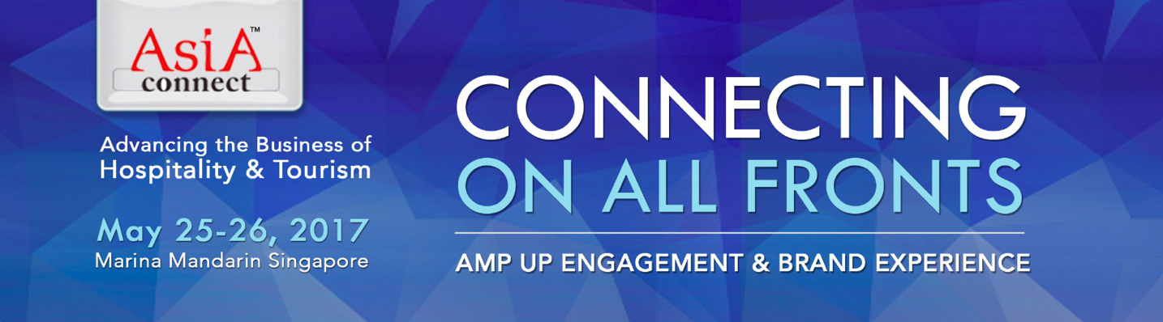

A wider scope, lively and innovative format and inaugural awards at the exciting new edition of the Asia Connect Leadership Forum & Networking Marketplace

Singapore (March 13, 2017) - After 10 great years and 20 Asia Connect Conferences across Asia, the revitalised Asia Connect will see a few firsts in 2017.

Well-known for bringing together global hospitality and tourism leaders to connect with new customers, future partners, trending issues and winning solutions, this year’s event will be held at Marina Mandarin Singapore from May 25-26, 2017.

The new edition conference will include a wider scope to address the entire tourism ecosystem; a lively and innovative ‘Three-In-One’ format; and the inaugural Asia Connect Customer Experience (ACCE) Tourism Awards.

This year’s theme is Connecting On All Fronts: Amp Up Engagement & Holistic Brand Experience. “With customers in today’s highly social and digital economy easily able to amplify their delight or discontent with their experiences, this presents a huge challenge and opportunity for the hospitality & tourism industry, where creating positive customer experiences and turning customers into advocates are critical for long-term success,” said Christine Toguchi, managing director of MacroVision Network Pte Ltd.

The conference will address how a holistic approach integrating marketing, human resource, sales and customer service functions is key to delivering exceptional customer experience. Main topics include “Branded Customer Experience: A Powerful and Sustainable Business Strategy and Competitive Edge”, “What’s Trending: The Rise of Affinity and Transformational Travel Experiences” and “Connected by Design: Creating a Cohesive, Collaborative and Customer-Centric Enterprise”.

A Fresh, Broader Approach
The revitalised Asia Connect event is expanding to appeal to a wide spectrum of the hospitality and tourism industry in Asia, including airlines, attractions, corporate travel, cruises, hotels, meetings & events and other service-related businesses vital to a thriving tourism ecosystem.

Created by MacroVision Network Pte Ltd (MVN) in 2005 to kick-start the establishment of the Hospitality Sales & Marketing Association International (HSMAI) in Asia Pacific, Asia Connect provides insightful views on the future of the hospitality and tourism industry and supports the professional development of marketing, sales, customer service and learning & development executives.

A Dynamic New Format
Much more than just another conference, Asia Connect 2017 will be a potent ‘Three-In-One’ event, combining for the first time:

Inspiring Keynote Speakers, lively and provocative panel discussions in the ‘Main Forum’

The Main Forum Keynote Speaker is Dr Janelle Barlow, noted public speaker, trainer, entrepreneur and best-selling author of business books including A Complaint Is a Gift. Passionate about Customer Service, Branding, and Complaint Handling as well as their strategic intersection, Dr Barlow is a consultant to some of the world’s leading corporations and has guided several hospitality brands in Asia through successful organisational transformations.

‘Fast Track’ Workshops with Master Classes in the ‘Active Learning Hub’ where delegates can personalise their learning experience

These workshops comprise 3 special interest tracks:

- Demand Generator, Marketer & Strategist
- Business Analyst, Technologist & Business Process Re-engineering Specialist
- Talent Scout, Mentor & People Developer

* Programme topics and workshop tracks are subject to adjustments and additions
‘Networking Marketplace & Social Mixer’ to connect with new customers, future partners and industry colleagues

Delegates will be treated to an entertaining and relaxed evening of quality networking as they mix, mingle and experience what’s new in Singapore’s Food, Lifestyle and Artisan Scene.

An Inaugural Award
It takes a team of dedicated and skilled employees to breathe life into a brand and create meaningful connections with customers. The Asia Connect Customer Experience (ACCE) Tourism Awards 2017 recognises hospitality and tourism’s ‘Best of the Best’ in Customer Experience Management and Employee Engagement. Held in conjunction with Asia Connect 2017, delegates have a complimentary seat to attend the ACCE Tourism Awards luncheon on May 26. Entries for the 2017 inaugural ACCE Tourism Awards now open at: http://www.macrovisionnetwork.com/asiaconnect

Event Information
Date: May 25-26, 2017
Venue: Marina Mandarin Singapore
Early Bird Registration fees are available until March 24, 2017:
To register online visit: http://www.cvent.com/d/cvqfk2

- ends -

Strategic & Supporting Partners

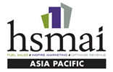
Hospitality Sales & Marketing Association International - Asia Pacific Chapter (HSMAI) is the largest and most active travel and hospitality sales & marketing association in the world with over 7,000 members in 30 countries and 60 chapters worldwide.


Direct Marketing Association of Singapore (DMAS) is a non-profit trade organisation established in 1983. Its mission is to enable members to keep abreast of industry trends and best practices in Singapore and the region.


Singapore Hotel Association (SHA) is the umbrella body for hotels in Singapore. Its membership is made up of hotel entities which are represented by proprietors of hotels or appointed representatives. Its current membership comprises 155 hotels which accounts for more than 90% of total gazetted room count.

Event Producer & Organizer

Established in 2001, MacroVision Network Pte Ltd is a marketing and event consultancy company that collaborates with the hospitality & tourism industry and educators to produce thought leadership forums and learning & networking events that inspire new thinking, best practices and creative leadership. Visit: www.macrovisionnetwork.com

Media Contact:
Christine Toguchi
Email: chris@macrovisionnetwork.com
Mobile: (65) 9185 6168

