The Nippon Foundation-GEBCO Seabed 2030 Project and Kongsberg Maritime enter partnership as the race for a complete map of the world’s seabed accelerates
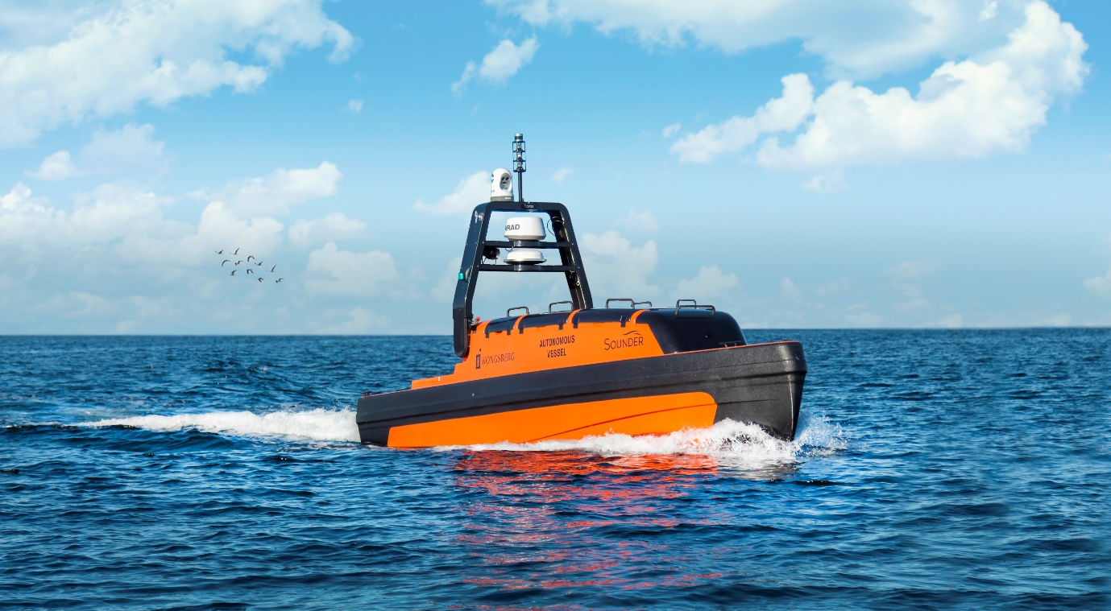
Kongsberg Maritime’s extensive subsea portfolio includes high performance multibeam and single beam echosounders, and several autonomous platforms such as the Sounder USV (pictured)

Kongsberg, Norway, 17th August 2021 – The Nippon Foundation-GEBCO Seabed 2030 Project and Kongsberg Maritime have entered a Memorandum of Understanding in support of the global initiative to produce the complete map of the ocean floor. Under the terms of the MOU, the two parties will work together to advance understanding of ocean bathymetry. The effort complements the goals of the United Nations Decade of Ocean Science for Sustainable Development.
Seabed 2030 is a collaborative project between The Nippon Foundation and GEBCO to inspire the complete mapping of the world's ocean by 2030, and to compile all bathymetric data into the freely available GEBCO Ocean Map. GEBCO is a joint project of the International Hydrographic Organization (IHO) and the Intergovernmental Oceanographic Commission (IOC), and is the only organisation with a mandate to map the entire ocean floor.
Kongsberg Maritime provides solutions for safe, efficient and sustainable maritime operations. The solutions are suitable for offshore energies, seaborne transportation, hydrography, science, navy, coastal marine, aquaculture, training services and more. Kongsberg Maritime is the largest business area within Kongsberg Gruppen ASA. The Group has an integrated portfolio of solutions for businesses, partners and nations operating from the depths of the sea to outer space and to the digital frontier.
“Seabed 2030 greatly welcomes the support of Kongsberg Maritime,” commented Jamie McMichael-Phillips, Director of the Seabed 2030 Project. “KONGSBERG’s prominent capabilities in providing sustainable maritime operations closely align with our ethos and aim here at Seabed 2030.”
Bjørn Jalving, Senior Vice President Technology, Kongsberg Maritime said: “As an organisation committed to offering the best marine technology, we are delighted to support Seabed 2030 in its mission of producing the definitive map of the seafloor.
“We envisage our systems for surveying, positioning and navigation to contribute rewardingly to this imperative global effort. We will specifically develop freely available functions for Kongsberg Maritime multibeam echo sounders, single beam echosounders and AUVs that ease the process of contributing bathymetric data to the Seabed 2030 data centres. The development will be collaboratively with the University of New Hampshire and Stockholm University.
“A complete map of the seafloor is a critical first step in understanding our planet through ocean exploration. We’re proud to support the Seabed 2030 Project.”
All data collected and shared with the Seabed 2030 Project is included in the GEBCO global grid, which is free and publicly available.
Ends

For further information, please contact:
Gunvor Hatling Midtbø, VP Communication
Kongsberg Maritime
Tel: +47 9921 4209
gunvor.hatling.midtbo@km.kongsberg.com

Pegah Souri
Tel: +44 (0)7951 581707
pegah@raittorr.co.uk

About The Nippon Foundation-GEBCO Seabed 2030 Project
The Nippon Foundation-GEBCO Seabed 2030 Project is a collaborative project between The Nippon Foundation and GEBCO. The Seabed 2030 Project, launched at the United Nations Ocean Conference in 2017 by Chairman Sasakawa of The Nippon Foundation, coordinates and oversees the sourcing and compilation of bathymetric data from different parts of the world’s ocean through its five centres into the freely-available GEBCO Grid. Four Regional Centres cover the Southern Ocean, the Arctic and North Pacific Ocean, the Atlantic and Indian Oceans, and the South and West Pacific Ocean. The Global Centre merges the regional datasets to generate global products.
Find out more about the project and how to get involved.

About Kongsberg Maritime
Kongsberg Maritime is a global marine technology company providing innovative and reliable ‘Full Picture’ technology solutions for all marine industry sectors including merchant, offshore, cruise, subsea and naval. Headquartered in Kongsberg, Norway, Kongsberg Maritime has manufacturing, sales and service facilities in 34 countries. Kongsberg Maritime is part of the stock listed group Kongsberg Gruppen ASA.
Web: Kongsberg Gruppen | Kongsberg Maritime
Social media: LinkedIn | Twitter | Facebook

