**Press release for immediate release 16 October 2024**

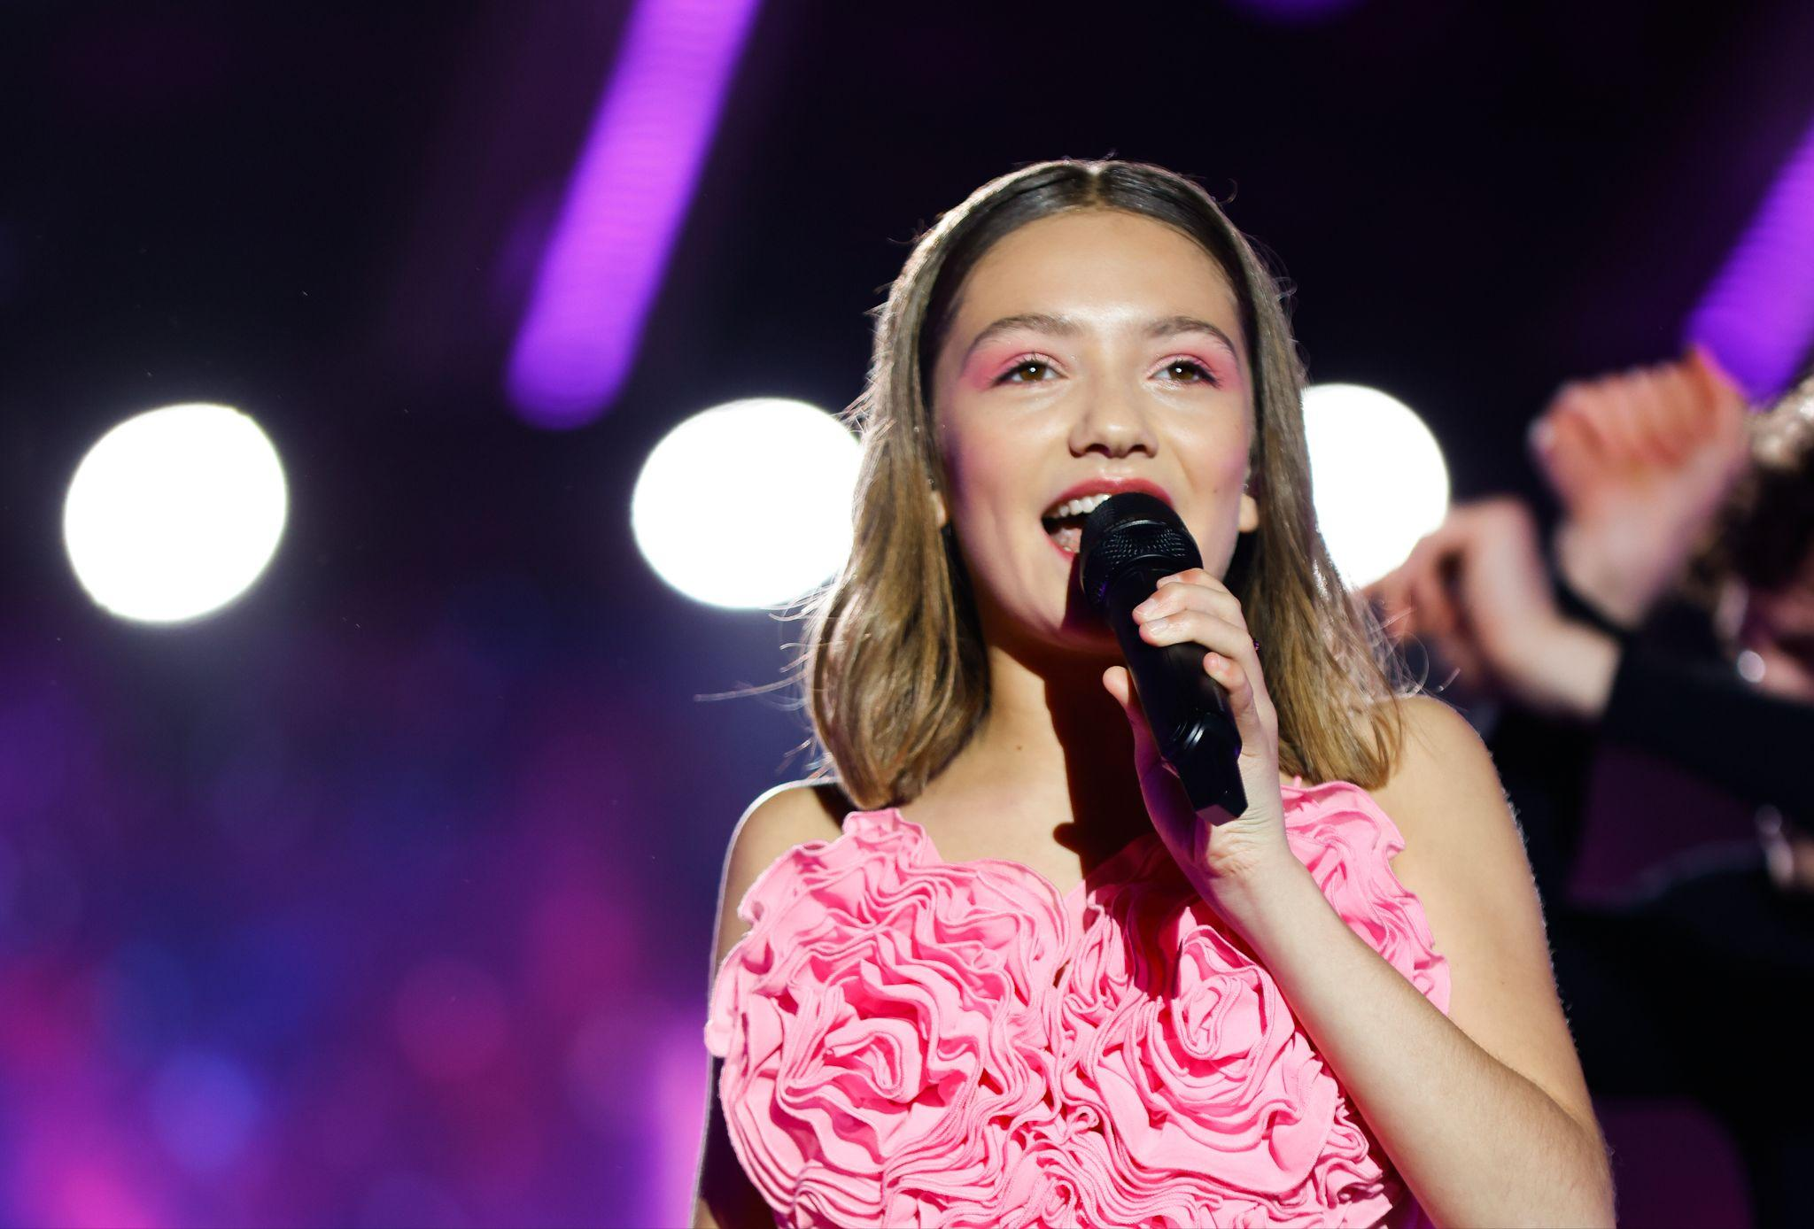

**Zoé Clauzure, Junior Eurovision Winner, Becomes Youngest Ambassador for Peace at the Non-Violence Project**

**October 16, 2024 – Zoé Clauzure, the 2023 Junior Eurovision winner, has just been named the youngest-ever Ambassador for Peace for the Non-Violence Project (NVP). At just 14, Zoé is already using her voice and music to champion peace and stand up against violence and bullying.**

In her new role as Ambassador, Zoé has reimagined the iconic *Knotted Gun* sculpture, originally created by Carl Fredrik Reuterswärd after John Lennon’s tragic death in 1980. Her version, *Dreams and Nature for Peace*, represents a world built on respect. Zoé handed the sculpture over to the 2024 Eurovision winner, Nemo, during the finals in Malmö this May, delivering a powerful message: Peace can be achieved through music and the arts, crossing borders and generations.

**“I’m so proud to be a Non-Violence Ambassador,” said Zoé Clauzure. “For me, peace means everyone respecting each other’s differences. It’s a world without violence, where music and lyrics can help build bridges to a more peaceful future.”**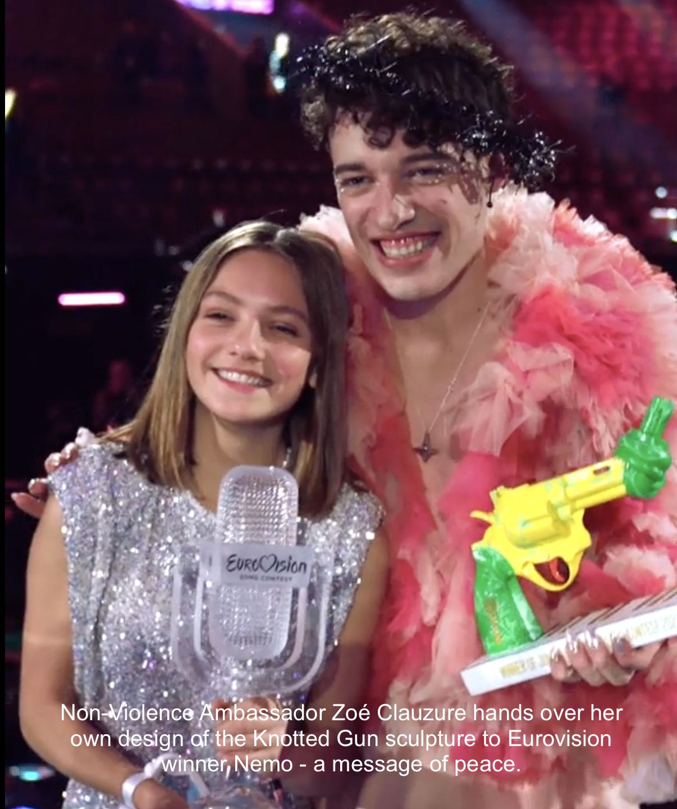

Zoé has already achieved remarkable things in her music career. She’s performed with artists like Amir, Yseult, and won praise from Camille Lellouche and Barbara Pravi. A semi-finalist on *The Voice Kids* in 2020, Zoé has released singles such as *Ma place* and built a loyal online following with her original music and piano covers. Very soon she will also release an EP of five songs.

**Her 2023 Junior Eurovision song *Coeur*—which focuses on school bullying—has struck a chord with audiences, becoming an anthem of resilience and hope. Zoé’s passion for addressing bullying through her music perfectly aligns with NVP’s mission of empowering young people to resolve conflicts peacefully.**

“We’re thrilled to welcome Zoé as our youngest Ambassador for Peace,” said Maria Norberg from the Non-Violence Project. “Her dedication to standing up against bullying and promoting peace through music is an inspiration. With her voice, Zoé embodies our mission to motivate and educate youth on solving conflicts peacefully, and she follows in the footsteps of Ambassadors like Sir Paul McCartney, Sir Ringo Starr, Patrizia Gucci, and Muhammad Ali.”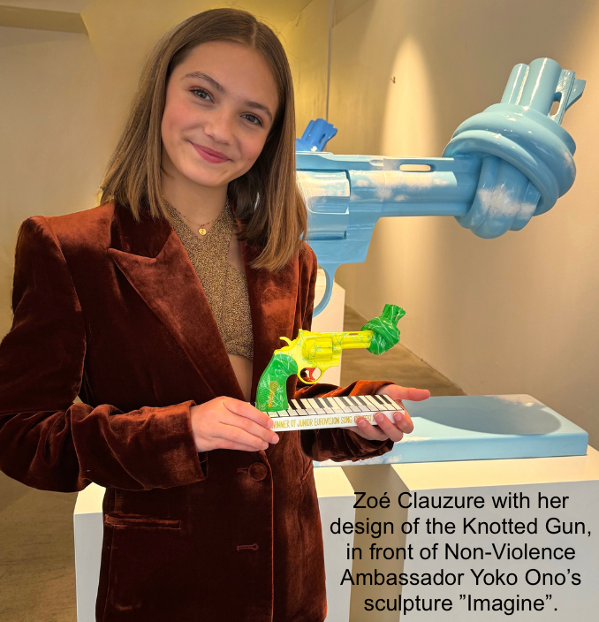

Zoé will return to the *Paradis Latin* stage in Paris starting on October 19th, and she’s set to perform at the Junior Eurovision Song Contest final in Madrid this November, where she will pass the torch to the next winner—continuing her mission to spread peace through music.

**About the Non-Violence Project**The Non-Violence Project Foundation (NVP) is a global organization dedicated to inspiring, motivating, and educating young people on how to resolve conflicts peacefully. Through creative learning programs in schools, sports clubs, and workplaces, NVP empowers youth to handle conflicts without resorting to violence. The *Knotted Gun* sculpture serves as a symbol of our mission to promote peace and non-violence across the world. The sculpture was created by Swedish artist Carl Fredrik Reuterswärd, after his friend John Lennon was shot outside his home in New York 1980. A global symbol for peace and non-violence, placed in over 30 strategic places around the world, and among them at the United Nations in New York.

www.nonviolence.com