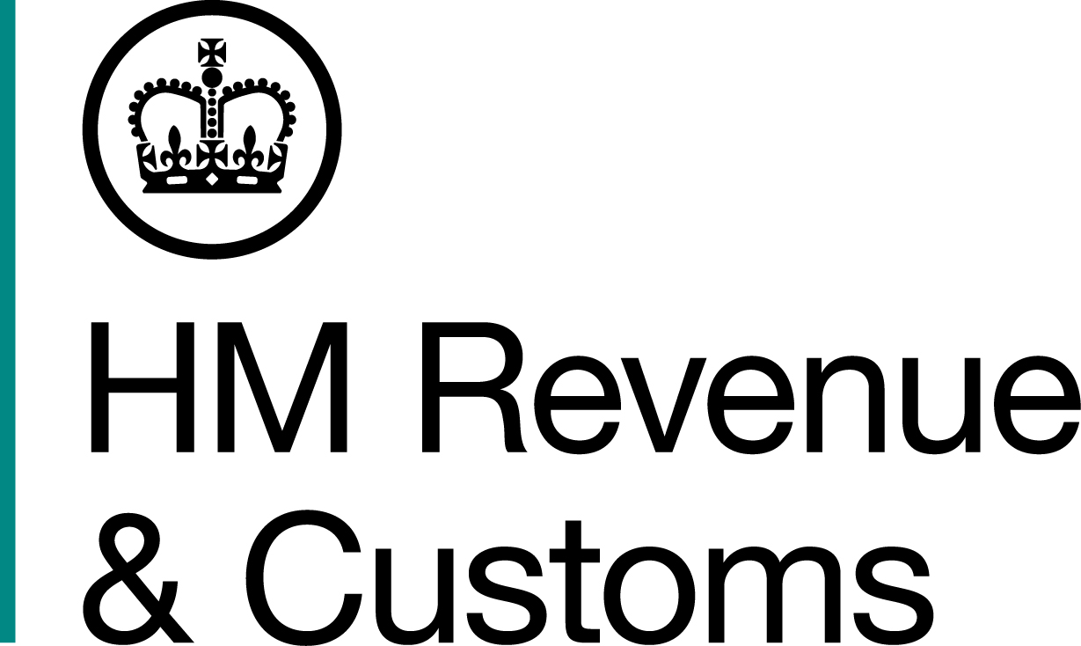
News Release

 | For the attention of News Desks |  | No of pages: 2
 | Date: | 05 03 2019 | Ref: | NW 05 19

Jailed drug dealer in £1million payback

A jailed Blackburn drug dealer and money launderer is being stripped of almost £1 million to repay his crimes.

Labib Arshid, 45, of Belthorn Road, was jailed for 10 and a half years in March 2018, after a joint HM Revenue and Customs (HMRC) and Lancashire Police investigation for possession of a class B drug with intent to supply and to money laundering.

HMRC investigators found Arshid had assets including a BMW X5, an Audi A3, and jewellery including Cartier and Chanel watches and a Tiffany necklace.

Arshid was ordered to repay £105,386 within three months or spend another year in jail and still owe the money at a confiscation hearing at Burnley Crown Court on Friday 1 March 2019. The convicted drug dealer has already had more than £840,000 in cash seized by HMRC.

Zoe Ellerbeck, Assistant Director, Fraud Investigation Service, HMRC, said:

“Arshid was a leading player in serious organised crime and his fraudulent activities funded a luxury lifestyle, denying the government of funds for hospitals and schools. He is now behind bars, and we are stripping him of his assets to reinvest in UK services. If he does not pay back the proceeds of the fraud in full amount Arshid will stay in jail for another year and still owe the money.

“HMRC will not give up the pursuit of criminal funds even after conviction, ensuring all tax is protected and used as originally intended. We urge anyone with information about money laundering or fraud to contact us online or to call 0800 788 887.”

HMRC investigators stopped Arshid in Chorley in November 2017 and found he had three bags containing almost £100,000 in cash. A search of his home uncovered hundreds of thousands of pounds in bank notes hidden behind tiles in an ensuite bathroom and under floorboards in his loft.

The cash was seized and forfeited while the drugs, with a street value of £8,459,440, were destroyed. Bank slips and notepads were also found at Arshid’s home which showed he had laundered £10.8m over the previous four months.

Information about any type of tax fraud can also be reported to HMRC online at www.gov.uk/report-an-unregistered-trader-or-business.

Notes to Editors

- Labib Arshid, DOB 09/10/1973, of Belthorn Road, Guide, Blackburn, BB1 2NL. Arshid was ordered to repay £105,386 within three months or face a default sentence of 12 months at a confiscation hearing at Burnley Crown Court on Friday March 1 2019.

- Follow HMRC Press Office on Twitter @HMRCpressoffice
- HMRC's Flickr channel: www.flickr.com/hmrcgovuk.

Issued by HM Revenue & Customs Press Office

Press enquiries only please contact:

Ed Casson
03000 524697
Ed.casson@hmrc.gsi.gov.uk

Or

Will Lyon
Tel: 03000 519451
Email: will.lyon@hmrc.gsi.gov.uk

Out of hours
Tel: 07860 359544

Website www.gov.uk/hmrc

