Press Release
Stockholm 14/05/2018

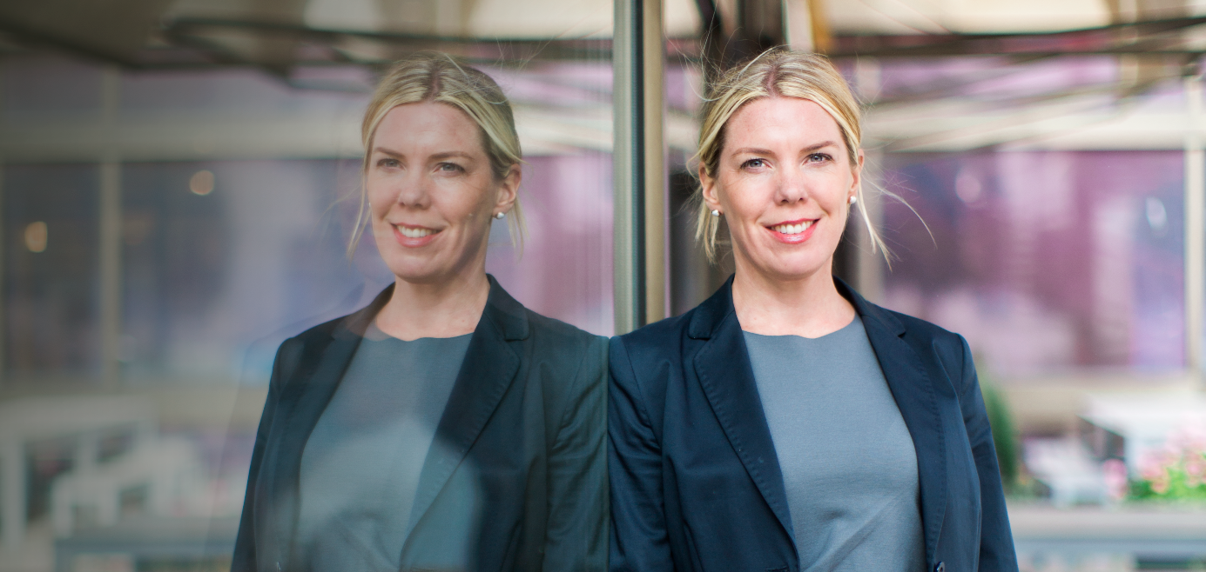
Photo: Jenny Drakenlind
Malin Nilsson, CEO of BDO Sweden

Commitment pays off – BDO has the most satisfied customers for the sixth consecutive year

The Swedish Quality Index (SKI) has just released the results of its annual industry rating on customer satisfaction, and BDO has done it again. For the sixth year in a row, BDO has the most satisfied customers in the industry.

Needless to say, Malin Nilsson, CEO of BDO Sweden, is proud of the agency’s employees who made this possible:

“We are delighted with the confidence demonstrated by our customers and I feel incredibly proud of all the employees driving our development.”

In an industry full of similar services and a powerful wave of digitalisation and automation, service and customer experience form an increasingly important competitive edge.

“We try to identify what drives value for the customer and the customer experience in general and we work constantly to develop our offering. Finishing in first place once again is unmistakable evidence that our offering appeals to our customers and that we are moving in the right direction as we pursue the same vision.”

BDO has a definite goal. To deliver the best service among all audit & advisory companies, and naturally customer satisfaction is high on the agenda.

“Our values are important for us so that we can reach our goals together. We only employ people we trust both as individuals and professionals. Their expertise and commitment to the customer are an intrinsic factor in our success.”

That’s why employees are put first at BDO
Nilsson explained that with an approach based on coaching and managers who build commitment, you see better results, increased profitability and satisfied customers. One of the initiatives launched during the years was a new coaching programme.

“This initiative is designed to help create new business opportunities and to encourage more women to stay and pursue careers at BDO.”

According to the Swedish Quality Index, which has been carrying out this rating since 2007, customers’ expectations of suppliers are extraordinarily high in the audit industry. The result for the whole industry is still high but has fallen slightly compared to the year before.

“This shows how important it is for us to keep our focus on values such as service, commitment and ‘proactivity’. We do not intend to get complacent. We aim to continue to shape and develop the business with an emphasis on the needs of the customer in order to retain the mark of quality that BDO has today.”

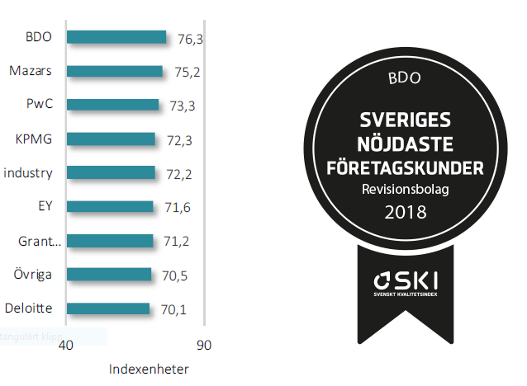

For more information, please contact:
Malin Nilsson, CEO
e-mail: malin.nilsson@bdo.se, phone: +46 10-171 50 00

About the company
BDO is one of the leading advisory and audit firms in Sweden. We offer a wide range of services within Advisory, Audit, Tax and Accounting. We are approximately 650 employees working in about 20 different offices around the country. BDO International is the fifth largest advisory, audit and consultant organization in the world with approximately 73 000 employees located at 1 500 offices in 160 countries.

