Pressinformation
Tender loving care for your skin with the new hansgrohe Croma 280 range of showerheads
Shower pleasure with people’s hansgrohe favourite
hansgroheCromaSelect280Showerpipe_Ambience01
Copyright: Hansgrohe SE
The hansgrohe Croma Select 280 Showerpipe pampers users with a voluptuous rain shower from a 280-millimetre spray disc.

Stockholm, April 2018. The new hansgrohe Croma 280 overhead showers bring clean design and the pleasure of a generous rain shower to the bathroom. Following the trend towards extra-large shower heads and all-in-one shower systems, the Croma 280 shower head range is expanding one of hansgrohe’s bestselling lines at an attractive price/performance ratio.
Quality and shower pleasure
Precise shapes and clean lines emphasise the high quality of the hansgrohe Croma 280 showerheads. Their design is the work of hansgrohe’s longstanding partner Phoenix Design. The 280-millimeter spray disc is generously sized; it is made of metal, is durable, robust and can be detached for easy cleaning. Thanks to air-enriched water drops, the lavish shower spray splashes less than conventional shower jets and envelops the body in a warm sense of wellbeing. The showerheads are available for ceiling or wall installation. Customers can opt for models equipped with hansgrohe EcoSmart water-saving technology. These use only about nine litres per minute, half the water used by showerheads without EcoSmart.
The showerpipe: an all-round talent
The hansgrohe Croma Select 280 showerpipe combines all components in a single system: overhead shower, hand shower, shower holder, thermostat and hose – a complete package convenient for both new construction projects and bathroom remodels. The showerpipe features high-quality materials, solid workmanship and easy cleaning. The horizontal shower arm can be used to swivel the overhead shower to the desired position. This is an advantage in small shower areas; for example, in situations where there is only room to install the showerpipe near a corner; in this case, the overhead shower can be centrally positioned, allowing for more freedom of movement. As an addition to the pleasurable overhead rain shower, the Croma Select S Multi hand shower offers flexibility with its three spray modes. Switching from one kind of spray to another is easy – all it takes is the push of a button. The integrated hansgrohe Ecostat Comfort thermostat allows the precise selection of individual temperature preferences and makes sure water doesn’t get too hot. The hansgrohe Croma Select 280 showerpipe comes in two additional versions: one with a single-lever mixer for bathtubs, and a renovation model for use with existing taps and mixers in bathroom renovation projects.

hansgrohe är premiummärket för duschar, duschsystem, badrum och kökskranar i den internationella Hansgrohe Group. Med prisbelönta produkter formar hansgrohe vattnet i köket och badrummet. Här använder människor tid som är särskilt viktigt för dem - och upplever betydelsefulla ögonblick med vatten. hansgrohe utvecklar framtida lösningar till dessa förnöjsamma stunder, som kombinerar utmärkt design, kvalitet, hållbarhet och intelligenta funktioner för bästa komfort. hansgrohe gör vatten till en fantastisk upplevelse.
hansgrohe. Meet the beauty of water.
Läs mer om märket hansgrohe på:
www.facebook.com/hansgrohe www.twitter.com/hansgrohe_pr

Sanitetsbranchens designfrämste
I den aktuella Rankingen från det Internationale Forum Design (iF) av de bästa verksamheter i världen när det handlar om design, ligger Hansgrohe SE på en 6:e plats av ca 2000 verksamheter. Med 1040 poäng mer än andra verksamheter är armatur- och duschspecialisten från Schiltach före verksamheter som Audi, BMW och Apple och toppar ännu en gång design-hitlistan för sanitetsbranschen.
www.hansgrohe.se/design

Ytterligare information: | Hansgrohe AB  Tlf. 031-21 66 00  info@hansgrohe.se  www.hansgrohe.se

Picture Overview
hansgrohe Croma 280
Copyright all images: hansgrohe/Hansgrohe SE
 |  | 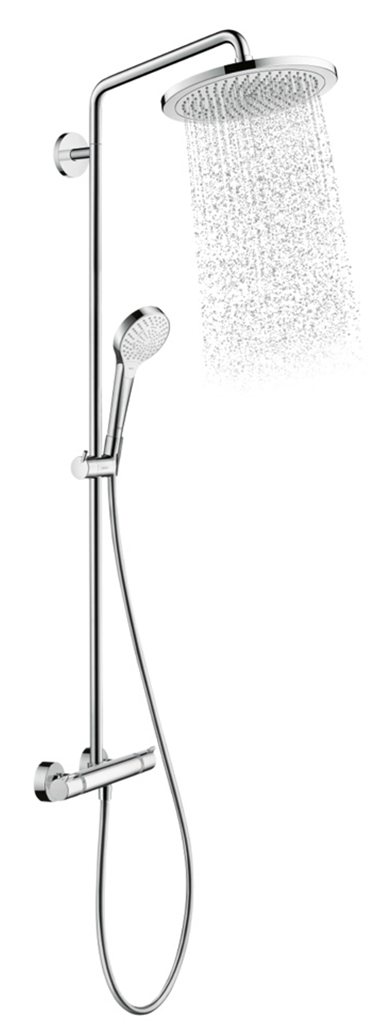
hansgroheCroma280OverheadShower_Ambience01 | hansgroheCroma280OverheadShower_Ambience02 | hansgroheCromaSelect280Showerpipe_Water
The new hansgrohe Croma 280 overhead showers bring clean design and the pleasure of a soothing rain shower to the bathroom. Thanks to the air-enriched water drops, the abundant shower spray splashes less than conventional shower jets and envelops the body in a warm sense of wellbeing.

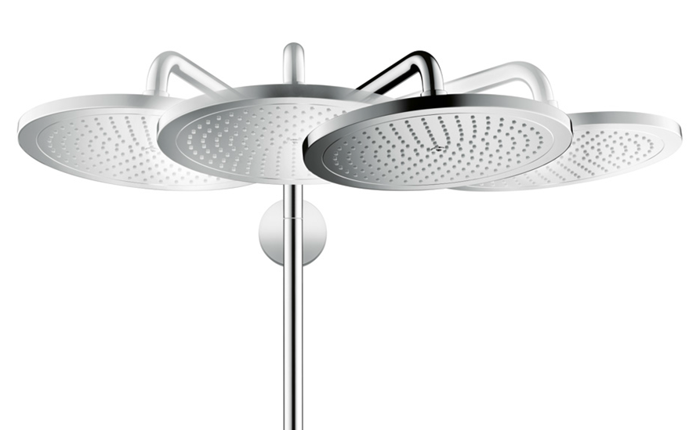 | 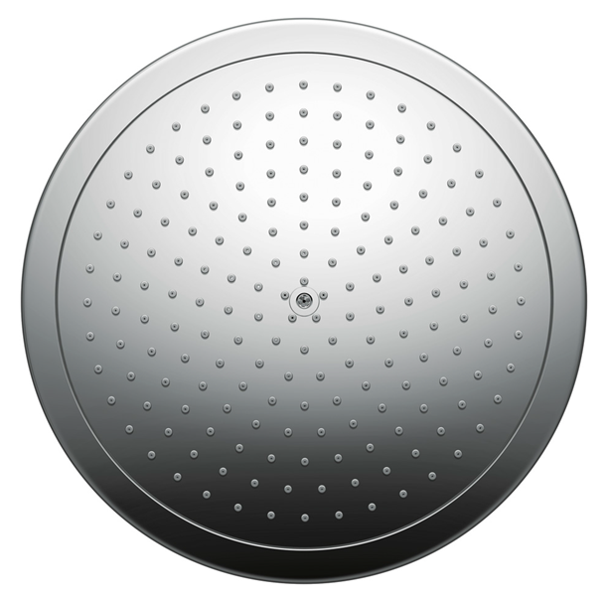 | 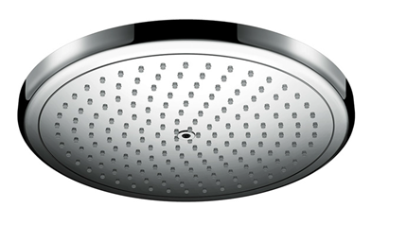
hansgroheCromaSelect280Showerpipe_Swivel | hansgroheCroma280_OverheadShower01 | hansgroheCroma280_  OverheadShower02
The horizontal shower arm can be used to swivel the overhead shower to the desired position. An advantage for installation in small shower areas. | Precise shapes and clean lines emphasise the quality of the hansgrohe Croma 280 showerheads. | The 280-millimeter spray disc is generously sized; it is made of metal, is durable, robust and can be detached for easy cleaning.

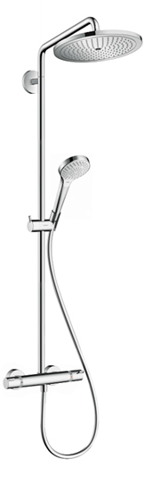 | 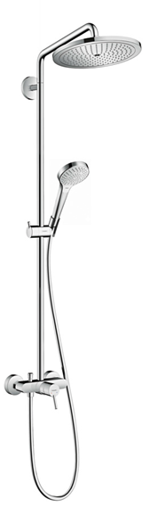 | 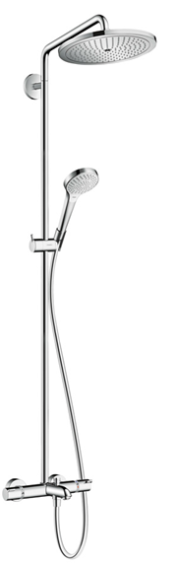 | 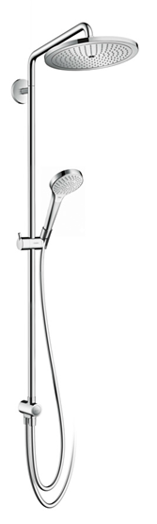
hansgroheCromaSelect280Showerpipe_Thermostat | hansgroheCromaSelect280Showerpipe_Mixer | hansgroheCromaSelect280Showerpipe_Bathtub | hansgroheCromaSelect280Showerpipe_Reno
The hansgrohe Croma Select 280 showerpipe comes in two additional versions: one with a single-lever mixer for bathtubs, and a renovation model for use with existing taps and mixers in bathroom renovation projects.

Picture link: http://www.mynewsdesk.com/se/hansgrohe
Copyright: We must draw your attention to the fact that we have only limited usage rights for the images provided, all further rights however belong to the respective photographers. These images may therefore only be published free of charge if they clearly and expressly serve to portray or advertise the performances, products or projects of Hansgrohe SE and/or its brands (AXOR, hansgrohe). Any other form of publication requires the approval of the respective copyright owner and remuneration must be made in agreement with said copyright owner.

