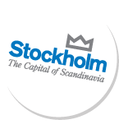


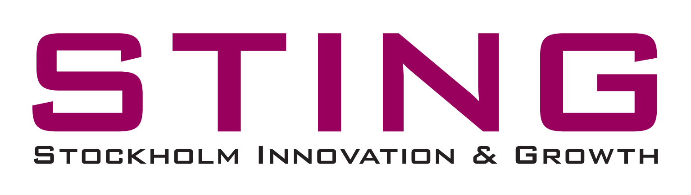

Pressrelease 2010-04-15

Cleantech innovation meet international investors at Stockholm Cleantech Venture Day 2010

The leading conference for cleantech innovation and investments - Stockholm Cleantech Venture Day 2010 - is held for the fourth consecutive year on the 30th of September, 2010 in Kista Science City. This year the focus is on the entire European market.

The main objective of the event is the match making between promising cleantech entrepreneurs, investors and decision makers where global influential representatives will share ideas, network and do business. The theme of this years’ conference is ”Cleantech Solutions for a Sustainable City”. Stockholm Innovation & Growth (STING) and Kista Science City AB are organising.

The invitation to participate is now extended to the entire European market. 25 carefully selected mature cleantech companies will be screened in a selection process by a well renowned jury and invited to present their investment cases during the event. The market demands are identified within the fields of renewable energy, energy efficiency improvements, energy storage, green IT and smart grid applications as well as water monitoring and treatment, waste management and air pollution reductions.

- As Stockholm is the first “European Green Capital of the Year” during 2010 we are eager to showcase European cleantech solutions to the rest of the world. This, together with a market demand outlook, will be emphasized during the conference programme. The ambition to match the selected companies with investors as well as with potential international and regional customers is imperative, says Magnus Rehn, Business Coach for cleantech at STING.

- The event is a highly relevant example of an activity that in the long term seriously changes the conditions, not only for a selected few, but for people all over the world. Sustainable solutions are here to stay, and the market demands continue to grow. Investing in these companies are investing in innovation and the future, says Anette Scheibe, CEO Kista Science City AB and the Electrum Foundation.

More information:
Therese Ronnevi, project leader SCVD2010
therese.ronnevi@kista.com

Magnus Rehn, Business Coach, Stockholm Innovation & Growth
magnus.rehn@stockholminnovation.com

Press contact & ackreditations:
Annica Englund, Kista Science City AB
annica.englund@kista.com
+46(0)702 46 36 88

The event website:
http://www.stockholmcleantechventureday.com

About STING:
http://www.stockholminnovation.com

About Kista Science City:
http://www.kista.com

