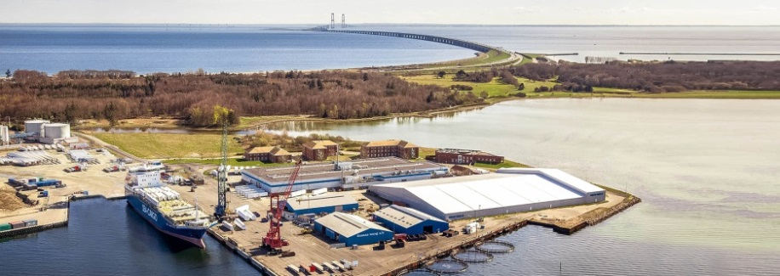
Glunz & Jensen A/S
Selandia Park 1
DK-4100 Ringsted
Denmark
Tel.: +45 5768 8181

Ringsted, 22 January 2018

GLUNZ & JENSEN CONSOLIDATES PRODUCTION AND R&D AT THEIR NEW DANISH HEADQUARTERS
In the past year Glunz & Jensen has been restructuring their business to transform the company into a more profitable, efficient and more cohesive business. A part of the plan has been to merge departments across Denmark and move their activities and headquarters to Nyborg, the eastern part of Funen.
The next step of the plan is to strengthen their Flexographic business area. It has been decided to consolidate the company´s production and R&D activities from Rosate (Italy) and Ringe (Denmark) - at the new headquarters in Nyborg, Denmark. These two sites will be consolidated into the 5,850 m² production and warehouse facility in Nyborg creating a Flexographic centre of excellence.
René Normann Christensen:
“We are equipping ourselves for the future, so we can continue to deliver superior products and services to all our valuable customers. We are convinced that with our new setup in Nyborg, and joining international functions like production and R&D into the same location, we will be able to deliver innovative products at a faster and more efficiently pace.”
The company will successively move into the new locations on Lindholm Havnevej 33 in Nyborg in the first 6 months of 2018. The 5,800m² buildings are situated directly at the beautiful harbor front and combines offices, production and warehouse facilities.

For more information, please contact:
René Normann Christensen, CEO - Email: rnc@glunz-jensen.com, Phone: +45 2423 4677

About Glunz & Jensen
Glunz & Jensen is the world’s leading and most trusted provider of equipment and solutions for the global prepress industry. We offer innovative solutions and dedicated support services to optimise your prepress workflow, maximise productivity and deliver outstanding quality and results.

Glunz & Jensen has been a recognized leader in prepress for nearly 45 years. Our innovative solutions have set the benchmark for excellence. By focusing on the areas that are most important to your needs – simplicity, performance, reliability and the lowest cost of ownership – our products and systems have become the preferred choice for companies operating a successful packaging and print media business. Today, thousands of organisations worldwide rely on Glunz & Jensen equipment.

We have long-standing relationships with major partners and customers such as Agfa, Asahi, DuPont, Flint, Fujifilm, Heidelberg, Kodak and MacDermid, the world's largest suppliers to the printing industry. Our products are sold through a comprehensive and worldwide network of distributors and dealers.

The Glunz & Jensen Group has approx. 230 employees in our subsidiaries and production facilities in Denmark, Slovakia, USA, Italy and UK. Glunz & Jensen A/S is listed on Nasdaq OMX Copenhagen A/S.

