

News Release

Stockholm, December 10, 2015

**Svenskt Tenn and Daniel Carlsten in collaboration for the Red Cross**

**A new tray design is now for sale at Svenskt Tenn. The Ace of Hearts tray is designed by Daniel Carlsten and sold for the benefit of the Red Cross and their efforts to support refugees.**

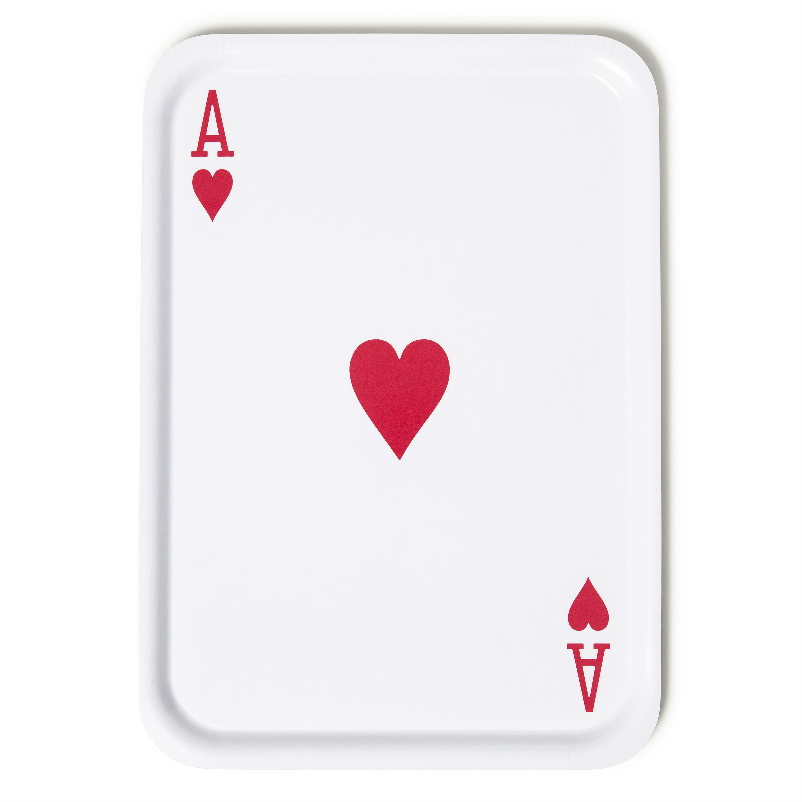The designer Daniel Carlsten has worked *pro bono* on this project, while Svenskt Tenn has covered manufacturing costs. The tray is priced at SEK 500 and the entire proceeds from sales will go to the Red Cross. The tray is available in a limited edition of 200 in the size 53x38 cm.

“For as long as I can remember, I have been captivated by playing cards,” says designer Daniel Carlsten. “This interest became inspiration for the Ace of Spades tray, which I introduced together with Svenskt Tenn earlier this year. From the outset, the idea was to make an Ace of Hearts tray as well, and to employ the symbolism of the heart to demonstrate love by action, and not just visually.”

In 2009, after five years as an art director at the agency Acne, Daniel Carlsten decided to set out on his own. Today his design works can be found, among many places, in the permanent collections at Nationalmuseum in Stockholm and the Röhsska Museum in Göteborg.

“With current world events in mind, it is essential to do what we can for people in need,” says Thommy Bindefeld, marketing manager at Svenskt Tenn. “When Daniel Carlsten approached Svenskt Tenn with the idea to produce a tray for a good cause, it came naturally to us to be part of this project and donate all proceeds.”

**For further information, please contact:**

Vicky Nordh, Press Contact: +46 8-670 16 23 or vicky.nordh@svenskttenn.se

Thommy Bindefeld, Marketing Director: +46 8 670 16 02 or thommy.bindefeld@svenskttenn.se

Svenskt Tenn is an interior design company with retail stores at Strandvägen in Stockholm and online. Since 1975, Svenskt Tenn is owned by the Kjell and Märta Beijer Foundation, which provides research grants within ecology, medicine and the preservation of Swedish interior design tradition.