Embargoed until 13 January, 10:00 a.m. SGT (GMT +8)

Unified Inbox launches its first product, Outbox Pro – the social media publishing tool that simplifies content creation and approval

Singapore, 13 January — Unified Inbox, the global Unified Communications as a Service (UCaaS) company, today announced the launch of its first product, cloud-based Outbox Pro, which improves the quality of organizations’ social media posts by making it faster and easier for teams to create and publish engaging posts on multiple social networks. This revolutionary web browser extension, currently available for Chrome, enables users to more easily create, share, review, edit, approve, schedule, publish, and track both original and curated web content from one or more authors on the most popular social networks, including Facebook, Twitter, and LinkedIn.
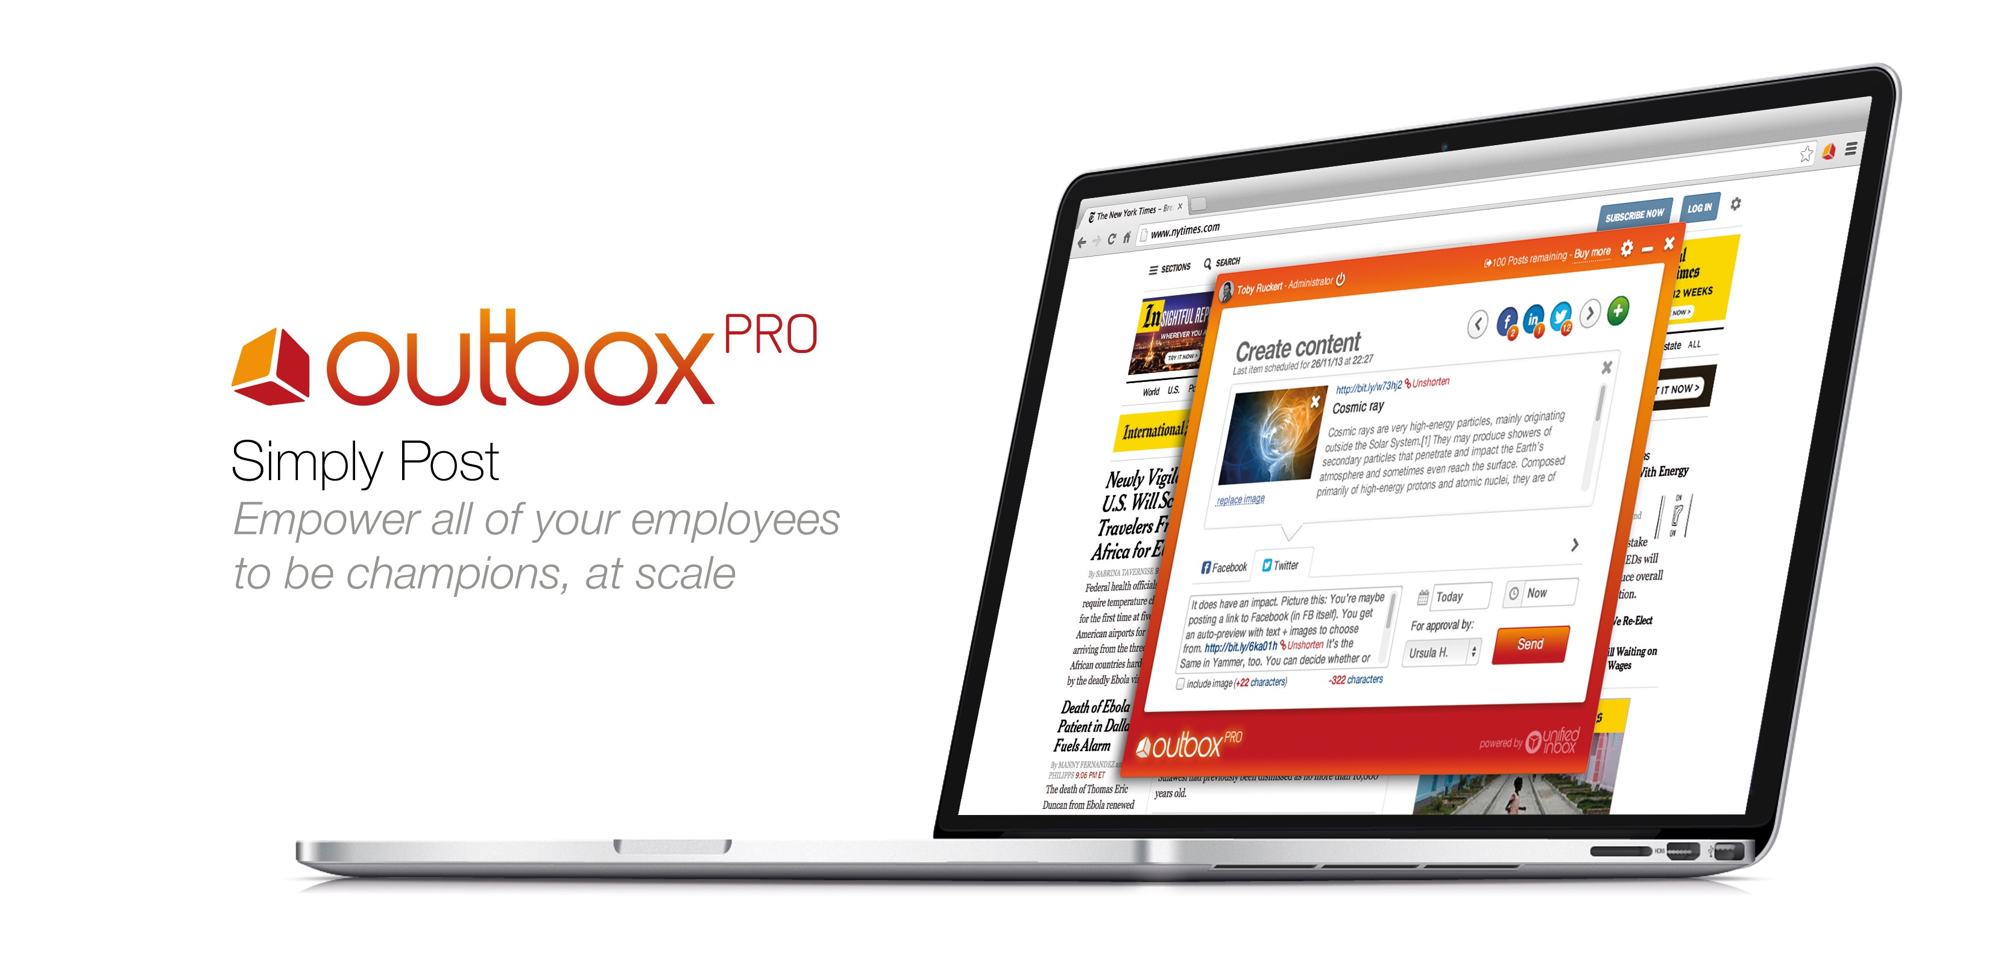
Social media spending is expected to grow to 21.4% of marketing budgets by 2019. As companies require greater ROI from their increased investment in social media, it is crucial for them to increase the quality of and reduce the time needed for their content marketing creation and management processes. Outbox Pro introduces a smart new workflow that enables in-house and/or agency marketing, communications, and PR teams to:
- Manage one or more “Authors” by centrally assigning and managing permissions-based roles
- Create secure access to live social networks without sharing social media passwords
- Create original and curated web content, customized for each social network
- Designate an “Admin” for social media content review and approval
- Receive and review approval requests via email from any mobile device
- Edit declined posts and resubmit them for approval

“Organizations no longer ask ‘Should we do social media?’ Instead they ask, ‘What tools will help us do it better and faster?’ We are excited to launch Outbox Pro to help companies increase the quality of their posts by simplifying their social media creation, approval, and posting processes,” said Toby Ruckert, Founder and Chief Executive Officer of Unified Inbox. “Companies can now improve their social media ROI by having full visibility and control of their real-time and scheduled social marketing content.”

Another way Outbox Pro increases the effectiveness of social content is by giving companies the ability to include authors outside of traditional digital marketing roles. For example, restaurants’ marketing departments can publish content created by their produce buyers to show fresh and unique ingredients “live from the market,” in the most appropriate formats on each of their different social media platforms.

The Singapore Days and Ramada Hotels have already implemented Outbox Pro to leverage customer-facing team members’ ability to capture real-time content to create a pipeline of compelling social media content for their different social networks. Tony Cousens, General Manager of the Wyndham Hotel Group Singapore, shared, “To communicate these achievements and better engage with our customers, we've been actively leveraging social media and recently with Outbox Pro. With at least four brands to cover on multiple social media sites at any point, an effective and productive strategy, but at the same time secure way of making social media work for us is key. The ability to schedule posts cross channel with one click is an important and productive marketing element for us. Furthermore, we can now draw good content from a wide variety of sources – our own staff of course, but eventually even our partners, visitors and customers themselves. This has only been made possible by the quick and easy workflow and approval function Outbox Pro provides. We've already been discussing the opportunity to widen its use for other properties in Asia-Pacific for Wyndham Hotel Group.”

Outbox Pro is available now for download on the Google Chrome Web Store, and at launch, supports social networks Facebook, Twitter, and LinkedIn, with more social networks to be announced. To incentivize new users, Outbox Pro’s first 100 posts are free, with additional posts costing 25 cents (U.S.) per post.

Click here to download Outbox Pro now.

About Unified Inbox
Unified Inbox is a global Unified Communications as a Service (UCaaS) company with three major product lines for enterprise communications, collaboration, and social media posting.

Unified Inbox’s cloud-based unified communication and social collaboration platform centralizes external conversations, social engagement, and internal team collaboration into one single experience across all desktop and mobile devices.

Unified Inbox enables employees to respond faster and more efficiently, and to build business relationships — improving your ability to connect with prospects, customers, and other internal departments across multiple channels and devices — all from a single screen.

Unified Inbox has team members in Singapore, New Zealand, India, Germany, and the United States.

Learn more about Unified Inbox now at unifiedinbox.com.

About Singapore Days and Ramada Hotels
Opened just over 18 months ago, the Days and Ramada Hotels at Zhongshan Park Singapore have already won several awards for outstanding service and left quite an impression on the Singapore hotel industry. Its two restaurants Flavours and 21 on Rajah have been very popular with locals and visitors alike.

Media contacts:
Serene Chow, PRecious Communications for Unified Inbox
Phone: +65-3151 4760
Email: serene@preciouscomms.com

Felicia Goh, PRecious Communications for Unified Inbox
Phone: +65-3151 4760
Email: felicia@preciouscomms.com

Ursula Hoult, Head of Operations at Unified Inbox
Phone: +1-408 490 3430 ext 728
Email: pr@unifiedinbox.com

“CMO Report: Highlights and Insights” http://cmosurvey.org/files/2014/09/The_CMO_Survey-Highlights_and_Insights-Aug-2014.pdf

