## **Press release**

# 01 February 2019

# **Univox launches TeamTalk, a 2.4GHz duplex communication system at ISE**

**Univox launches TeamTalk, a 2.4GHz duplex communication system at ISE. The system is designed to help presenters, leaders, teachers, instructors, guides, etc. in difficult sound environments. TeamTalk can be used both by hard-of-hearing persons and people with normal hearing.**

Univox launches [TeamTalk](https://univox.eu/product/teamtalk/), a 2.4GHz duplex communication system at [ISE](https://univox.eu/news/see-you-at-ise-2019/). The system consists of one leader unit and an unlimited number of participant units. The leader unit features full-duplex capability and transmits on an open channel. The participant unit also features full-duplex capability and transmits by pressing down the push-to-talk button.

The system is designed to help presenters, leaders, teachers, instructors, guides, etc. in difficult sound environments. The system has a range up to 150m and can be used both by hard-of-hearing persons and people with normal hearing.

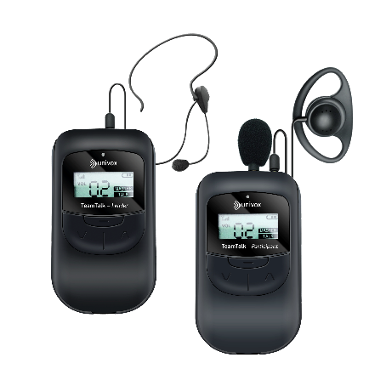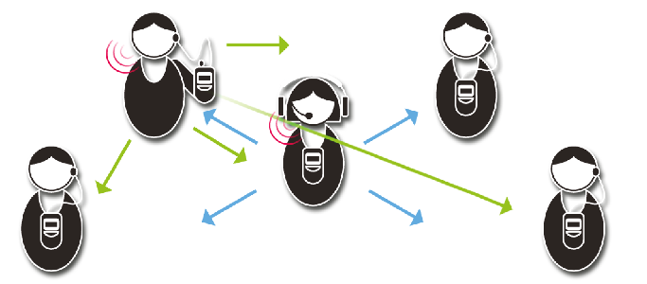

**About Univox**Univox is a developer and producer of high quality assistive listening products including hearing loops, IR and FM systems. We have been in business since 1965 and have distributors in over 35 countries all over the world. A Swedish based company known for a strong emphasis on research and development, continuing to innovate to deliver more firsts in the industry, constantly improving the performance of our products and service for hard of hearing communities. [www.univox.eu](http://www.univox.eu)

**Media contact:**

**Ulrika Magnusson, PR and Marketing assistant**

[**ulrika.magnusson@edin.se**](mailto:ulrika.magnusson@edin.se)