APPROVED PRESS RELEASE 3rd July 2019
CK ATRONIK INCREASES INTEGRAL CONTROL VERSATILITY OF ROTORK MODULAR ELECTRIC VALVE ACTUATORS
Rotork has increased the versatility of the CK range of modular electric valve actuators with the introduction of the CK Atronik, an intermediate level integral control option, providing a ready-to-operate actuation solution to meet the standard requirements of many plant specifications.
The CK Atronik control module houses a reversing contactor starter with mechanical and electrical interlocking, a proven and reliable Rotork design for electric actuation. Connection to a suitable power supply is all that is required for local operation of the actuator.

Digital microprocessor driven functionality delivers reliable motor control for isolating, regulating or modulating valve duties. Configuration is simply achieved with on-board dual in-line switches. Integral local control selectors are provided, together with clear LED status indication of valve open, valve closed, valve moving and alarm. Mechanical valve position indication is also provided on the actuator gearcase. Options include analogue control for positioning, analogue feedback, additional relay and network bus connectivity.

All CK modular actuators are environmentally sealed to IP68 (8 metres for 96 hours) as standard for long-term reliability in harsh operating conditions. Plug and socket connections for power, control and between modules assist swift site wiring and maintenance. Manual handwheel operation is independent of the motor drive and selected with a lockable hand / auto lever acting on a safe, low speed clutch. Separate thrust or non-thrust bases are available, enabling removal of the actuator from the valve without affecting valve position.

CK Atronik actuators can be specified for operation from single-phase or three-phase electrical supplies. For three-phase supplies the maximum actuator output torque is 500 Nm (369 lbf.ft) in an output speed range of 9 - 230 rpm.
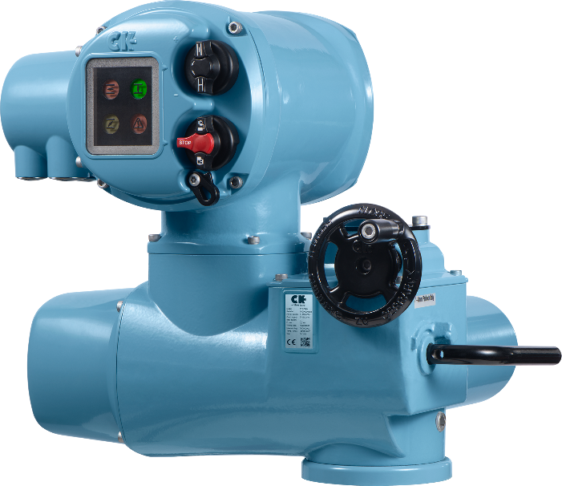

END
Photo captions
Rotork’s CK Atronik control module provides intermediate level integral controls for the standard CK electric actuator.

For further information please contact Rotork PLC
Sarah Kellett/Liam Jones Brassmill Lane
Group Marketing Communications Manager Bath
Telephone: +44 (0) 1225 733492 BA1 3JQ
Email: Sarah.Kellett@rotork.com/Liam.Jones@rotork.com UK

About Rotork
Rotork is the market leading actuator manufacturer and flow control company that operates in any market where the flow of gases or liquids needs to be controlled. It has established manufacturing facilities, a global network of local offices and agents who can truly provide a worldwide service. You will be able to locally source Rotork’s products, supported by life-of-plant maintenance, repair and upgrade services.

