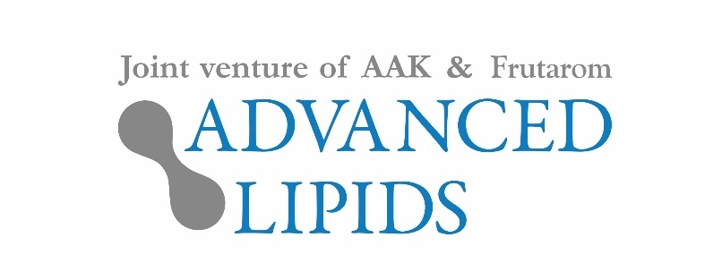

Thursday 17th May, 2018

PRESS RELEASE

INFAT® is infant nutrition ingredient of the year

INFAT®, a highly successful value-adding ingredient for infant formula, has been named Infant Nutrition Ingredient of the Year.

The high-quality fat product is manufactured by Advanced Lipids – a joint venture between AAK and Frutarom. INFAT® is a specially structured vegetable oil with high level of SN-2 palmitate, also known as OPO, it mimics the structure of human milk fat, and provides important benefits to the baby.

At the Nutraingredients Awards last night, INFAT® was named Infant Nutrition Ingredient of the year. In making their decision, the panel of eight industry experts noted the growing body of clinical research demonstrating its benefits for infant health.

A study published last year found that babies fed with formula containing INFAT®, cry less and sleep more. Another showed that it may have the potential to support healthy bone growth, and other benefits include better fat and calcium absorption, better comfort generated by softer stool, supporting healthy gut bacteria and better intestinal health which enhances the Infant immunity.

Consumer awareness of these benefits has fuelled demand, particularly in China. The Chinese consumer is well aware of the importance of high quality formula and the beneficial effect of OPO, and is looking for this ingredient when they choose the best formula for their little ones.

Ronald van der Knaap, CEO of Advanced Lipids, said: “It’s an honour to have received this prestigious award and we’re absolutely delighted. Mother’s milk will always be the gold standard of infant nutrition, but OPO ingredients like INFAT® help formula manufacturers come as close to mother's milk as possible. Both Frutarom and AAK are extremely proud of the expert team at Advanced Lipids who have contributed so much to scientific and consumer awareness of the benefits of OPO for infants and their parents.”

About Advanced Lipids

Advanced Lipids is a joint venture established by Enzymotec, a member of the Frutarom group and a leading biotech company specializing in lipid-based bio-functional ingredients; and AAK, a global producer and supplier of speciality vegetable fats and oils for the infant formula industry. Combining Enzymotec’s clinical and chemical expertise in lipid technologies with AAK’s international strength in food safety, production and logistics, Advanced Lipids offers a unique package of clinical research, development, flexible blending, quality and logistics.

Find out more at www.advancedlipids.com

