FACT SHEET
CoreValve™ Evolut™ R Transcatheter Aortic Valve System
Disease Overview:  Aortic Stenosis | Aortic stenosis is a common heart problem caused by a narrowing of the heart’s aortic valve due to excessive calcium deposited on the valve leaflets. When the valve narrows, it does not open or close properly, making the heart work harder to pump blood throughout the body. Eventually, this causes the heart to weaken and function poorly, which may lead to heart failure and increased risk for sudden cardiac death.  The CoreValve Evolut R System replaces a diseased aortic heart valve through a minimally invasive procedure, without open-heart surgery and without surgical removal of the diseased native or surgical valve. In the catheter-based procedure, a physician makes a small incision in the leg (transfemoral approach), upper chest (direct aortic approach) or shoulder (subclavian approach) to access the vasculature, and then guides the new valve into position to replace the failing aortic valve. Once in place, the device expands into place and takes over the original valve’s function to enable oxygen-rich blood to flow efficiently out of the heart.
Evolut R  Technology Overview | The CoreValve Evolut R System is a next-generation transcatheter aortic valve from Medtronic, offering enhanced valve performance and deliverability during transcatheter aortic valve replacement (TAVR) with the ability to recapture and reposition the valve during deployment. With its advanced design and features, the CoreValve Evolut R System represents the TAVR platform of the future.  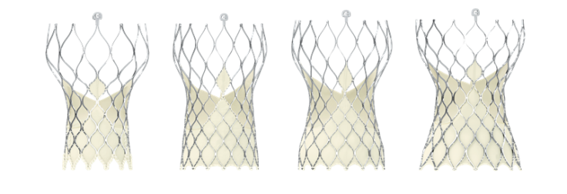  The self-expanding device is intended to treat patients with severe aortic stenosis who are considered at high or extreme risk for open-heart surgery.  Evolut R 23 mm  R 23mm  First-Time Positioning Accuracy  Evolut R 34 mm  Evolut R 29 mm  Evolut R 26 mm  - Consisting of the CoreValve Evolut R transcatheter aortic valve and the EnVeo™ R Delivery Catheter System, the CoreValve Evolut R System is designed for optimal valve performance with first time positioning accuracy, 1:1 response and self-centering to enable controlled valve deployment.  - The CoreValve Evolut R System provides the option to recapture (re-sheath the valve back into the catheter) and reposition (move the valve to a new position either above or below its current placement) the valve even after it has been mostly deployed to ensure optimal placement within a patient’s diseased valve.  EnVeo R Delivery Catheter System  Lowest Delivery Profile  - The novel system also offers a new InLine™ Sheath that significantly reduces the profile to the lowest on the market (approximately 1/5 inch); a smaller profile size provides a greater opportunity to treat patients with smaller vessels (now down to 5.0 mm in diameter), which may minimize the risk of major vascular complications in some patients.  Optimized Hemodynamic Performance  - The Evolut R System is anatomically designed to increase conformability at the annulus for optimal annular fit and sealing, while maintaining supra-annular valve position for improved hemodynamic performance.  Reduced Paravalvular Leak  - The 26 mm, 29 mm and 34 mm sizes of the CoreValve Evolut R transcatheter aortic valve are uniquely designed with an extended sealing skirt to further promote valve sealing at the annulus.
Regulatory Status | The CoreValve Evolut R System—which includes the Evolut R 23 mm, 26 mm and 29 mm sized valves—is available for use in the United States for patients at extreme or high risk for surgery, following U.S. Food and Drug Administration (FDA) approval in June 2015. The Evolut R 34 mm valve was FDA approved in October 2016. The 23 mm, 26 mm and 29 mm are also available in Europe and other countries that recognize the CE (Conformité Européene) mark for use in severe aortic stenosis patients at extreme, high and intermediate surgical risk.  In February 2016, the FDA approved an expanded indication trial for Evolut R that will include patients with aortic stenosis who are at a low surgical mortality risk, as determined by a heart team. It will include 1,200 low risk patients from 80 U.S. clinical sites and is designed as an adaptive trial with a primary endpoint of all-cause mortality or disabling stroke. The trial has a 2-year endpoint and allows for a one-year analysis for early FDA submission. Additionally, the trial will include a sub-study of leaflet mobility in 400 patients.

