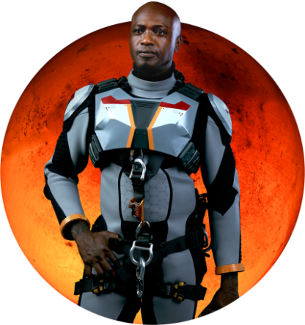

**CREW MEMBER: Robert Foucault**

ASSIGNMENT: Mechanical engineer and roboticist

NATIONALITY: Nigerian

NOTES: The son of an elite bureaucrat and a French diplomat, Foucault showed exceptional intelligence from a young age, and excelled academically at a series of top-level institutions, eventually receiving a Ph.D. in robotics from Stanford University. Though driven and dedicated to the Mars mission, he can take on too much at times.

**ACTOR BIO: Sammi Rotibi**

Sammi Rotibi plays Nigerian mechanical engineer and roboticist Robert Foucault. Originally from Nigeria, Rotibi is best known for his role as the rebellious slave in Quentin Tarantino’s “Django Unchained.” Most recently, he appeared in the DC/Warner Bros. film “Batman v Superman” and wrapped the comedy “Going Under” opposite Bruce Willis and John Goodman. On the TV side, he has recurred on shows such as the CW’s “Secret” and Robert Rodriguez’s “Matador” for El Rey. Other feature films include the supporting role of Andre Baptiste Junior in Andrew Nichol’s “Lord of War” alongside Nicolas Cage and Jared Leto, the gritty independent feature “Luv” with Common and the outstanding role of Arthur Azuka opposite Bruce Willis in Antoine Fuqua’s “Tears of the Sun.”