

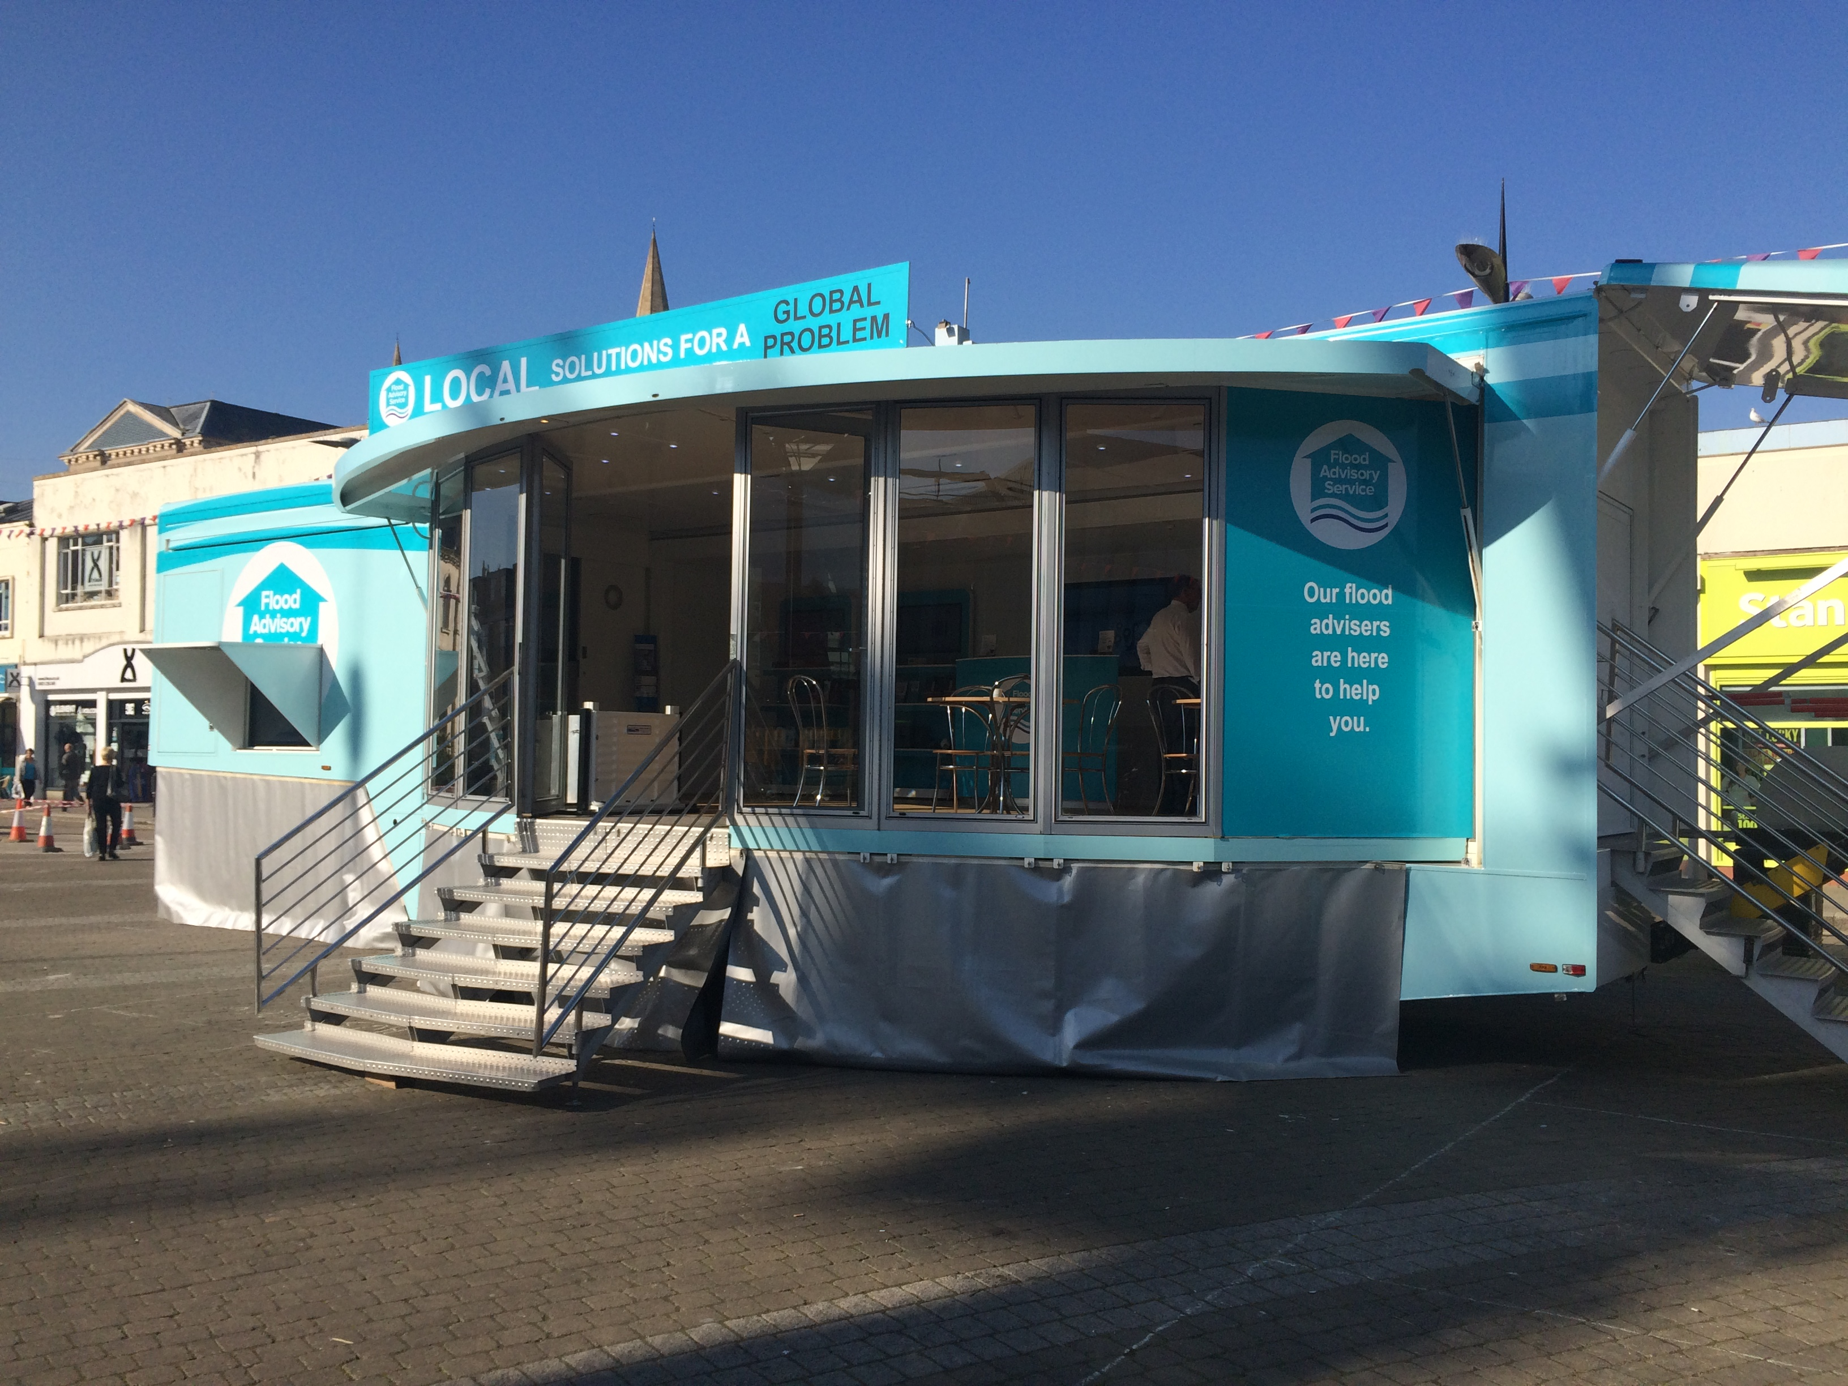
PRESS RELEASE

Target: Editors
Date: 13 / 10 / 2015
Page: 1 of 2
Photograph: The Flood Advisory Service mobile roadshow trailer, that will take the message of flood prevention to the worst hit communities in the UK, being launched at Flood Expo 2015.

Headline: Flood Advisory Service and Flood Professionals Joint UK Launch at Flood Expo

Main Body:

If you can cast your mind back to Christmas of 2012, most people will talk of fond festive memories of tinsel and Turkey; but for some communities in the UK their recollection of Christmas that year is one of misery due to flooding. It was the worst flooding in parts since Boscastle in 2004. The River Exe, amongst other burst its banks causing untold damage. Whilst most of the country sat back and watched one leading flood expert, Frank Kelly, vowed to fight back.

The Flood Advisory Service had been conceived as an idea back in 2010 by Frank Kelly, but the devastation of flood water in people’s homes provided the catalyst to move the idea into reality. Frank Kelly’s vision was to create a single point of contact for vulnerable communities and the public to turn to for independent advice, help and guidance.

Managing Director of the Flood Advisory Service, Sarah Marriott explains. “When Frank saw those devastating images back in 2012, then more in 2013 and 2014 he knew the time had come to act. So together we started to focus on developing a solution. It was obvious that people just didn’t know where to go for help and information and we both knew that we could help. Having worked alongside Frank for many years in the flood defence sector, he appointed me Managing Director of the Flood Advisory Service to deliver his vision. It has been a while in development but we are delighted to be launching the new mobile trailer here at Flood Expo. It’s full of lots of free information with independent advice on hand from our Flood Professionals via the means of a mobile Roadshow, which will roll out throughout the UK.”

Flood Professionals which is also being launched at Flood Expo is the UK’s first and only BSI Kitemark™ certified flood scheme covering products, surveys and installations. It has been carefully developed to ensure home owners can easily access both approved Kitemark products and certified flood specialists who will survey and install to the strict Kitemark requirements. This is coupled with impartial advice on products from a variety of manufacturers. Only those with the highest of standards will become a certified scheme member as qualifying involves passing both the industry leading Flood Professionals training course and a series of live ‘quality tests’ taking place in both the classroom and out in the field. Member businesses are then comprehensively audited to ensure compliance standards are met and all appropriate insurances are held, giving home owners peace of mind. It is one of the key services being offered via the Flood Advisory Service as it tours the UK.

Frank Kelly added “By combining the Flood Advisory Service mobile roadshow with the solid local knowledge of the Flood Professionals team which is all underpinned by BSI, then we have a complete solution and single point of contact for those worried about the serious issue of flooding. Not only that, it provides complete peace of mind for homeowners and for some it may be whilst they are dealing with the devastating effects of flooding. It’s why we have kept things so simple. Prevention is always better than cure of course and the mobile roadshow trailer gives plenty of free, impartial advice to help owners protect themselves and their properties. I’m proud that the service is a not for profit organisation. To have the support of BSI and many key players in the insurance sector supporting these crucial services is a UK first.”

The Flood Advisory Service and Flood Professionals is officially launched at the Flood Expo at ExCeL in London on 14th & 15th October 2015.

The company plans a national roll out over the coming months with full details of locations and dates being available from their website. If you have been affected by flooding or have questions about flood defence please visit www.floodadvisoryservice.co.uk and www.floodprofessionals.co.uk for more information.

--------ENDS-------

Media Contact: David Jones
Managing Director
Thirty 30 Media Ltd
M: +44 (0)7813 291216
E: david@thirty30media.co.uk
W: www.thirty30media.co.uk

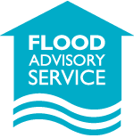

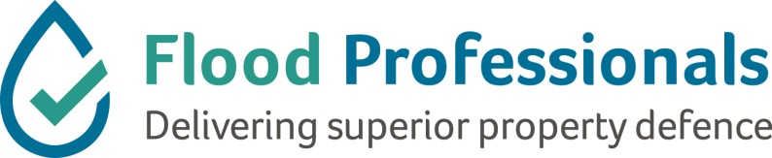

Notes to Editors:

The Flood Advisory Service & Flood Professionals officially launch at the Flood Expo at ExCeL in London on 14th & 15th October 2015. To book interviews with Frank Kelly or Sarah Marriot at Flood Expo please contact David Jones.

To contact the Flood Advisory please send e-mail to info@floodadvisoryservice.co.uk

If you have been affected by flooding or have questions about flood defence please visit www.floodadvisoryservice.co.uk and www.floodprofessionals.co.uk for more information.

Dates for the national roll out of the mobile trailer will be announced in mid-October 2015.

