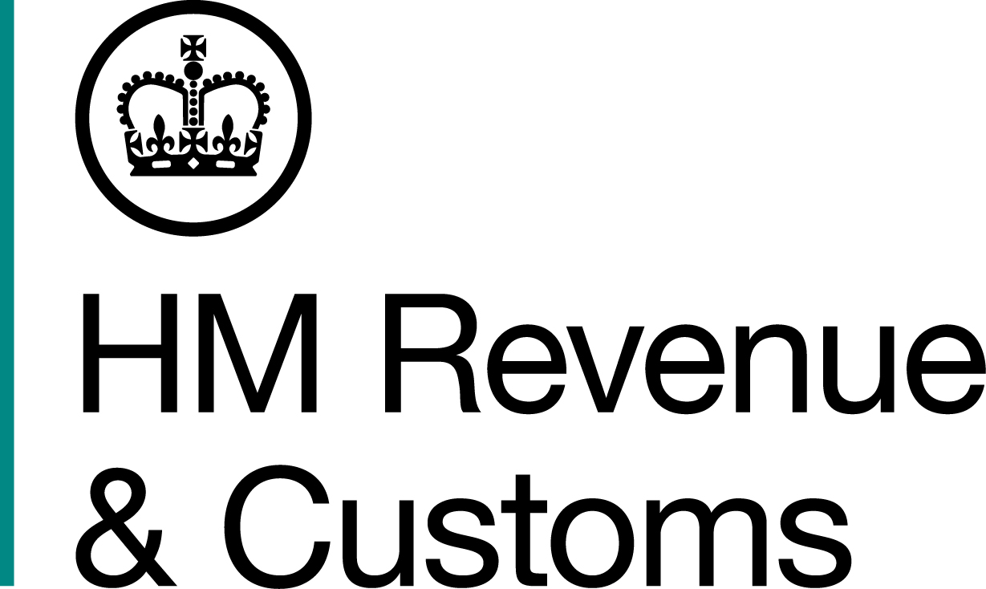
News Release

 | For the attention of News Desks |  | No of pages: 4
 | Date: | 11 May 18 | Ref: | NTH 06 18

Tobacco smuggling gang leader behind bars

A Leeds fraudster, who led a six-man tobacco smuggling gang in a conspiracy to put millions of illegal cigarettes on the streets, has been jailed for seven years.

Discount furniture store owner, Geoffrey David Moon, of Thwaite Lane, Leeds, presided over a criminal gang which brought tobacco products worth more than £2 million in unpaid duty into the UK.

HM Revenue and Customs (HMRC) seized more than eight million cigarettes and 200kg of hand-rolling tobacco from an industrial unit used by Moon and his gang in 2015. All the goods were counterfeit.

The gang was also caught with more than £1 million cash made from their crimes. Nearly half the money was found hidden within a lorry load of small metal ovens.

Moon used money from the fraud to fund a house by the canal, fully equipped with a 5-a-side football pitch and a canal boat.

Today (May 11), Moon was handed a seven-year jail sentence for his crimes. His associates, who helped move and distribute the illegal goods and cash, were also convicted for their roles in the conspiracy. They were:

- Sean Hirst, 52, of Kelsall Terrace, Leeds, was handed a five and-a-half year prison sentence.
- Paul Heselgrave, 46, of Temple Drive, Leeds, was handed a 12-month prison sentence, suspended for two years, and ordered to do 150 hours unpaid work.
- Anthony Queenan, 57, of Briarsdale Heights, Leeds, was handed a 12-month prison sentence, suspended for two years, and ordered to do 150 hours unpaid work.
- Gerard McKeown, 60, of Clonmore Rd, Dungannon, Northern Ireland, was handed an eight-month prison sentence suspended for 12 months.
- Another defendant, who cannot be named for legal reasons, was handed a six-year prison sentence.

Eden Noblett, Assistant Director, Fraud Investigation Service, HMRC, said:

“Moon was at the forefront of a shocking criminal operation which aimed to put masses of illegal tobacco products on the streets and cost UK taxpayers’ millions of pounds. The gang are now paying the price for their crimes.

“Trade in illegal tobacco harms legitimate businesses and starves the UK of money which should be used to fund our vital public services. Moon and his gang stole enough money to pay the salaries of 142 trainee firefighters for a year.

“Anyone with information about tax fraud should report it to HMRC online or contact our Fraud Hotline on 0800 788 887.”

Moon used his business Supa Sofa Ltd on Clarence Road, Leeds, as a front for the fraud and let gang members use company vehicles to make tobacco and cash drop-offs.

Five cash seizures totalling £1,111,180 were made from gang members between 2014 and 2016. The largest coming in July 2014 when £499,890 was found.

HMRC investigators saw the gang members with a lorry at an industrial estate in Leeds.
Border Force officers in Dover searched the lorry and found two bags containing the cash hidden inside one of the ovens along with a small quantity of em@il red branded counterfeit cigarettes. All the ovens had purpose built hidden compartments in the back of them.

In November 2015, HMRC officers searched a unit rented by Moon on Cross Green Way, Leeds, and they discovered 8,344,100 Excellence and Palace cigarettes, and 200kg Golden Virginia and Amber Leaf branded tobacco. The counterfeit goods, worth £2,030,573 in unpaid duty, were seized by HMRC.

Moon was subsequently arrested at his home on 17 November 2015.

He was released on bail and two months later he was caught handing a bag containing £81,220 cash to McKeown at a supermarket carpark in Hunslet, Leeds. McKeown was arrested but Moon fled before abandoning his car at a nearby shopping centre. He was arrested at his home later that day.

Moon was found guilty of cheating the public revenue at Leeds Crown Court on 3 April 2018, and was sentenced at the same court today (May 11), by His Honour Judge Kearl QC.

Hirst and another defendant, who cannot be named, were also found guilty of cheating the public revenue. Heselgrave, McKeown and Queenan admitted cheating the public revenue.

Two other men are currently being pursued in connection to the crimes.

A court ruled £1,107,180 of the seized cash could be paid into the public purse after the defendants could not show a legitimate source for it. Another £4,000 is currently under dispute.

Proceedings are also underway to recover the unpaid duty

Information about any type of tax fraud can be reported to HMRC online at https://www.gov.uk/report-an-unregistered-trader-or-business.

Notes to Editors

- Geoffrey David Moon, DOB 04/08/1964, of Thwaite Lane, Leeds.
- Sean Hirst, DOB 14/06/1965, of Kelsall Terrace, Leeds.
- Paul Heselgrave, DOB 08/10/1971, of Temple Drive, Leeds.
- Anthony Queenan, DOB 13/06/1960, of Briarsdale Heights, Leeds.
- Gerard McKeown, DOB, 03/11/1957, of Clonmore Rd, Dungannon, Northern Ireland.
- Another defendant, who cannot be named for legal reasons, was sentenced.
- Two other men are currently being pursued in connection to the crimes.
- The starting salary for a trainee firefighter is £22,017. When full competence is achieved, this rises to £29,345. Higher rates apply for overtime. Crew manager salaries range from £31,189 (development) to £32,533 (competent). https://www.prospects.ac.uk/job-profiles/firefighter
- Follow HMRC Press Office on Twitter @HMRCpressoffice.
- HMRC's Flickr channel: www.flickr.com/hmrcgovuk.

Issued by HM Revenue & Customs Press Office

Press enquiries only please contact:

Ashleigh Prince
Tel: 03000 598834
Email: Ashleigh.prince@hmrc.gsi.gov.uk

Or

Jon Sibley
Tel: 03000 552871
Email: jonathon.sibley@hmrc.gsi.gov.uk

Out of hours
Tel: 07860 359544
Website www.gov.uk/hmrc

